Table of Contents

Reshaping Data 1

Ridge Regression 3

Ridge Classifier 7

Saving and Re-Using Trained Models 11

## Reshaping Data

Many algorithms will require a transformation to adjust how X and y values are arranged. The need to transform, scale and then revert back to original formats is magnified when working with machine learning algorithms. The need to switch data formats can be frustrating but the problem will become less troubling with practice and experience. A common error to watch for is:

**Reshape your data either using array.reshape(-1, 1)**

Example 1: Resolving the Reshape Error

This example demonstrates the reshape error. Initially the data is presented as:

642 5

679 5

473 5

390 8

1096 6

When trying to scale the data, the following error displays:

**Reshape your data either using array.reshape(-1, 1)**

The code needs to be transformed into a set of vertical arrays.

[[5]

[5]

[5]

...

[6]

[6]

[5]]

Here is the code which leads to the error while scaling:

|  |
| --- |
| import pandas as pd  import numpy as np  from sklearn.metrics import mean_squared_error  from sklearn.model_selection import train_test_split  import statsmodels.api as sm  PATH = "/Users/pm/Desktop/DayDocs/data/"  CSV_DATA = "winequality.csv"  dataset = pd.read_csv(PATH + CSV_DATA)  # Show all columns.  pd.set_option('display.max_columns', None)  # Include only statistically significant columns.  X = dataset[['volatile acidity', 'chlorides', 'total sulfur dioxide',  'pH', 'sulphates','alcohol']]  y = dataset['quality']  X_train, X_test, y_train, y_test = train_test_split(X, y, test_size=0.2, random_state=0)  # Stochastic gradient descent models are sensitive to differences  # in scale so a MinMax is usually used.  from sklearn.preprocessing import MinMaxScaler  scalerX = MinMaxScaler()  scalerX.fit(X_train)  print(y_train)  # Build scaler for y.  scalerY = MinMaxScaler()  scalerY.fit(y_train) |

To fix the error we use:

y_train = np.array(y_train).reshape(-1, 1)

To transform the y values to the following format of vertical arrays:

Modified y_train

[[5]

[5]

[5]

...

[6]

[6]

[5]]

To build this example, replace the code that performs the scaling in Example 1 with the following:

|  |
| --- |
| import numpy as np  # Create array of y-values and reshape.  y_train = np.array(y_train).reshape(-1, 1)  print("\nModified y_train")  print(y_train)  # Build scaler for y.  scalerY = MinMaxScaler()  scalerY.fit(y_train)  y_scaled = scalerY.transform(y_train)  print("\nScaled y")  print(y_scaled) |

## Ridge Regression -> (doesn’t necessarily make it better)

Ridge regression is an algorithm that builds on gradient descent to find an optimum regression. Ridge regression adds a penalty measure to enable a more flexible best-fit line. This video by Josh Stormer explains nicely how the ridge regression works.

<https://www.youtube.com/watch?v=Q81RR3yKn30>

Example 2: Ridge Regression Introduction

This example will summarize the highlights from the video. We can use a best-fit line for training data with an algorithm like ordinary least squares like the one in Figure 1.

Figure 1: Best Fit Line with our Sample Data

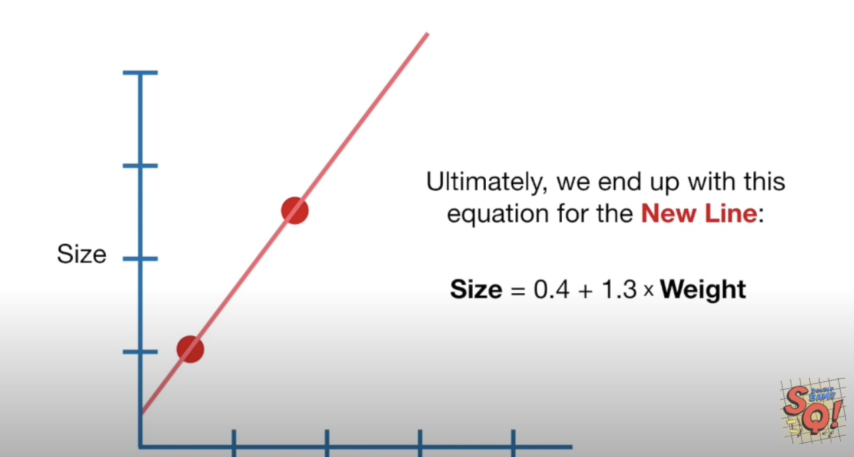

However, if our training set is in red and the test set is in green (refer to Figure 2) then the least squares fit actually is actually quite poor.

Figure 2: Poor fitting regression line

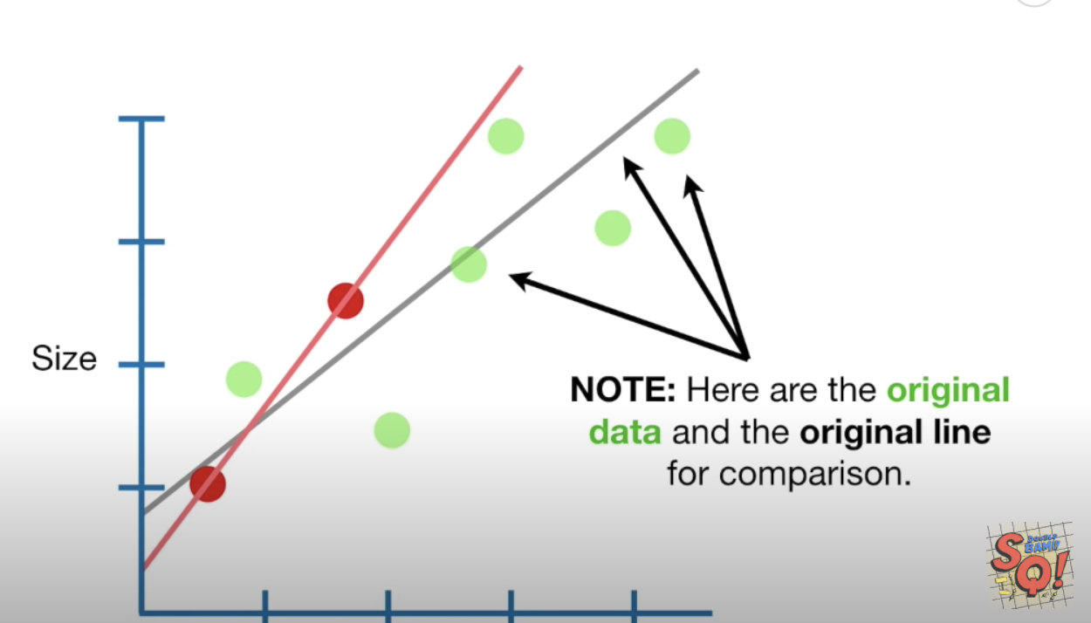

Ridge regression uses a penalty measure to avoid this problem of over-fitting on the training data. Ridge regression combines the least squares algorithm with a penalty that equals $λ∙{slope}^{2}$. $λ$ determines how severe the penalty is. The equation for ridge regression becomes:

y-axis-intercept + slope $∙$ weight + $λ∙{slope}^{2}$

Notice in Figure 3 how the slope is slightly reduced with the penalty. The best-fit line does not fit the training data as well but it does have a better fit with the test data. Cross fold validation is used to find the optimum penalty.

Figure 3: Effect on fit with penalty

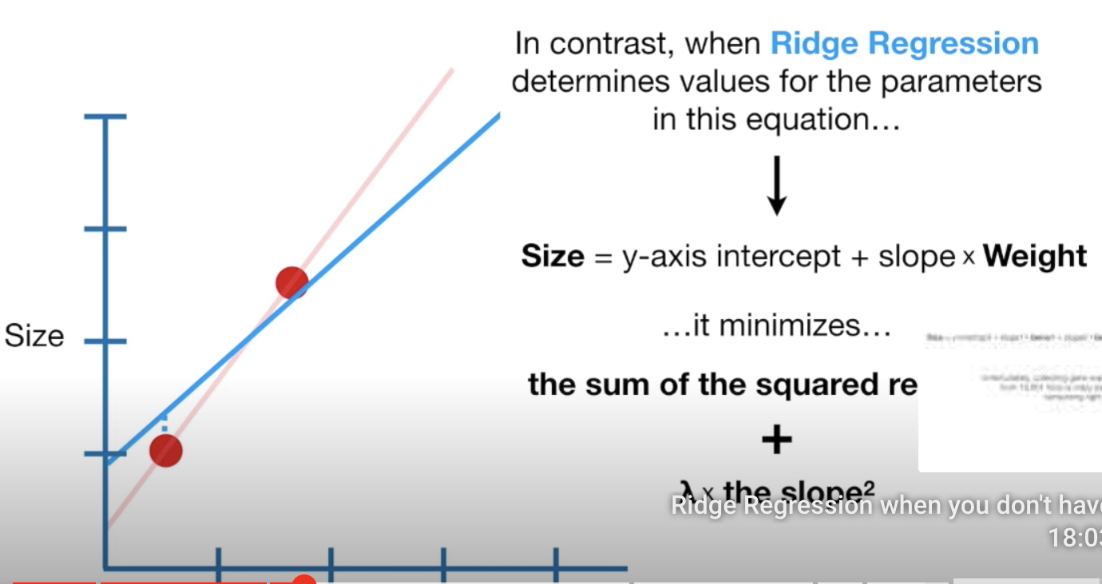 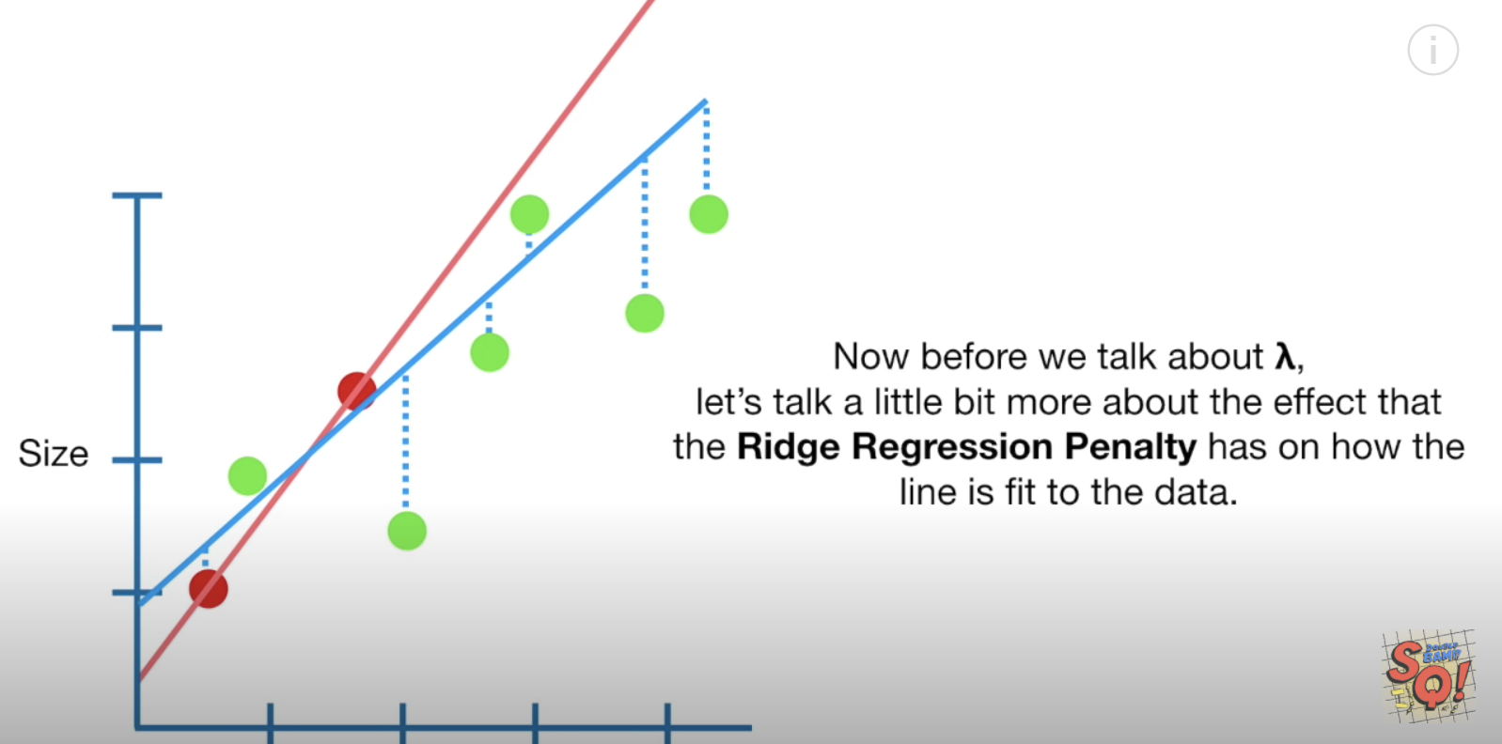

Example 3: Ridge Regression

This example shows how to use ridge regression to predict wine quality. If you compare the predictions of wine quality for OLS, Ridge and Stochastic Gradient Descent regression the results are not very dramatic in this case.

SGD (Calculated in the lab)

Root Mean Squared Error: 0.6223729015084277

OLS Regression

Root Mean Squared Error: 0.6206983401233142

Ridge Regression

Root Mean Squared Error: 0.6199800116556096

The code for the ridge regression is highlighted in yellow.

|  |
| --- |
| import pandas as pd  import numpy as np  from sklearn.metrics import mean_squared_error  from sklearn.model_selection import train_test_split  import statsmodels.api as sm  PATH = "/Users/pm/Desktop/DayDocs/data/"  CSV_DATA = "winequality.csv"  dataset = pd.read_csv(PATH + CSV_DATA,  skiprows=1, # Don't include header row as part of data.  encoding = "ISO-8859-1", sep=',',  names=('fixed acidity', 'volatile acidity', 'citric acid',  'residual sugar', 'chlorides', 'free sulfur dioxide',  'total sulfur dioxide', 'density', 'pH', 'sulphates',  'alcohol', 'quality'))  # Show all columns.  pd.set_option('display.max_columns', None)  # Increase number of columns that display on one line.  pd.set_option('display.width', 1000)  print(dataset.head())  print(dataset.describe())  # Include only statistically significant columns.  X = dataset[['volatile acidity',  'chlorides', 'total sulfur dioxide',  'pH', 'sulphates','alcohol']]  y = dataset['quality']  X_train, X_test, y_train, y_test = train_test_split(X, y, test_size=0.2, random_state=0)  # Stochastic gradient descent models are sensitive to differences  # in scale so a MinMax is usually used.  from sklearn.preprocessing import MinMaxScaler  scalerX = MinMaxScaler()  scalerX.fit(X_train)  # Build scaler for y.  scalerY = MinMaxScaler()  reshapedYtrain = np.array(y_train).reshape(-1,1)  scalerY.fit(reshapedYtrain)  # Scale X_train, X_test and y_train.  X_trainScaled = scalerX.transform(X_train)  X_testScaled = scalerX.transform(X_test)  y_trainScaled = scalerY.transform(reshapedYtrain)  # Add constant to scaled data.  X_trainScaled = sm.add_constant(X_trainScaled)  X_testScaled = sm.add_constant(X_testScaled)  #---------------------------------------------------------------  # Perform OLS regression.  model = sm.OLS(y_trainScaled, X_trainScaled).fit()  predictions = model.predict(X_testScaled) # make the predictions by the model  print(model.summary())  # Convert predictions to unscaled predicitons and compare with y_test.  unscaledPredictionsOLS = scalerY.inverse_transform(predictions.reshape(-1,1))  print('Root Mean Squared Error:',  np.sqrt(mean_squared_error(y_test, unscaledPredictionsOLS)))  #---------------------------------------------------------------  # Perform Ridge regression.  print("\nRidge Regression")  from sklearn.linear_model import Ridge  ridge_reg = Ridge(solver='auto')  ridge_reg.fit(X_trainScaled, y_trainScaled)  predictions = ridge_reg.predict(X_testScaled)  # Convert predictions to unscaled predicitons and compare with y_test.  unscaledPredictionsRidge = scalerY.inverse_transform(predictions.reshape(-1,1))  print('Root Mean Squared Error:',  np.sqrt(mean_squared_error(y_test, unscaledPredictionsRidge))) |

Example 4: OLS Using the USA Housing Data Set

Here is code which performs OLS regression on the USA housing data set to predict price. It will be used to answer questions that follow.

|  |
| --- |
| import pandas as pd  import numpy as np  from sklearn import metrics  from sklearn.model_selection import train_test_split  import statsmodels.api as sm  PATH = "/Users/pm/Desktop/DayDocs/data/"  CSV_DATA = "USA_Housing.csv"  df = pd.read_csv(PATH + CSV_DATA)  # Show all columns.  pd.set_option('display.max_columns', None)  # Increase number of columns that display on one line.  pd.set_option('display.width', 1000)  print(df.head())  print(df.describe())  X = df[['Avg. Area Income', 'Avg. Area House Age', 'Avg. Area Number of Rooms', 'Area Population']].values  # Adding an intercept *** This is required ***. Don't forget this step.  # The intercept centers the error residuals around zero  # which helps to avoid over-fitting.  X = sm.add_constant(X)  y = df['Price'].values  X_train, X_test, y_train, y_test = train_test_split(X, y, test_size=0.2, random_state=0)  model = sm.OLS(y_train, X_train).fit()  predictions = model.predict(X_test) # make the predictions by the model  print(model.summary())  print('Root Mean Squared Error:',  np.sqrt(metrics.mean_squared_error(y_test, predictions))) |

Exercise 1 (1 mark)

What is the RMSE value for the regression that is shown Example 4?

|  |
| --- |
| Root Mean Squared Error: 102671.05426155146 |

Exercise 2 (4 marks)

Scale the X and y data in Example 4 using a MinMaxScaler. Perform an inverse_transform() on the predictions. Then calculate the RMSE for the unscaled predictions and original y_test data. Show your code here:

|  |
| --- |
| from sklearn.metrics import mean_squared_error   import pandas as pd import numpy as np from sklearn import metrics from sklearn.model_selection import train_test_split import statsmodels.api as sm  PATH = "/Users/hyerimshin/PycharmProjects/MachineLearning/datasets/" CSV_DATA = "USA_Housing.csv"  df = pd.read_csv(PATH + CSV_DATA) # Show all columns. pd.set_option('display.max_columns', None)  # Increase number of columns that display on one line. pd.set_option('display.width', 1000)  print(df.head()) print(df.describe()) X = df[['Avg. Area Income', 'Avg. Area House Age', 'Avg. Area Number of Rooms', 'Area Population']].values  # Adding an intercept *** This is required ***. Don't forget this step. # The intercept centers the error residuals around zero # which helps to avoid over-fitting. X = sm.add_constant(X) y = df['Price'].values  X_train, X_test, y_train, y_test = train_test_split(X, y, test_size=0.2, random_state=0)  # model = sm.OLS(y_train, X_train).fit() # predictions = model.predict(X_test) # make the predictions by the model # print(model.summary()) # print('Root Mean Squared Error:', # np.sqrt(metrics.mean_squared_error(y_test, predictions)))  from sklearn.preprocessing import MinMaxScaler scalerX = MinMaxScaler() scalerX.fit(X_train)  # Build scaler for y. scalerY = MinMaxScaler() reshapedYtrain = np.array(y_train).reshape(-1,1) scalerY.fit(reshapedYtrain)  # Scale X_train, X_test and y_train. X_trainScaled = scalerX.transform(X_train) X_testScaled = scalerX.transform(X_test) y_trainScaled = scalerY.transform(reshapedYtrain)  # Add constant to scaled data. X_trainScaled = sm.add_constant(X_trainScaled) X_testScaled = sm.add_constant(X_testScaled)  #--------------------------------------------------------------- # Perform OLS regression. model = sm.OLS(y_trainScaled, X_trainScaled).fit() predictions = model.predict(X_testScaled) # make the predictions by the model print(model.summary())  # Convert predictions to unscaled predicitons and compare with y_test. unscaledPredictionsOLS = scalerY.inverse_transform(predictions.reshape(-1,1)) print('Root Mean Squared Error:',  np.sqrt(mean_squared_error(y_test, unscaledPredictionsOLS)))  #--------------------------------------------------------------- # Perform Ridge regression. print("\nRidge Regression") from sklearn.linear_model import Ridge ridge_reg = Ridge(solver='auto') ridge_reg.fit(X_trainScaled, y_trainScaled) predictions = ridge_reg.predict(X_testScaled)  # Convert predictions to unscaled predicitons and compare with y_test. unscaledPredictionsRidge = scalerY.inverse_transform(predictions.reshape(-1,1)) print('Root Mean Squared Error:', np.sqrt(mean_squared_error(y_test, unscaledPredictionsRidge))) |

Show your RMSE here:

|  |
| --- |
| Root Mean Squared Error: 102671.05426154629 |

Exercise 3 (4 marks)

Perform Ridge regression to predict housing prices with the data presented in Example 4. Ensure the data is scaled with a MinMaxScaler object. Show your code here:

|  |
| --- |
| from sklearn.metrics import mean_squared_error   import pandas as pd import numpy as np from sklearn import metrics from sklearn.model_selection import train_test_split import statsmodels.api as sm  PATH = "/Users/hyerimshin/PycharmProjects/MachineLearning/datasets/" CSV_DATA = "USA_Housing.csv"  df = pd.read_csv(PATH + CSV_DATA) # Show all columns. pd.set_option('display.max_columns', None)  # Increase number of columns that display on one line. pd.set_option('display.width', 1000)  print(df.head()) print(df.describe()) X = df[['Avg. Area Income', 'Avg. Area House Age', 'Avg. Area Number of Rooms', 'Area Population']].values  # Adding an intercept *** This is required ***. Don't forget this step. # The intercept centers the error residuals around zero # which helps to avoid over-fitting. X = sm.add_constant(X) y = df['Price'].values  X_train, X_test, y_train, y_test = train_test_split(X, y, test_size=0.2, random_state=0)  # model = sm.OLS(y_train, X_train).fit() # predictions = model.predict(X_test) # make the predictions by the model # print(model.summary()) # print('Root Mean Squared Error:', # np.sqrt(metrics.mean_squared_error(y_test, predictions)))  from sklearn.preprocessing import MinMaxScaler scalerX = MinMaxScaler() scalerX.fit(X_train)  # Build scaler for y. scalerY = MinMaxScaler() reshapedYtrain = np.array(y_train).reshape(-1,1) scalerY.fit(reshapedYtrain)  # Scale X_train, X_test and y_train. X_trainScaled = scalerX.transform(X_train) X_testScaled = scalerX.transform(X_test) y_trainScaled = scalerY.transform(reshapedYtrain)  # Add constant to scaled data. X_trainScaled = sm.add_constant(X_trainScaled) X_testScaled = sm.add_constant(X_testScaled)  #--------------------------------------------------------------- # Perform OLS regression. model = sm.OLS(y_trainScaled, X_trainScaled).fit() predictions = model.predict(X_testScaled) # make the predictions by the model print(model.summary())  # Convert predictions to unscaled predicitons and compare with y_test. unscaledPredictionsOLS = scalerY.inverse_transform(predictions.reshape(-1,1)) print('Root Mean Squared Error:',  np.sqrt(mean_squared_error(y_test, unscaledPredictionsOLS)))  #--------------------------------------------------------------- # Perform Ridge regression. print("\nRidge Regression") from sklearn.linear_model import Ridge ridge_reg = Ridge(solver='auto') ridge_reg.fit(X_trainScaled, y_trainScaled) predictions = ridge_reg.predict(X_testScaled)  # Convert predictions to unscaled predicitons and compare with y_test. unscaledPredictionsRidge = scalerY.inverse_transform(predictions.reshape(-1,1)) print('Root Mean Squared Error:', np.sqrt(mean_squared_error(y_test, unscaledPredictionsRidge))) |

Show your RMSE here:

|  |
| --- |
| Root Mean Squared Error: 102552.7018936574 |

Exercise 4 (1 mark)

Compare the RMSE’s for the OLS model and Ridge regression for the USA Housing set. Explain which model performs better.

|  |
| --- |
| Ridge regression’s RMSE is lower than OLS model so Ridge regression is better performed model. |

## Ridge Classifier

Example 5: Ridge Classification

As a reference, here is code to perform the same college admissions classification that was done earlier in class with a Ridge classifier. Once again, the results of Ridge regression with scaling exhibit perfect accuracy.

Accuracy: 1.0

Confusion Matrix

Predicted 0 1

Actual

0 5 0

1 0 5

The ridge regression code is highlighted in yellow below.

|  |
| --- |
| import pandas as pd  import numpy as np  from sklearn.model_selection import train_test_split  from sklearn.linear_model import LogisticRegression  from sklearn import metrics  # Setup data.  candidates = {'gmat': [780,750,690,710,680,730,690,720,  740,690,610,690,710,680,770,610,580,650,540,590,620,  600,550,550,570,670,660,580,650,660,640,620,660,660,  680,650,670,580,590,690],  'gpa': [4,3.9,3.3,3.7,3.9,3.7,2.3,3.3,  3.3,1.7,2.7,3.7,3.7,3.3,3.3,3,2.7,3.7,2.7,2.3,  3.3,2,2.3,2.7,3,3.3,3.7,2.3,3.7,3.3,3,2.7,4,  3.3,3.3,2.3,2.7,3.3,1.7,3.7],  'work_experience': [3,4,3,5,4,6,1,4,5,  1,3,5,6,4,3,1,4,6,2,3,2,1,4,1,2,6,4,2,6,5,1,2,4,6,  5,1,2,1,4,5],  'admitted': [1,1,1,1,1,1,0,1,1,0,0,1,  1,1,1,0,0,1,0,0,0,0,0,0,0,1,1,0,1,1,0,0,1,1,1,0,0,  0,0,1]}  df = pd.DataFrame(candidates,columns= ['gmat', 'gpa',  'work_experience','admitted'])  print(df)  # Separate into x and y values.  X = df[['gmat', 'gpa','work_experience']]  y = df['admitted']  # Import the necessary libraries first  from sklearn.feature_selection import SelectKBest  from sklearn.feature_selection import chi2  # Show chi-square scores for each feature.  # There is 1-degree freedom since 1 predictor during feature evaluation.  # Generally, >=3.8 is good)  test = SelectKBest(score_func=chi2, k=3)  chiScores = test.fit(X, y) # Summarize scores  np.set_printoptions(precision=3)  print("\nPredictor Chi-Square Scores: " + str(chiScores.scores_))  # Re-assign X with significant columns only after chi-square test.  X = df[['gmat', 'work_experience']]  # Split data.  X_train,X_test,y_train,y_test = train_test_split(  X, y, test_size=0.25,random_state=0)  # Perform logistic regression.  logisticModel = LogisticRegression(fit_intercept=True, random_state = 0,  solver='liblinear')  # Stochastic gradient descent models are sensitive to differences  # in scale so a StandardScaler is usually used.  from sklearn.preprocessing import MinMaxScaler  scaler = MinMaxScaler()  scaler.fit(X_train)  X_trainScaled = scaler.transform(X_train)  X_testScaled = scaler.transform(X_test)  print("\nRidge Classifier")  from sklearn.linear_model import RidgeClassifier  clf = RidgeClassifier(solver='auto')  clf.fit(X_trainScaled, y_train)  y_pred = clf.predict(X_testScaled)  print(y_pred)  # Show confusion matrix and accuracy scores.  confusion_matrix = pd.crosstab(y_test, y_pred,  rownames=['Actual'],  colnames=['Predicted'])  print('\nAccuracy: ',metrics.accuracy_score(y_test, y_pred))  print("\nConfusion Matrix")  print(confusion_matrix) |

Exercise 5 (1 mark)

Why isn’t the y value in Example 5 scaled?

|  |
| --- |
| Because it is logical regression. It used Sigmund function to scale the value of y between 0 and 1 |

Exercise 6 (3 marks)

The following code uses logistic regression to predict whether a patient has heart disease.

|  |
| --- |
| import pandas as pd  import numpy as np  from sklearn.model_selection import train_test_split  from sklearn.linear_model import LogisticRegression  from sklearn import metrics  import statsmodels.api as sm  PATH = "/Users/pm/Desktop/DayDocs/data/"  FILE = 'heart_disease.csv'  df = pd.read_csv(PATH + FILE)  print(df)  # Separate into x and y values.  X = df[['age',  'sex', 'cp', 'trestbps', 'chol', 'fbs', 'restecg', 'thalach', 'exang',  'oldpeak', 'slope', 'ca', 'thal']]  y = df['target']  # Import the necessary libraries first  from sklearn.feature_selection import SelectKBest  from sklearn.feature_selection import chi2  # Show chi-square scores for each feature.  # There is 1-degree freedom since 1 predictor during feature evaluation.  # Generally, >=3.8 is good)  test = SelectKBest(score_func=chi2, k=3)  chiScores = test.fit(X, y) # Summarize scores  np.set_printoptions(precision=3)  print("\nPredictor Chi-Square Scores: " + str(chiScores.scores_))  # Re-assign X with significant columns only after chi-square test.  X = df[['age',  'sex', 'cp', 'trestbps', 'chol', 'fbs', 'thalach', 'exang',  'oldpeak', 'slope', 'ca', 'thal']]  # Split data.  X_train,X_test,y_train,y_test = train_test_split(  X, y, test_size=0.25,random_state=0)  # Stochastic gradient descent models are sensitive to differences  # in scale so a StandardScaler is usually used.  from sklearn.preprocessing import MinMaxScaler  scaler = MinMaxScaler()  scaler.fit(X_train)  X_trainScaled = scaler.transform(X_train)  X_testScaled = scaler.transform(X_test)  X_trainScaled = sm.add_constant(X_trainScaled)  X_testScaled = sm.add_constant(X_testScaled)  print("\nLogistic Regression")  # Perform logistic regression.  logisticModel = LogisticRegression(fit_intercept=True, random_state = 0,  solver='liblinear')  logisticModel.fit(X_trainScaled, y_train)  y_pred = logisticModel.predict(X_testScaled)  # Show confusion matrix and accuracy scores.  confusion_matrix = pd.crosstab(y_test, y_pred,  rownames=['Actual'],  colnames=['Predicted'])  print('\nAccuracy: ', metrics.accuracy_score(y_test, y_pred))  print("\nConfusion Matrix")  print(confusion_matrix) |

Modify the code to use the RidgeClassifier to predict if a patient has heart disease. Show the new confusion matrix and accuracy score here (It is possible that the accuracy may not be as good as the Logistic regression classifier). Compare this output to the confusion matrix and accuracy score for logistic regression:

|  |
| --- |
|  |

Show your code here:

|  |
| --- |
| import pandas as pd import numpy as np from sklearn.model_selection import train_test_split from sklearn.linear_model import LogisticRegression from sklearn import metrics import statsmodels.api as sm  PATH = "/Users/hyerimshin/PycharmProjects/MachineLearning/datasets/" FILE = 'heart_disease.csv' df = pd.read_csv(PATH + FILE) print(df)  # Separate into x and y values. X = df[['age',  'sex', 'cp', 'trestbps', 'chol', 'fbs', 'restecg', 'thalach', 'exang',  'oldpeak', 'slope', 'ca', 'thal']] y = df['target']  # Import the necessary libraries first from sklearn.feature_selection import SelectKBest from sklearn.feature_selection import chi2  # Show chi-square scores for each feature. # There is 1-degree freedom since 1 predictor during feature evaluation. # Generally, >=3.8 is good) test = SelectKBest(score_func=chi2, k=3) chiScores = test.fit(X, y) # Summarize scores np.set_printoptions(precision=3) print("\nPredictor Chi-Square Scores: " + str(chiScores.scores_))  # Re-assign X with significant columns only after chi-square test. X = df[['age',  'sex', 'cp', 'trestbps', 'chol', 'fbs', 'thalach', 'exang',  'oldpeak', 'slope', 'ca', 'thal']]  # Split data. X_train,X_test,y_train,y_test = train_test_split(  X, y, test_size=0.25,random_state=0)    # Stochastic gradient descent models are sensitive to differences # in scale so a StandardScaler is usually used. from sklearn.preprocessing import MinMaxScaler scaler = MinMaxScaler() scaler.fit(X_train) X_trainScaled = scaler.transform(X_train) X_testScaled = scaler.transform(X_test)  print("\nRidge Classifier") from sklearn.linear_model import RidgeClassifier clf = RidgeClassifier(solver='auto') clf.fit(X_trainScaled, y_train)  y_pred = clf.predict(X_testScaled) print(y_pred)  # Show confusion matrix and accuracy scores. confusion_matrix = pd.crosstab(y_test, y_pred,  rownames=['Actual'],  colnames=['Predicted'])  print('\nAccuracy: ',metrics.accuracy_score(y_test, y_pred)) print("\nConfusion Matrix") print(confusion_matrix) |

## Saving and Re-Using Trained Models

Most machine learning models can be saved as a binary file after they have been trained. You can then use the saved model to make predictions without training later. Using a binary model will save you an enormous amount of time as your training sets grow in size.

Example 6: Saving a Ridge Regression Model

This example shows how you could save and then re-use the saved pre-trained ridge regression model to make predictions. To build this example, add this code to Example 5.

|  |
| --- |
| import pickle  # save model to file  pickle.dump(clf, open("myRidgeModel.dat", "wb"))  # load model from file  loaded_model = pickle.load(open("myRidgeModel.dat", "rb"))  ridgePredictions = loaded_model.predict(X_testScaled)  print(ridgePredictions) |

Exercise 7 (2 marks)

Adjust your program in Exercise 6 to also save your model for logistic regression. Then, load it and use it to make predictions for the test set. Show your code here:

|  |
| --- |
| import pandas as pd import numpy as np from matplotlib.pyplot import clf from sklearn.model_selection import train_test_split from sklearn.linear_model import LogisticRegression from sklearn import metrics import statsmodels.api as sm  PATH = "/Users/hyerimshin/PycharmProjects/MachineLearning/datasets/" FILE = 'heart_disease.csv' df = pd.read_csv(PATH + FILE) print(df)  # Separate into x and y values. X = df[['age',  'sex', 'cp', 'trestbps', 'chol', 'fbs', 'restecg', 'thalach', 'exang',  'oldpeak', 'slope', 'ca', 'thal']] y = df['target']  # Import the necessary libraries first from sklearn.feature_selection import SelectKBest from sklearn.feature_selection import chi2  # Show chi-square scores for each feature. # There is 1-degree freedom since 1 predictor during feature evaluation. # Generally, >=3.8 is good) test = SelectKBest(score_func=chi2, k=3) chiScores = test.fit(X, y) # Summarize scores np.set_printoptions(precision=3) print("\nPredictor Chi-Square Scores: " + str(chiScores.scores_))  # Re-assign X with significant columns only after chi-square test. X = df[['age',  'sex', 'cp', 'trestbps', 'chol', 'fbs', 'thalach', 'exang',  'oldpeak', 'slope', 'ca', 'thal']]  # Split data. X_train,X_test,y_train,y_test = train_test_split(  X, y, test_size=0.25,random_state=0)  # Stochastic gradient descent models are sensitive to differences # in scale so a StandardScaler is usually used. from sklearn.preprocessing import MinMaxScaler scaler = MinMaxScaler() scaler.fit(X_train) X_trainScaled = scaler.transform(X_train) X_testScaled = scaler.transform(X_test) X_trainScaled = sm.add_constant(X_trainScaled) X_testScaled = sm.add_constant(X_testScaled)  print("\nLogistic Regression") # Perform logistic regression. logisticModel = LogisticRegression(fit_intercept=True, random_state = 0,  solver='liblinear')  logisticModel.fit(X_trainScaled, y_train) y_pred = logisticModel.predict(X_testScaled)  # Show confusion matrix and accuracy scores. confusion_matrix = pd.crosstab(y_test, y_pred,  rownames=['Actual'],  colnames=['Predicted']) print('\nAccuracy: ', metrics.accuracy_score(y_test, y_pred)) print("\nConfusion Matrix") print(confusion_matrix)  import pickle # save model to file pickle.dump(clf, open("myLogisticModel.dat", "wb"))  # load model from file loaded_model = pickle.load(open("myLogistic.dat", "rb")) logisticPredictions = loaded_model.predict(X_testScaled) print(logisticPredictions) |

**Table of Contents**

**Artificial Neural Networks 1**

**Deep Learning 1**

**Multi-Layer Perceptron (MLP) 1**

**Manually Coding a Single Node Feedforward Neural Network 2**

**TensorFlow and Keras 6**

Artificial Neural Networks

An artificial neural network (ANN) is a network of nodes. Each node processes a portion of the data but the efforts of all nodes are weighted and combined to perform classifications and regressions for continuous variables.

Deep Learning

When we work with neural networks we are extending our machine learning algorithms to layered networks. You will often hear people refer to these algorithms as deep learning algorithms due to the inclusion of multiple hidden layers.

Multi-Layer Perceptron (MLP)

This is a forward feed multi-layer perceptron network. All nodes, called **neurons**, are interconnected in this case. The data is fed through the network and classification predictions are the output.

Simple networks with linear relationships may require fewer layers. However, more complex relationships can be represented with deeper (more hidden layer) networks.

*Figure 1: MLP Neural Network*

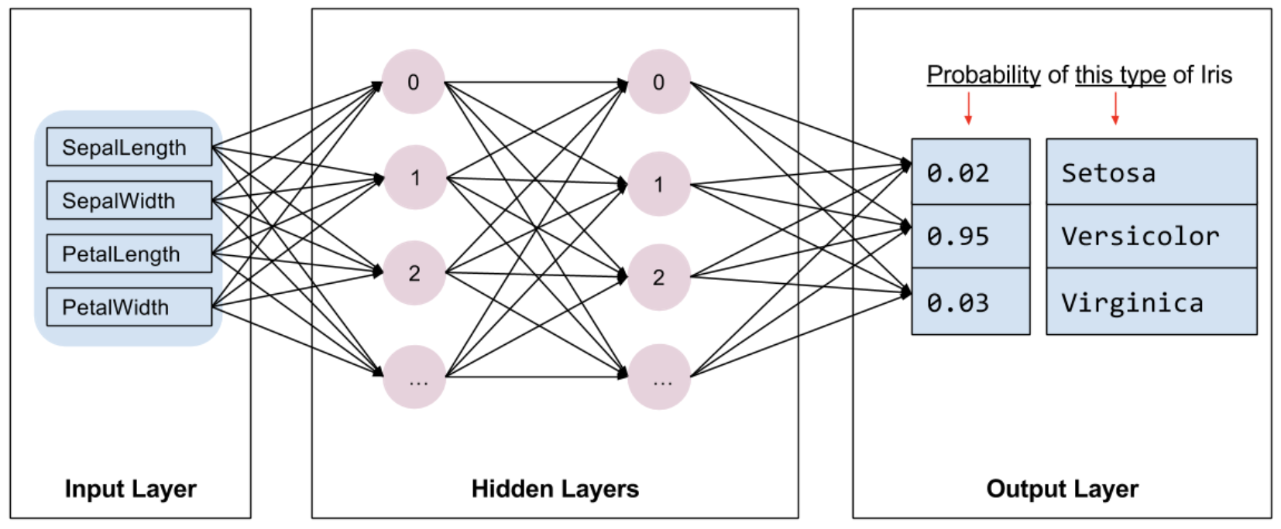

Manually Coding a Single Node Feedforward Neural Network

*Example 1: Building a Single Neural Network Node*

This example shows a feedforward neural network with back propagation. The loss (cost) is calculated using gradient descent. The gradient descent algorithm was discussed last day.

The example is based on code that is written during the following video series which is worth watching if you have time:

<https://www.youtube.com/watch?v=gwitf7ABtK8&list=PLxt59R_fWVzT9bDxA76AHm3ig0Gg9S3So&index=4>

<https://www.youtube.com/watch?v=c6NBkkKNZXw&list=PLxt59R_fWVzT9bDxA76AHm3ig0Gg9S3So&index=5>

<https://www.youtube.com/watch?v=Gvq9sUHPgrc&list=PLxt59R_fWVzT9bDxA76AHm3ig0Gg9S3So&index=6>

<https://www.youtube.com/watch?v=EnGmg-kvpYs&list=PLxt59R_fWVzT9bDxA76AHm3ig0Gg9S3So&index=7>

<https://www.youtube.com/watch?v=GwVTM28HKYk&list=PLxt59R_fWVzT9bDxA76AHm3ig0Gg9S3So&index=8>

[**https://www.youtube.com/watch?v=fh1QZ97izSM&list=PLxt59R_fWVzT9bDxA76AHm3ig0Gg9S3So&index=9**](https://www.youtube.com/watch?v=fh1QZ97izSM&list=PLxt59R_fWVzT9bDxA76AHm3ig0Gg9S3So&index=9)

<https://www.youtube.com/watch?v=bP2SCk-QGkw&list=PLxt59R_fWVzT9bDxA76AHm3ig0Gg9S3So&index=10>

<https://www.youtube.com/watch?v=gQLKufQ35VE&list=PLxt59R_fWVzT9bDxA76AHm3ig0Gg9S3So&index=11>

The network built in this example receives flower length and width to predict flower colour. Refer to Figure 2 to view the actual flower attribute values and the network diagram.

*Figure 2: Data Inputs and Neural Network Diagram*

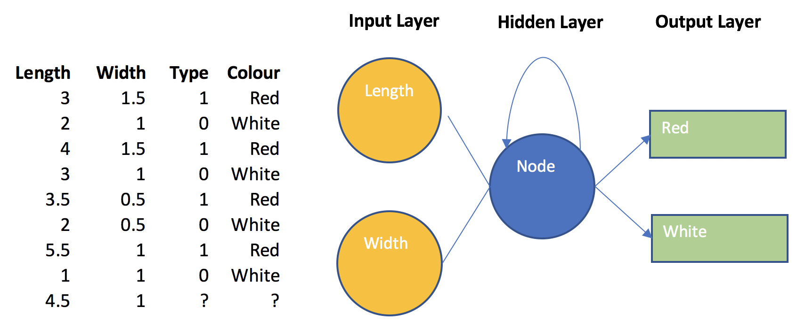

If we plot the data we can see there is reasonable separation between the red and blue flowers. The mystery flower (see the green dot) appears to have attributes that fall within the red flower category (refer to Figure 3).

*Figure 3; Scatter Plot of Flower Samples for Blue, Red and Mystery Flowers*

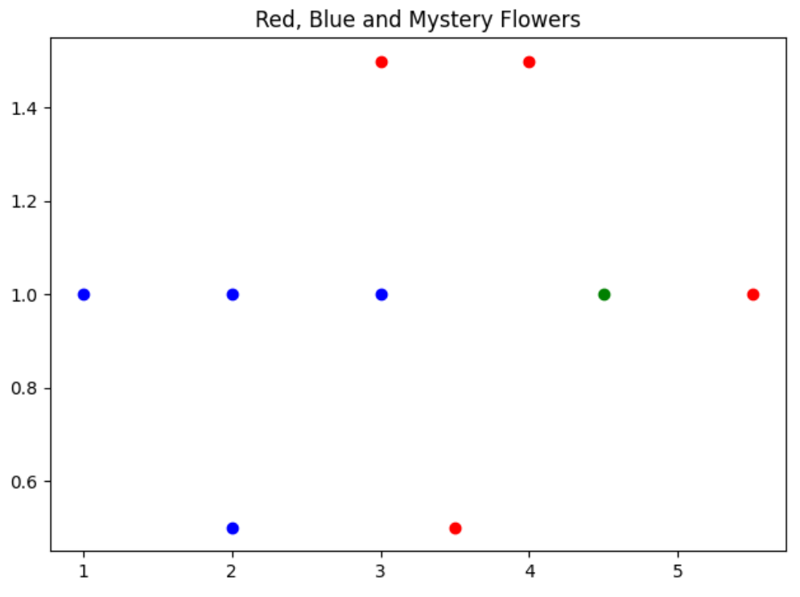

Some short-cuts were taken so proper validation was not performed in this example. However, aside from the highlighted error, the output from running the program generally suggests that the final model is successful.

|  |
| --- |
| ***Predictions Using Training Data  [3, 1.5, 1] predicted color: 0.8983977639667545 red  [2, 1, 0] predicted color: 0.006042552646746413 blue  [4, 1.5, 1] predicted color: 0.9997461355333558 red  [3, 1, 0] predicted color: 0.7302794628250244 red  [3.5, 0.5, 1] predicted color: 0.9459351023673833 red  [2, 0.5, 0] predicted color: 0.0018580382044924844 blue  [5.5, 1, 1] predicted color: 0.99999991176948 red  [1, 1, 0] predicted color: 1.3649737587078628e-05 blue  ***Predictions Using Mystery Flower  [4.5, 1] predicted color: 0.9999607061817346 red |

This may be one of the last times that you will see a neural network that is coded from scratch during this course. Understanding the neural network now will give you more confidence when working with more advanced structures and code libraries later. Here is the code which uses the gradient descent loss function algorithm which was covered last day:

|  |
| --- |
| import matplotlib.pyplot as plt  import numpy as np  def visualizeData(data, mystery_flower):  # EDA: Draw a scatter plot to visualize the data.  for i in range(len(data)):  point = data[i]  color = 'r'  if point[2] == 0:  color = 'b'  plt.scatter(point[0], point[1], c=color)  plt.scatter(mystery_flower[0], mystery_flower[1], color='green')  plt.title("Red, Blue and Mystery Flowers")  plt.show()  # Compress linear equation result to a floating-point value between 0 and 1.  def sigmoid(x):  return 1 / (1 + np.exp(-x))  def showLosses(losses):  plt.plot(losses)  plt.title("Loss")  plt.show()  def getOptimalWeightsAndBias(data):  # Initialize weights and bias.  w1 = np.random.randn()  w2 = np.random.randn()  b = np.random.randn()  costs = []  learning_rate = 0.2  for i in range(10000):  # Get random element from data set.  ri = np.random.randint(len(data))  point = data[ri]  # Regression line for flowers.  z = w1*point[0] + w2*point[1] + b  # Force prediction to a floating point value between a value of 0 and 1.  pred = sigmoid(z)  target = point[2] # This is a 1 or 0.  # This is the residual square which is the loss function.  cost = (pred - target) ** 2  # This is the derivative of the cost function with respect to the prediction.  dcost_pred = 2 * (pred - target)  # Change in cost with respect to the change in the target.  dcost_dz = dcost_pred * pred  # Change in cost with respect to change in weight 1.  dcost_dw1 = dcost_dz * point[0]  # Change in cost with respect to change in weight 2.  dcost_dw2 = dcost_dz * point[1]  # Update weights and bias.  w1 = w1 - learning_rate * dcost_dw1  w2 = w2 - learning_rate * dcost_dw2  b = b - learning_rate * dcost_dz  # Calculate cost every 10 iterations.  if (i % 10 == 0):  cost = 0  point = data[ri]  # Calculate cost for current prediction  z = point[0] * w1 + point[1] * w2 + b  pred = sigmoid(z)  target = point[2]  cost += np.square(pred - target)  costs.append(cost)  showLosses(costs)  return w1, w2, b  def showPredictions(data, title, w1, w2, b):  print("\n***Predictions Using " + title)  # Show predictions for each data point.  for i in range(len(data)):  point = data[i]  z = point[0] * w1 + point[1] * w2 + b  pred = sigmoid(z)  color = 'blue'  if(pred > 0.5):  color = 'red'  color = str(pred) + " " + color  print(str(point) + " predicted color: " + color)  # Input data.  data = [  [3, 1.5, 1],  [2, 1, 0],  [4, 1.5, 1],  [3, 1, 0],  [3.5, .5, 1],  [2, .5, 0],  [5.5, 1, 1],  [1, 1, 0]]  # Unknown value.  mystery_flower = [4.5, 1]  w1, w2, b = getOptimalWeightsAndBias(data)  showPredictions(data, "Training Data", w1, w2, b)  showPredictions([mystery_flower], "Mystery Flower", w1, w2, b) |
|  |

*Exercise 1 (3 marks)*

The following list describes the steps that are taken by the code in Example 1. However, the steps listed below are not in the proper order:

* The network performs a linear prediction by applying weights and bias to a sample.
* The weights and biases of the linear equation are then updated with the rates of change during the current epoch.
* These steps are then repeated.
* Rates of change for the cost function are then calculated.
* The squared residual, ${(actual-prediction)}^{2}$, is then calculated using the output of the sigmoid function to determine the cost.
* The linear prediction is fed to a sigmoid function to transform it to a value between 0 and 1.

Proper order is:

The network performs a linear prediction by applying weights and bias to a sample.

The linear prediction is fed to a sigmoid function to transform it to a value between 0 and 1.

The squared residual, 〖(actual-prediction)〗^2, is then calculated using the output of the sigmoid function to determine the cost.

Rates of change for the cost function are then calculated.

The weights and biases of the linear equation are then updated with the rates of change during the current epoch.

These steps are then repeated.

*Exercise 2 (1 mark)*

Fill in the blank. In Example 1, weights and bias for the linear equation are updated each step by adjusting them with rates of change multiplied by a _________cost (derivative of cost)________.

*Exercise 3 (1 mark)*

Show a picture of the graph for a sigmoid function here:

|  |
| --- |
|  |

*Exercise 4 (1 mark)*

What is input into the sigmoid function in Example 1? What is the output from the sigmoid function?

|  |
| --- |
| Input is ( point[0] * w1 + point[1] * w2 + b(bias) )  Which are the randomly assigned number w1, w2 and b. these random number w1 and w2 will be multiplied by weight and width respectively. And then 2 number will be added. The final result will be input.  Output is the predicted color of the flower. |

TensorFlow and Keras

TensorFlow is the premier open-source deep learning framework. It is maintained by Google. Keras is an API that helps to simplify the use of TensorFlow.

*Example 2: Building a Neural Network with tf.Keras*

This example shows how to implement TensorFlow to develop a neural network model to perform classification predictions using the data from Example 1. For this current case, the data is stored in a data frame:

|  |
| --- |
| Length Width IsRed  0 3.0 1.5 1.0  1 2.0 1.0 0.0  2 4.0 1.5 1.0  3 3.0 1.0 0.0  4 3.5 0.5 1.0  5 2.0 0.5 0.0  6 5.5 1.0 1.0  7 1.0 1.0 0.0 |

We first need to isolate the predictor columns. This line of code extracts the first two columns for length and width into a separate data frame.

|  |
| --- |
| dfX = df.iloc[:, 0:2] |

We then need to express each row from our predictor data in a vertical array of features. This code transforms the X values into the required format.

|  |
| --- |
| ROW_DIM = 0  COL_DIM = 1  x_array = dfX.values  x_arrayReshaped = x_array.reshape(x_array.shape[ROW_DIM],  x_array.shape[COL_DIM]) |

These are the X values after the transformation:

|  |
| --- |
| array([[3. , 1.5],  [2. , 1. ],  [4. , 1.5],  [3. , 1. ],  [3.5, 0.5],  [2. , 0.5],  [5.5, 1. ],  [1. , 1. ]]) |

The target column also needs to be in a vertical array as well so we need to reshape it in the same manner as the predictor columns:

|  |
| --- |
| dfY = df.iloc[:, 2:3]  y_array = dfY.values  y_arrayReshaped = y_array.reshape(y_array.shape[ROW_DIM],  y_array.shape[COL_DIM]) |

After the transformation, the target variable column from the DataFrame becomes:

|  |
| --- |
| array([[1.],  [0.],  [1.],  [0.],  [1.],  [0.],  [1.],  [0.]]) |

This example shows how to predict flower colour by using length and width as inputs:

|  |
| --- |
| from tensorflow.keras import Sequential  from tensorflow.keras.layers import Dense  import numpy as np  import pandas as pd  # Load the flower feature data into a DataFrame.  df = pd.DataFrame(columns=['Length', 'Width', 'IsRed'])  data = [  {'Length':3, 'Width':1.5, 'IsRed': 1},  {'Length':2, 'Width':1, 'IsRed': 0},  {'Length':4, 'Width':1.5, 'IsRed': 1},  {'Length':3, 'Width':1, 'IsRed': 0},  {'Length':3.5, 'Width':.5, 'IsRed': 1},  {'Length':2, 'Width':.5, 'IsRed': 0},  {'Length':5.5, 'Width':1, 'IsRed': 1},  {'Length':1, 'Width':1, 'IsRed': 0}]  for i in range(0, len(data)):  df = df.append(data[i], ignore_index=True)  print(df)  ROW_DIM = 0  COL_DIM = 1  # Convert DataFrame columns to vertical columns of features (as mentioned earlier).  dfX = df.iloc[:, 0:2]  ROW_DIM = 0  COL_DIM = 1  x_array = dfX.values  x_arrayReshaped = x_array.reshape(x_array.shape[ROW_DIM],  x_array.shape[COL_DIM])  # Convert DataFrame columns to vertical columns of target variables values.  dfY = df.iloc[:, 2:3]  y_array = dfY.values  y_arrayReshaped = y_array.reshape(y_array.shape[ROW_DIM],  y_array.shape[COL_DIM])  # Build a network model of sequential layers.  model = Sequential()  # Add 1st hidden layer. Note 1st hidden layer also receives data from input layer.  # The input array must contain two feature columns and any number of rows.  model.add(Dense(10, activation='sigmoid',  input_shape=(x_arrayReshaped.shape[COL_DIM],)))  # Add 2nd hidden layer.  model.add(Dense(3, activation='sigmoid'))  # Add output layer.  model.add(Dense(1, activation='sigmoid'))  # Compile the model.  # Binary cross entropy is used to measure error cost for binary predictions.  model.compile(loss='binary_crossentropy', metrics=['accuracy'])  # Fit the model  # An epoch is one iteration for all samples through the network.  # verbose can be set to 1 to show detailed output during training.  model.fit(x_arrayReshaped, y_arrayReshaped, epochs=1000, verbose=1)  # Evaluate the model  loss, acc = model.evaluate(x_arrayReshaped, y_arrayReshaped, verbose=0)  print('Test Accuracy: %.3f' % acc)  # Make a prediction  row = [4.5,1]  yhat = model.predict([row])  print('Predicted: %.3f' % yhat) |

*Exercise 5 (1 mark)*

Starting with Example 2, replace the code in the first hidden layer with:

|  |
| --- |
| model.add(Dense(3, activation='sigmoid', input_shape=(2,))) |

Does the code work? Explain in your own words why or why not. How many neurons are in the first hidden layer after the change?

|  |
| --- |
| It works because but input data must be given as (m, n) where m is the height-dimension and m is the width-dimension. Since the feature size is 2, it is the Colum n dimension of the input matrix. This means that the row dimension of the hidden layer is also 2. shape is given as 2. 2 refers to the number of features in each input sample instead of the batch size so input dimension is (None, 2, ).  Text  Description automatically generated  First hidden layer is 9 and First dense/ hidden layer has 3 neurons, which is it’s output dimension. |

*Exercise 6 (1 mark)*

Starting with Example 2, replace the code in the first hidden layer with:

|  |
| --- |
| model.add(Dense(10, activation='sigmoid', input_shape=(4,))) |

Does the code work? Explain in your own words why or why not.

|  |
| --- |
| It is not working because because column dimension of the matrix is 2. I cannot be 4. |

*Exercise 7 (1 mark)*

The loss function option, sparse_categorical_crossentropy, is used to generate classification predictions when the target variable is expressed as an non-binary integer. For example, a target variable that qualifies could have the values: 0, 1, 2. Starting with Example 2, replace the compile instruction with:

|  |
| --- |
| model.compile(loss='sparse_categorical_crossentropy', metrics=['accuracy']) |

Does the code work? Explain in your own words why or why not.

|  |
| --- |
| It is not working because 'sparse_categorical_crossentropy' will give you the loss value which is not 0 or 1. But the for the accuracy we have to received a label has to be between 0 and 1. |

*Exercise 8 (1 mark)*

If you remove the second hidden layer from Example 2, does the code work? What conclusion can you make based on the result of removing the second hidden layer?

|  |
| --- |
| It is working. If you remove the 2nd hidden layers, the number of total neurons has decreased.  Without 2nd hidden layer  Graphical user interface, text  Description automatically generated  With 2nd hidden layer  Text  Description automatically generated |

*Exercise 9 (8 marks)*

In this exercise you will build a neural network to make predictions for the Iris data set. Please use the iris_old.csv file that is in the data sets folder within COMP4948. This first block of code helps to prepare DataFrame objects to store the X and Y values.

|  |
| --- |
| import pandas as pd  from sklearn.model_selection import train_test_split  from sklearn.preprocessing import LabelEncoder  from tensorflow.keras import Sequential  from tensorflow.keras.layers import Dense  PATH = "/Users/pm/Desktop/DayDocs/data/"  df = pd.read_csv(PATH + 'iris_old.csv')  df.columns = ['Sepal L', 'Sepal W', 'Petal L', 'Petal W', 'Iris Type']  print(df)  # Convert text to numeric category.  # 0 is setosa, 1 is versacolor and 2 is virginica  df['y'] = LabelEncoder().fit_transform(df['Iris Type'])  # Prepare the data.  dfX = df.iloc[:, 0:4] # Get X features only from columns 0 to 3  dfY = df.iloc[:, 5:6] # Get X features only from column 5 |

Your next task is to resize the data into vertical arrays. See Example 2 for a demonstration of how to do this. Be sure to read the discussion which leads up to the code for additional information on how to perform this task. Next, after reshaping your data, use the following code to split it into test and training sets.

|  |
| --- |
| # Split into train and test data sets.  X_train, X_test, y_train, y_test = train_test_split(  x_arrayReshaped, y_arrayReshaped, test_size=0.33) |

After, address these requirements:

* create a 12:3 network. In other words, the first hidden layer is 12 neurons and the output layer is 3 neurons.
* Use a ***sigmoid*** activation function for your first hidden layer.
* Use a ***softmax*** activation function for the output layer. Use ***sparse_categorical_crossentropy*** as the option for the loss function when compiling the model. (‘softmax’ allows a multi-class output. ‘*sparse_categorical_crossentropy’* allows for multi-class integer labels.)
* Evaluate the function with the test data. Your accuracy should be over 90% if you performed the tasks properly.
* Make a prediction with the following data set: row = [5.1, 3.5, 1.4, 0.2]. Display the predicted Iris type for the test row.

Show your full program here:

|  |
| --- |
| # import matplotlib.pyplot as plt # import numpy as np # # def visualizeData(data, mystery_flower): # # EDA: Draw a scatter plot to visualize the data. # for i in range(len(data)): # point = data[i] # color = 'r' # if point[2] == 0: # color = 'b' # plt.scatter(point[0], point[1], c=color) # # plt.scatter(mystery_flower[0], mystery_flower[1], color='green') # plt.title("Red, Blue and Mystery Flowers") # plt.show() # # # Compress linear equation result to a floating-point value between 0 and 1. # def sigmoid(x): # return 1 / (1 + np.exp(-x)) # # def showLosses(losses): # plt.plot(losses) # plt.title("Loss") # plt.show() # # def getOptimalWeightsAndBias(data): # # Initialize weights and bias. # w1 = np.random.randn() # w2 = np.random.randn() # b = np.random.randn() # # costs = [] # learning_rate = 0.2 # # for i in range(10000): # # Get random element from data set. # ri = np.random.randint(len(data)) # point = data[ri] # # # Regression line for flowers. # z = w1*point[0] + w2*point[1] + b # # # Force prediction to a floating point value between a value of 0 and 1. # pred = sigmoid(z) # target = point[2] # This is a 1 or 0. # # # This is the residual square which is the loss function. # cost = (pred - target) ** 2 # # # This is the derivative of the cost function with respect to the prediction. # dcost_pred = 2 * (pred - target) # # # Change in cost with respect to the change in the target. # dcost_dz = dcost_pred * pred # # # Change in cost with respect to change in weight 1. # dcost_dw1 = dcost_dz * point[0] # # # Change in cost with respect to change in weight 2. # dcost_dw2 = dcost_dz * point[1] # # # Update weights and bias. # w1 = w1 - learning_rate * dcost_dw1 # w2 = w2 - learning_rate * dcost_dw2 # b = b - learning_rate * dcost_dz # # # Calculate cost every 10 iterations. # if (i % 10 == 0): # cost = 0 # point = data[ri] # # # Calculate cost for current prediction # z = point[0] * w1 + point[1] * w2 + b # pred = sigmoid(z) # target = point[2] # cost += np.square(pred - target) # costs.append(cost) # showLosses(costs) # return w1, w2, b # # def showPredictions(data, title, w1, w2, b): # print("\n***Predictions Using " + title) # # Show predictions for each data point. # for i in range(len(data)): # point = data[i] # z = point[0] * w1 + point[1] * w2 + b # print('***Z****') # print(z) # pred = sigmoid(z) # print('***result***') # print(pred) # # color = 'blue' # if(pred > 0.5): # color = 'red' # color = str(pred) + " " + color # print(str(point) + " predicted color: " + color) # # # Input data. # data = [ # [3, 1.5, 1], # [2, 1, 0], # [4, 1.5, 1], # [3, 1, 0], # [3.5, .5, 1], # [2, .5, 0], # [5.5, 1, 1], # [1, 1, 0]] # # # Unknown value. # mystery_flower = [4.5, 1] # # w1, w2, b = getOptimalWeightsAndBias(data) # showPredictions(data, "Training Data", w1, w2, b) # showPredictions([mystery_flower], "Mystery Flower", w1, w2, b) # visualizeData(data, mystery_flower)   # from tensorflow.keras import Sequential # from tensorflow.keras.layers import Dense # # import numpy as np # import pandas as pd # # # Load the flower feature data into a DataFrame. # df = pd.DataFrame(columns=['Length', 'Width', 'IsRed']) # data = [ # {'Length':3, 'Width':1.5, 'IsRed': 1}, # {'Length':2, 'Width':1, 'IsRed': 0}, # {'Length':4, 'Width':1.5, 'IsRed': 1}, # {'Length':3, 'Width':1, 'IsRed': 0}, # {'Length':3.5, 'Width':.5, 'IsRed': 1}, # {'Length':2, 'Width':.5, 'IsRed': 0}, # {'Length':5.5, 'Width':1, 'IsRed': 1}, # {'Length':1, 'Width':1, 'IsRed': 0}] # # for i in range(0, len(data)): # df = df.append(data[i], ignore_index=True) # print(df) # # ROW_DIM = 0 # COL_DIM = 1 # # # Convert DataFrame columns to vertical columns of features (as mentioned earlier). # dfX = df.iloc[:, 0:2] # # ROW_DIM = 0 # # COL_DIM = 1 # # x_array = dfX.values # x_arrayReshaped = x_array.reshape(x_array.shape[ROW_DIM], # x_array.shape[COL_DIM]) # # # Convert DataFrame columns to vertical columns of target variables values. # dfY = df.iloc[:, 2:3] # y_array = dfY.values # y_arrayReshaped = y_array.reshape(y_array.shape[ROW_DIM], # y_array.shape[COL_DIM]) # # # Build a network model of sequential layers. # model = Sequential() # # # Add 1st hidden layer. Note 1st hidden layer also receives data from input layer. # # The input array must contain two feature columns and any number of rows. # model.add(Dense(10, activation='sigmoid', # input_shape=(x_arrayReshaped.shape[COL_DIM],))) # # model.add(Dense(3, activation='sigmoid', input_shape=(2,))) # # model.add(Dense(10, activation='sigmoid', input_shape=(4,))) # # # Add 2nd hidden layer. # model.add(Dense(3, activation='sigmoid')) # # # Add output layer. # model.add(Dense(1, activation='sigmoid')) # # # Compile the model. # # Binary cross entropy is used to measure error cost for binary predictions. # model.compile(loss='binary_crossentropy', metrics=['accuracy']) # # model.compile(loss='sparse_categorical_crossentropy', metrics=['accuracy']) # # # Fit the model # # An epoch is one iteration for all samples through the network. # # verbose can be set to 1 to show detailed output during training. # model.fit(x_arrayReshaped.astype(np.float32), y_arrayReshaped.astype(np.float32), epochs=1000, verbose=1) # # # Evaluate the model # loss, acc = model.evaluate(x_arrayReshaped.astype(np.float32), y_arrayReshaped.astype(np.float32), verbose=0) # print('Test Accuracy: %.3f' % acc) # # # Make a prediction # row = [4.5,1] # yhat = model.predict([row]) # print('Predicted: %.3f' % yhat) # # model.summary()  import pandas as pd from sklearn.model_selection import train_test_split from sklearn.preprocessing import LabelEncoder from tensorflow.keras import Sequential from tensorflow.keras.layers import Dense import numpy as np  PATH = "/Users/hyerimshin/PycharmProjects/MachineLearning/datasets/" df = pd.read_csv(PATH + 'iris_old.csv') df.columns = ['Sepal L', 'Sepal W', 'Petal L', 'Petal W', 'Iris Type'] print(df)  def sigmoid(x):  return 1 / (1 + np.exp(-x))   # Convert text to numeric category. # 0 is setosa, 1 is versacolor and 2 is virginica df['y'] = LabelEncoder().fit_transform(df['Iris Type'])   # Prepare the data. dfX = df.iloc[:, 0:4] # Get X features only from columns 0 to 3 dfY = df.iloc[:, 5:6] # Get X features only from column 5 ROW_DIM = 0 COL_DIM = 1  x_array = dfX.values x_arrayReshaped = x_array.reshape(x_array.shape[ROW_DIM],  x_array.shape[COL_DIM]) y_array = dfY.values y_arrayReshaped = y_array.reshape(y_array.shape[ROW_DIM],  y_array.shape[COL_DIM])    # Split into train and test data sets. X_train, X_test, y_train, y_test = train_test_split(  x_arrayReshaped, y_arrayReshaped, test_size=0.33)  model = Sequential()  # Add 1st hidden layer. Note 1st hidden layer also receives data from input layer. # The input array must contain two feature columns and any number of rows. model.add(Dense(10, activation='sigmoid',  input_shape=(4,)))  # # Add 2nd hidden layer. # model.add(Dense(3, activation='sigmoid'))  # Add output layer. model.add(Dense(3, activation='softmax'))  # Compile the model. # Binary cross entropy is used to measure error cost for binary predictions. # model.compile(loss='binary_crossentropy', metrics=['accuracy']) model.compile(loss='sparse_categorical_crossentropy', metrics=['accuracy'])  # Fit the model # An epoch is one iteration for all samples through the network. # verbose can be set to 1 to show detailed output during training. model.fit(x_arrayReshaped, y_arrayReshaped, epochs=1000, verbose=1)  # Evaluate the model loss, acc = model.evaluate(x_arrayReshaped, y_arrayReshaped, verbose=0) print('Test Accuracy: %.3f' % acc)  # Make a prediction row = [5.1, 3.5, 1.4, 0.2] yhat = model.predict([row]) print(yhat)  iris = 'setosa' if yhat <= 0:  iris = 'setosa' elif yhat <= 1:  iris = 'versicolor' elif yhat <= 2:  iris = 'virginica'  print('Predicted: %.3f' % yhat + " Predicted Iris is: " + iris) model.summary() |

**Table of Contents**

**Timing Algorithms 1**

**GridSearchCV 3**

RandomSearchCV 5

**Visualizing Loss and Accuracy for a Classification Model 6**

**Viewing Losses for Classification and Linear Models 10**

Timing Algorithms

By now you likely have noticed how computationally expensive neural network algorithms are. Timing is a significant factor now when evaluating the feasibility of a model. Because of potential time constraints, you increasingly will want to consider the execution time of your algorithms as a limiting factor.

*Example 1: Timing Functions*

This example shows a simple way to record the execution time of a function. This code can easily be modified as each case requires.

|  |
| --- |
| import time  def currentTimeInMilliseconds():  newTime = int(round(time.time() * 1000))  return newTime  def doSomething():  for i in range(0,10000):  print(i)  startTime = currentTimeInMilliseconds()  doSomething()  endTime = currentTimeInMilliseconds()  time_diff = endTime - startTime  print("Time taken is: " + str(time_diff) + " ms") |

The output from this example is:

|  |
| --- |
| Time taken is: 70 ms |

*Exercise 1 (1 mark)*

Add a second calling instruction for the doSomething() function. Pad the second calling instruction with code to enable additional logging and output of execution times. Show your revised program here.

|  |
| --- |
| import time  def currentTimeInMilliseconds():  newTime = int(round(time.time() * 1000))  return newTime  def doSomething():  for i in range(0,10000):  print(i)  def timeDifferenceCalculater(numberOfOperation):  total_time_difference = 0  for i in range(1, numberOfOperation +1):  startTime = currentTimeInMilliseconds()  doSomething()  endTime = currentTimeInMilliseconds()  time_diff = endTime - startTime  total_time_difference += time_diff  print("Time taken is for operation" + str(i) + ": " + str(time_diff) + " ms")  print("Total time taken for the operations is: " + str(total_time_difference) + " ms")   timeDifferenceCalculater(2) |

Example 1 offers a simple and flexible approach to log execution times for code routines. Sometimes it will provide exactly what you need. You can easily customize this code as each case requires. A disadvantage with the timing routine in Example 1 is that the extra timing code adds clutter.

*Example 2: Clutter-Free Time Logging*

This example shows a cleaner alternative to logging execution times in larger applications. In this example, a timeit() method allows us to implement a @timeit decorator. The @timeit decorator can be placed automatically above any function to record its execution time. A showTimeResults() function allows us to display the execution times of each function once they have executed.

|  |
| --- |
| import time  import pandas as pd  #-------------------------------------------------------------------  # Logs method execution times to a data frame.  #-------------------------------------------------------------------  timeItList = []  def showTimeResults():  timeItDf = pd.DataFrame()  for i in range(0, len(timeItList)):  timeItDf = timeItDf.append(timeItList[i], ignore_index=True)  print("\n")  print(timeItDf)  return timeItDf  #-------------------------------------------------------------------  # Enables @timeit decorator.  #-------------------------------------------------------------------  def timeit(method):  def timed(*args, **kw):  ts = time.time()  result = method(*args, **kw)  te = time.time()  if 'log_time' in kw:  name = kw.get('log_name', method.__name__.upper())  kw['log_time'][name] = int((te - ts) * 1000)  else:  diff = (te - ts) * 1000  timeItList.append({ 'Method':method.__name__, 'Time (ms)':diff})  print('%r %2.2f ms' % (method.__name__, diff))  return result  return timed  @timeit # Prefix any function with this code to automatically log execution time.  def doSomething():  for i in range(0,1000):  print(i)  for x in range(0,3):  doSomething()  showTimeResults() |

*Exercise 2 (2 marks)*

Add a new method called doSomethingElse(), in addition to doSomething(). In doSomethingElse(), print out your first name 100 times. Call your new function. Use the @timeit decorator with the function to show how long it takes to run your new function. Show your revised program here:

|  |
| --- |
| import time import pandas as pd  #------------------------------------------------------------------- # Logs method execution times to a data frame. #------------------------------------------------------------------- timeItList = [] def showTimeResults():  timeItDf = pd.DataFrame()  for i in range(0, len(timeItList)):  timeItDf = timeItDf.append(timeItList[i], ignore_index=True)  print("\n")  print(timeItDf)  return timeItDf  #------------------------------------------------------------------- # Enables @timeit decorator. #------------------------------------------------------------------- def timeit(method):  def timed(*args, **kw):  ts = time.time()  result = method(*args, **kw)  te = time.time()   if 'log_time' in kw:  name = kw.get('log_name', method.__name__.upper())  kw['log_time'][name] = int((te - ts) * 1000)  else:  diff = (te - ts) * 1000  timeItList.append({ 'Method':method.__name__, 'Time (ms)':diff})  print('%r %2.2f ms' % (method.__name__, diff))  return result  return timed  # @timeit # Prefix any function with this code to automatically log execution time. # def doSomething(): # for i in range(0,1000): # print(i)   @timeit def doSomethingElse():  for i in range(0,100):  print(i)  for x in range(0,3):  doSomethingElse()  # doSomething  showTimeResults() |

Show your DataFrame output after adding doSomethingElse(). The output must show execution times for each time the doSomething() and doSomethingElse() methods are invoked.

|  |
| --- |
|  |

GridSearchCV

You may have noticed that performing the GridSearch last week was exhausting in terms of time.

*Example 3: GridSearch*

Last week this code was used to perform a GridSearch to determine the best parameters for adding a new layer. The process may take between 20 minutes to an hour.

|  |
| --- |
| import pandas as pd  import tensorflow  from sklearn.model_selection import train_test_split  PATH = "C:\\datasets\\"  CSV_DATA = "housing.data"  df = pd.read_csv(PATH + CSV_DATA, header=None)  # Show all columns.  pd.set_option('display.max_columns', None)  # Increase number of columns that display on one line.  pd.set_option('display.width', 1000)  print(df.head())  print(df.tail())  print(df.describe())  dataset = df.values  # split into input (X) and output (Y) variables  X = dataset[:,0:13]  y = dataset[:,13]  ROW_DIM = 0  COL_DIM = 1  x_arrayReshaped = X.reshape(X.shape[ROW_DIM],  X.shape[COL_DIM])  # Convert DataFrame columns to vertical columns of target variables values.  y_arrayReshaped = y.reshape(y.shape[ROW_DIM],1)  X_train, X_test, y_train, y_test = train_test_split(x_arrayReshaped,  y_arrayReshaped, test_size=0.2, random_state=0)  n_features = X_train.shape[1]  from keras.models import Sequential  from keras.layers import Dense  from keras.wrappers.scikit_learn import KerasRegressor  from sklearn.model_selection import GridSearchCV  # Define the model.  def create_model(numNeurons=5, initializer='uniform', activation='softplus'):  # create model  model = Sequential()  model.add(Dense(25, kernel_initializer='uniform',  input_dim=n_features, activation='softplus'))  model.add(Dense(numNeurons, kernel_initializer=initializer,  activation=activation))  model.add(Dense(1, kernel_initializer='he_normal', activation='softplus'))  opt = tensorflow.keras.optimizers.Adam(lr=0.005)  # Compile model  model.compile(loss='mse', optimizer=opt)  return model  ### Grid Building Section #######################  # Define the parameters to try out  params = { 'activation' : ['softmax', 'softplus', 'softsign', 'relu', 'tanh',  'sigmoid', 'hard_sigmoid', 'linear'],  'numNeurons':[10, 15, 20, 25, 30, 35],  'initializer': ['uniform', 'lecun_uniform', 'normal', 'zero',  'glorot_normal', 'glorot_uniform', 'he_normal', 'he_uniform']  }  model = KerasRegressor(build_fn=create_model, epochs=100,  batch_size=9, verbose=1)  grid = GridSearchCV(estimator=model, param_grid=params, n_jobs=-1, cv=3)  #################################################  grid_result = grid.fit(X_train, y_train)  # summarize results  print("Best: %f using %s" % (grid_result.best_score_, grid_result.best_params_))  means = grid_result.cv_results_['mean_test_score']  stds = grid_result.cv_results_['std_test_score']  params = grid_result.cv_results_['params']  for mean, stdev, param in zip(means, stds, params):  print("%f (%f) with: %r" % (mean, stdev, param)) |

RandomSearchCV

If you are short on time you can use RandomSearchCV which implements a random subset of combinations of the GridSearchCV algorithm. RandomSearchCV() is faster than GridSearchCV() but RandomSearchCV is less accurate. Still, during a first pass you might consider using RandomSearchCV() to discover suitable parameter combinations and ranges before running a more time consuming grid search.

Switching to using a RandomSearchCV() function instead of the GridSearchCV() function only involves swapping out two lines of code. To make the change, replace:

|  |
| --- |
| grid = GridSearchCV(estimator=model, param_grid=params, n_jobs=-1, cv=3) |

with:

|  |
| --- |
| from sklearn.model_selection import RandomizedSearchCV  grid = RandomizedSearchCV(model, param_distributions = params, cv = 3) |

*Example 4: Using RandomSearchCV() and Timing While Tuning*

This example shows how to implement a random search and time recording while fitting the neural network that is presented in Example 3. Unfortunately, the @timeit decorator does not work GridSearchCV() function so a more basic approach is used to calculate and display the execute time duration.

To enable the random search, starting with Example 3, replace the following line:

|  |
| --- |
| grid = GridSearchCV(estimator=model, param_grid=params, n_jobs=-1, cv=3) |

with this code:

|  |
| --- |
| from sklearn.model_selection import RandomizedSearchCV  grid = RandomizedSearchCV(model, param_distributions = params, cv = 3) |

Next, to record the execution time, replace the instruction:

|  |
| --- |
| grid_result = grid.fit(X_train, y_train) |

with this basic set of instructions to record the time:

|  |
| --- |
| import time  def currentTimeInMilliseconds():  newTime = int(round(time.time() * 1000))  return newTime  startTime = currentTimeInMilliseconds()  grid_result = grid.fit(X_train, y_train)  endTime = currentTimeInMilliseconds()  time_diff = endTime - startTime  print("The time to perform the search is: " + str(time_diff) + " ms.") |

The output confirms that approximately 83 seconds were taken to perform a random search. A grid search likely would find a better set of parameters but the random search is faster.

|  |
| --- |
| The time to perform the search is: 82835 ms.  Best: -19.642832 using {'numNeurons': 15, 'initializer': 'zero', 'activation': 'linear'}  -85.678594 (15.195062) with: {'numNeurons': 30, 'initializer': 'glorot_normal', 'activation': 'hard_sigmoid'}  -22.580643 (4.320906) with: {'numNeurons': 10, 'initializer': 'uniform', 'activation': 'softplus'}  -86.138295 (15.683223) with: {'numNeurons': 25, 'initializer': 'uniform', 'activation': 'tanh'}  -19.642832 (2.034633) with: {'numNeurons': 15, 'initializer': 'zero', 'activation': 'linear'}  … |

Visualizing Loss and Accuracy for a Classification Model

Being able to visualize loss and accuracy during training and testing helps to understand the effectiveness of the hyperparameters. Figure 1 shows an ideal scenario for loss and accuracy for a classification model. Loss decline is smooth. The accuracy peaks at approximately 200 epochs. There is some fluctuation in accuracy. The information suggests that potentially 200 to 400 epochs are required for reaching peak performance during training with the current set of parameters. You will also notice that validation (test) sets have slightly higher losses and the tests sets are also slightly less accurate than the training sets.

*Figure 1: Visualizing Loss and Accuracy Parameters for a Classification Model*

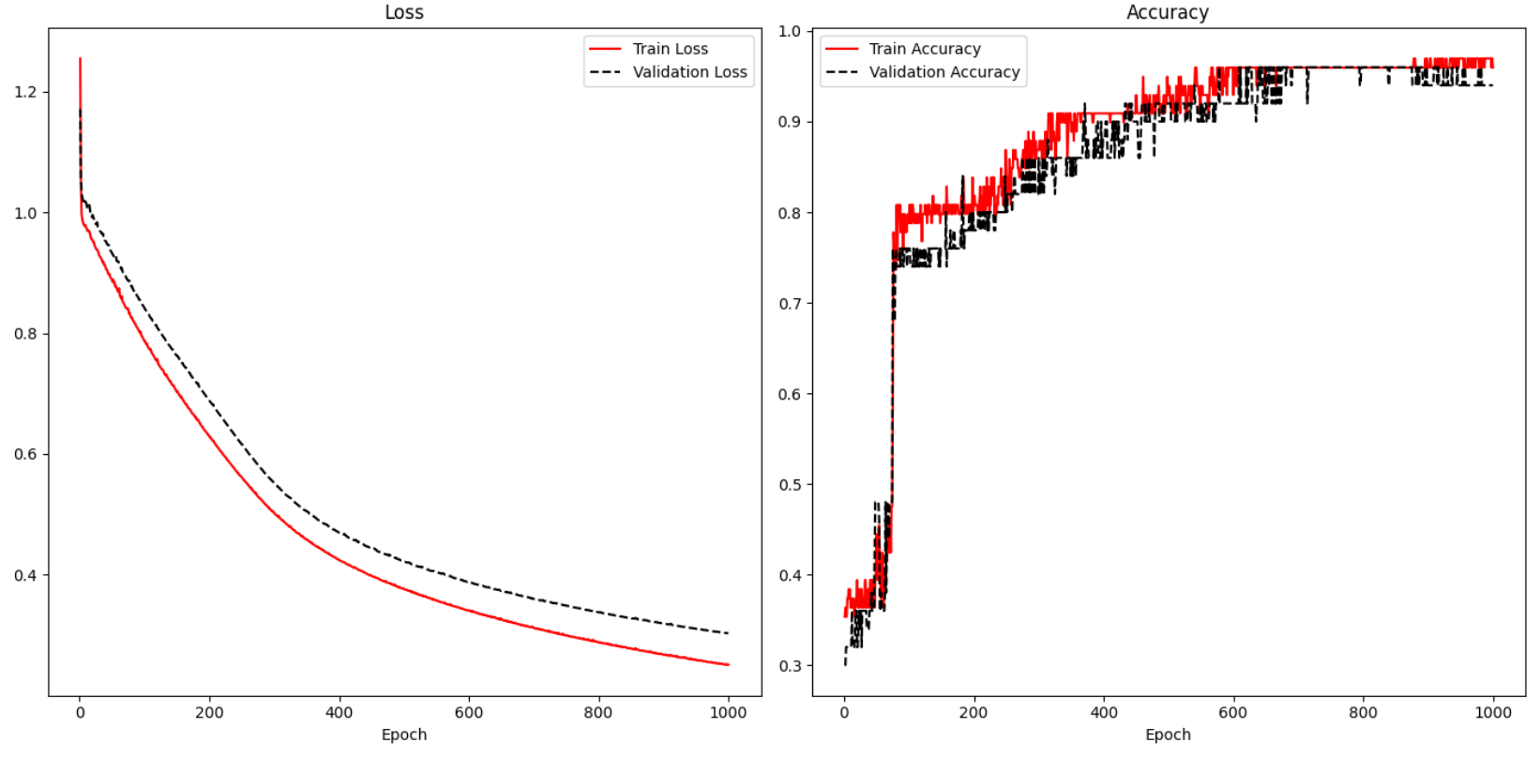

To enable display of test results, validation_data arguments must be supplied in the model.fit() instruction. A history variable is needed to store the loss and accuracy results.

|  |
| --- |
| history = model.fit(X_train, y_train, epochs=1000, batch_size=28, verbose=1,  validation_data=(X_test, y_test)) |

To track the accuracy of the result, metrics=['accuracy'] is included in the compile statement.

|  |
| --- |
| model.compile(optimizer='sgd', loss='sparse_categorical_crossentropy',  metrics=['accuracy']) |

*Example 5: Visualizing Loss and Accuracy*

Here is the code that is used to the accuracy and losses in Figure 1 when fitting an iris data set prediction model. The locations where the history variable is set and referenced are highlighted to show how the losses and accuracy are tracked.

|  |
| --- |
| import pandas as pd  from sklearn.model_selection import train_test_split  from sklearn.preprocessing import LabelEncoder  from tensorflow.keras import Sequential  from tensorflow.keras.layers import Dense  PATH = "/Users/pm/Desktop/DayDocs/data/"  df = pd.read_csv(PATH + 'iris_old.csv')  df.columns = ['Sepal L', 'Sepal W', 'Petal L', 'Petal W', 'Iris Type']  print(df)  # Convert text to numeric category.  # 0 is setosa, 1 is versacolor and 2 is virginica  df['y'] = LabelEncoder().fit_transform(df['Iris Type'])  # Prepare the data.  dfX = df.iloc[:, 0:4] # Get X features only from columns 0 to 3  dfY = df.iloc[:, 5:6] # Get X features only from column 5  ROW_DIM = 0  COL_DIM = 1  # Create vertical array of features.  x_array = dfX.values  x_arrayReshaped = x_array.reshape(x_array.shape[ROW_DIM],  x_array.shape[COL_DIM])  y_array = dfY.values  y_arrayReshaped = y_array.reshape(y_array.shape[ROW_DIM],  y_array.shape[COL_DIM])  # Split into train and test data sets.  X_train, X_test, y_train, y_test = train_test_split(  x_arrayReshaped, y_arrayReshaped, test_size=0.33)  n_features = X_train.shape[COL_DIM]  # Define the model.  model = Sequential()  # Hidden layer 1 (also receives the input layer)  model.add(Dense(2, activation='relu', input_shape=(n_features,)))  # Output layer  model.add(Dense(3, activation='softmax'))  # Compile the model.  model.compile(optimizer='sgd', loss='sparse_categorical_crossentropy', metrics=['accuracy'])  # Fit the model.  history = model.fit(X_train, y_train, epochs=1000, batch_size=28, verbose=1,  validation_data=(X_test, y_test))  # Evaluate the model.  loss, acc = model.evaluate(X_test, y_test, verbose=0)  print('Test Accuracy: %.3f' % acc)  # make a prediction  row = [5.1, 3.5, 1.4, 0.2]  yhat = model.predict([row])  print('Predicted: s (class=d)' + str(yhat))  import matplotlib.pyplot as plt  def showLoss(history):  # Get training and test loss histories  training_loss = history.history['loss']  validation_loss = history.history['val_loss']  # Create count of the number of epochs  epoch_count = range(1, len(training_loss) + 1)  plt.subplot(1, 2, 1)  # Visualize loss history for training data.  plt.plot(epoch_count, training_loss, label='Train Loss', color='red')  # View loss on unseen data.  plt.plot(epoch_count, validation_loss, 'r--', label='Validation Loss',  color='black')  plt.xlabel('Epoch')  plt.legend(loc="best")  plt.title("Loss")  def showAccuracy(history):  # Get training and test loss histories  training_loss = history.history['accuracy']  validation_loss = history.history['val_accuracy']  # Create count of the number of epochs  epoch_count = range(1, len(training_loss) + 1)  plt.subplot(1, 2, 2)  # Visualize loss history for training data.  plt.plot(epoch_count, training_loss, label='Train Accuracy', color='red')  # View loss on unseen data.  plt.plot(epoch_count, validation_loss, 'r--',  label='Validation Accuracy', color='black')  plt.xlabel('Epoch')  plt.legend(loc="best")  plt.title('Accuracy')  plt.subplots(nrows=1, ncols=2, figsize=(14,7))  showLoss(history)  showAccuracy(history)  plt.show() |

Viewing Losses for Classification and Linear Models

Since linear models use measures such as RMSE to judge accuracy, accuracy is not plotted for linear models like in Figure 1. However, the loss plot is still useful for linear models.

The loss plot on the left of Figure 2 shows a situation where overfitting occurs. The overfitting is observed when the test data suddenly demonstrates rising losses while the training losses continue to decline.

The graph at the right of Figure 2 suggests underfitting. For this case, it appears as if the minimum loss has not been reached. The model may be improved by increasing the number of epochs.

*Figure 2: Overfitting and Underfitting*

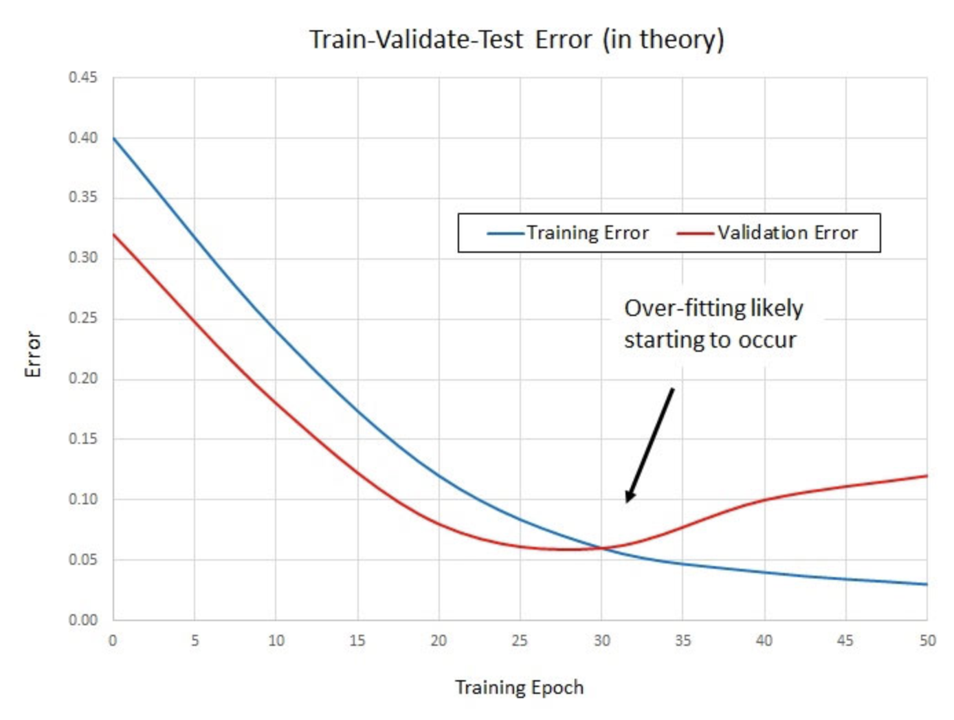 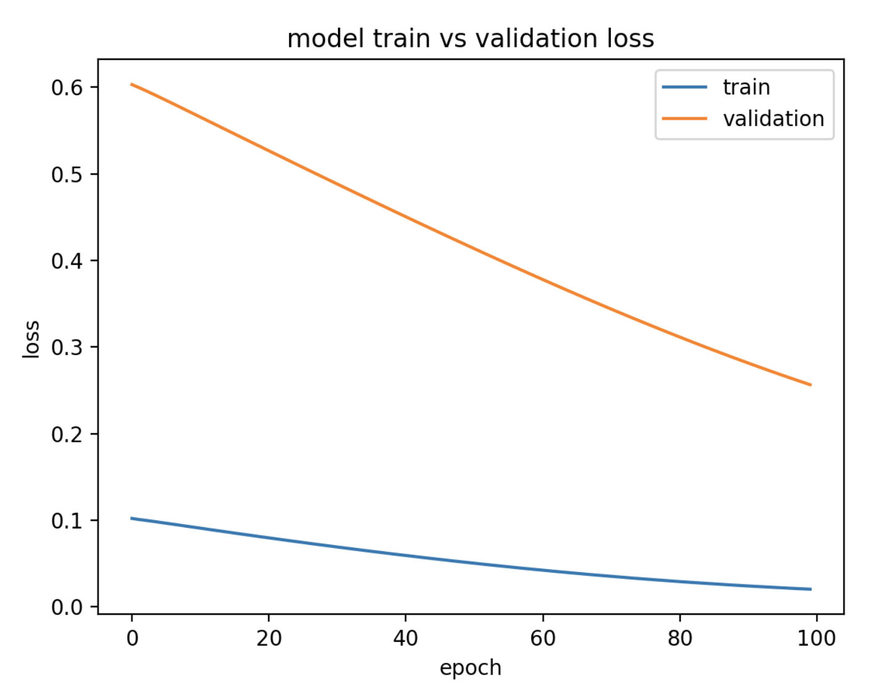

*Example 6: Predicting Housing Price*

Last day, the following code for predicting housing prices was discussed. This code implements a neural network that was optimized with a grid search.

|  |
| --- |
| import pandas as pd  import numpy as np  from sklearn import metrics  from sklearn.model_selection import train_test_split  PATH = "/Users/pm/Desktop/DayDocs/data/"  CSV_DATA = "housing.data"  df = pd.read_csv(PATH + CSV_DATA, header=None)  # Show all columns.  pd.set_option('display.max_columns', None)  # Increase number of columns that display on one line.  pd.set_option('display.width', 1000)  print(df.head())  print(df.tail())  print(df.describe())  dataset = df.values  # split into input (X) and output (Y) variables  X = dataset[:, 0:13]  y = dataset[:, 13]  ROW_DIM = 0  COL_DIM = 1  x_arrayReshaped = X.reshape(X.shape[ROW_DIM],  X.shape[COL_DIM])  # Convert DataFrame columns to vertical columns of target variables values.  y_arrayReshaped = y.reshape(y.shape[ROW_DIM], 1)  X_train, X_test, y_train, y_test = train_test_split(x_arrayReshaped,  y_arrayReshaped, test_size=0.2, random_state=0)  from keras.models import Sequential  from keras.layers import Dense  from keras.wrappers.scikit_learn import KerasRegressor  from sklearn.model_selection import cross_val_score  from sklearn.model_selection import KFold  # define base model  from keras.optimizers import Adam #for adam optimizer  def baseline_model():  model = Sequential()  model.add(Dense(25, input_dim=13, kernel_initializer='uniform',  activation='softplus'))  model.add(Dense(10, kernel_initializer='lecun_uniform', activation='softplus'))  model.add(Dense(1, kernel_initializer='uniform'))  # Use Adam optimizer with the given learning rate  opt = Adam(lr=0.005)  model.compile(loss='mean_squared_error')  return model  # evaluate model  estimator = KerasRegressor(build_fn=baseline_model, epochs=100,  batch_size=9, verbose=1)  kfold = KFold(n_splits=10)  results = cross_val_score(estimator, X_train, y_train, cv=kfold)  print("Baseline Mean (%.2f) MSE (%.2f) " % (results.mean(), results.std()))  print("Baseline RMSE: " + str(np.sqrt(results.std())))  # So then we build the model.  model = baseline_model()  history = model.fit(X_train, y_train, epochs=100,  batch_size=9, verbose=1,  validation_data=(X_test, y_test))  predictions = model.predict(X_test)  mse = metrics.mean_squared_error(y_test, predictions)  print("Neural network MSE: " + str(mse))  print("Neural network RMSE: " + str(np.sqrt(mse))) |

*Exercise 3 (1 mark)*

Explain why it does not make sense to draw an accuracy plot for the code in Example 6.

|  |
| --- |
| Because it uses leaner model |

*Exercise 4 (4 marks)*

Add code to time the duration needed to fit the model. You may want to implement the routine discussed in Example 1. Show your revised program here:

|  |
| --- |
| import pandas as pd import numpy as np from sklearn import metrics from sklearn.model_selection import train_test_split import time  PATH = "/Users/hyerimshin/PycharmProjects/MachineLearning/datasets/" CSV_DATA = "housing.data"  df = pd.read_csv(PATH + CSV_DATA, header=None)  # Show all columns. pd.set_option('display.max_columns', None)  # Increase number of columns that display on one line. pd.set_option('display.width', 1000)  print(df.head()) print(df.tail()) print(df.describe())  dataset = df.values # split into input (X) and output (Y) variables X = dataset[:, 0:13] y = dataset[:, 13]  ROW_DIM = 0 COL_DIM = 1 x_arrayReshaped = X.reshape(X.shape[ROW_DIM],  X.shape[COL_DIM])  # Convert DataFrame columns to vertical columns of target variables values. y_arrayReshaped = y.reshape(y.shape[ROW_DIM], 1)  X_train, X_test, y_train, y_test = train_test_split(x_arrayReshaped,  y_arrayReshaped, test_size=0.2, random_state=0)  from keras.models import Sequential from keras.layers import Dense from keras.wrappers.scikit_learn import KerasRegressor from sklearn.model_selection import cross_val_score from sklearn.model_selection import KFold  # define base model from keras.optimizers import Adam #for adam optimizer def baseline_model():  model = Sequential()  model.add(Dense(25, input_dim=13, kernel_initializer='uniform',  activation='softplus'))  model.add(Dense(10, kernel_initializer='lecun_uniform', activation='softplus'))  model.add(Dense(1, kernel_initializer='uniform'))   # Use Adam optimizer with the given learning rate  opt = Adam(lr=0.005)  model.compile(loss='mean_squared_error')  return model  # evaluate model estimator = KerasRegressor(build_fn=baseline_model, epochs=100,  batch_size=9, verbose=1) kfold = KFold(n_splits=10) results = cross_val_score(estimator, X_train, y_train, cv=kfold) print("Baseline Mean (%.2f) MSE (%.2f) " % (results.mean(), results.std())) print("Baseline RMSE: " + str(np.sqrt(results.std())))  #timeCalculation def currentTimeInMilliseconds():  newTime = int(round(time.time() * 1000))  return newTime  # So then we build the model. startTime = currentTimeInMilliseconds() model = baseline_model() history = model.fit(X_train, y_train, epochs=100,  batch_size=9, verbose=1,  validation_data=(X_test, y_test))  predictions = model.predict(X_test) mse = metrics.mean_squared_error(y_test, predictions) endTime = currentTimeInMilliseconds() time_diff = endTime - startTime print("Time taken to fit the model is: " + str(time_diff) + " ms") print("Neural network MSE: " + str(mse)) print("Neural network RMSE: " + str(np.sqrt(mse))) |

Show the time duration here:

|  |
| --- |
|  |

*Exercise 5 (6 marks)*

Plot the loss function output that occurs while the model in Example 6 is fit. Show your revised program here. Refer to Example 5 for code that plots the loss function.

|  |
| --- |
| import pandas as pd import numpy as np from sklearn import metrics from sklearn.model_selection import train_test_split import time from sklearn.preprocessing import LabelEncoder from tensorflow.keras import Sequential from tensorflow.keras.layers import Dense   PATH = "/Users/hyerimshin/PycharmProjects/MachineLearning/datasets/" CSV_DATA = "housing.data"  df = pd.read_csv(PATH + CSV_DATA, header=None)  # Show all columns. pd.set_option('display.max_columns', None)  # Increase number of columns that display on one line. pd.set_option('display.width', 1000)  print(df.head()) print(df.tail()) print(df.describe())  dataset = df.values # split into input (X) and output (Y) variables X = dataset[:, 0:13] y = dataset[:, 13]  ROW_DIM = 0 COL_DIM = 1 x_arrayReshaped = X.reshape(X.shape[ROW_DIM],  X.shape[COL_DIM])  # Convert DataFrame columns to vertical columns of target variables values. y_arrayReshaped = y.reshape(y.shape[ROW_DIM], 1)  X_train, X_test, y_train, y_test = train_test_split(x_arrayReshaped,  y_arrayReshaped, test_size=0.2, random_state=0)  from keras.models import Sequential from keras.layers import Dense from keras.wrappers.scikit_learn import KerasRegressor from sklearn.model_selection import cross_val_score from sklearn.model_selection import KFold  # define base model from keras.optimizers import Adam #for adam optimizer def baseline_model():  model = Sequential()  model.add(Dense(25, input_dim=13, kernel_initializer='uniform',  activation='softplus'))  model.add(Dense(10, kernel_initializer='lecun_uniform', activation='softplus'))  model.add(Dense(1, kernel_initializer='uniform'))   # Use Adam optimizer with the given learning rate  opt = Adam(lr=0.005)  model.compile(loss='mean_squared_error')  return model  import matplotlib.pyplot as plt import matplotlib matplotlib.use('TkAgg') import matplotlib.pyplot as plt def showLoss(history):  # Get training and test loss histories  training_loss = history.history['loss']  validation_loss = history.history['val_loss']   # Create count of the number of epochs  epoch_count = range(1, len(training_loss) + 1)  plt.subplot(1, 2, 1)  # Visualize loss history for training data.  plt.plot(epoch_count, training_loss, label='Train Loss', color='red')   # View loss on unseen data.  plt.plot(epoch_count, validation_loss, 'r--', label='Validation Loss',  color='black')   plt.xlabel('Epoch')  plt.legend(loc="best")  plt.title("Loss")  # evaluate model estimator = KerasRegressor(build_fn=baseline_model, epochs=100,  batch_size=9, verbose=1) kfold = KFold(n_splits=10) results = cross_val_score(estimator, X_train, y_train, cv=kfold) print("Baseline Mean (%.2f) MSE (%.2f) " % (results.mean(), results.std())) print("Baseline RMSE: " + str(np.sqrt(results.std())))  #timeCalculation def currentTimeInMilliseconds():  newTime = int(round(time.time() * 1000))  return newTime  # So then we build the model. startTime = currentTimeInMilliseconds() model = baseline_model() history = model.fit(X_train, y_train, epochs=100,  batch_size=9, verbose=1,  validation_data=(X_test, y_test))  predictions = model.predict(X_test) mse = metrics.mean_squared_error(y_test, predictions) endTime = currentTimeInMilliseconds() time_diff = endTime - startTime print("Time taken to fit the model is: " + str(time_diff) + " ms") print("Neural network MSE: " + str(mse)) print("Neural network RMSE: " + str(np.sqrt(mse)))  plt.subplots(nrows=1, ncols=2, figsize=(14,7)) showLoss(history) plt.show() |

Show a screenshot of the loss plot here:

|  |
| --- |
|  |

It is typical for the validation data to show higher losses than the training losses because the model learns with the training data. With this in mind, explain if you think the loss function shows a reasonably good fit, underfitting or overfitting.

|  |
| --- |
| I think this model is reasonably fit because the loss has the right curve and it has the less loss over the epochs. It may reach close to 0 losses with more epochs, batch or different learning rates. |

**Table of Contents**

**References – Better Deep Learning 1**

***Back Propogation Summary 1***

***Hyperparameter Tuning Continued 2***

**Adjusting the Decay Rate 2**

**ReLU – Vanishing Gradients 6**

**Leaky ReLU – Avoiding Dying ReLU 7**

**Overfitting-Early Stopping and Model Save 11**

References – Better Deep Learning

Decay rates – Chapter 5

ReLU and Vanishing Gradients – Chapter 7

Early Stopping – Chapter 18

“Better Deep Learning’ by Dr. Jason Brownlee <https://machinelearningmastery.com/better-deep-learning/>

Back Propogation Summary

**Hidden Layer(s)**

* Each neuron applies unique weights to attributes and sums the results.
* The activation function formats the sum and sends the neuron output to next layer.

**Output layer**

* Applies loss function.
* Calculates gradients.
* Back propogates changes to hidden layers where weights are updated.

**Repeat**

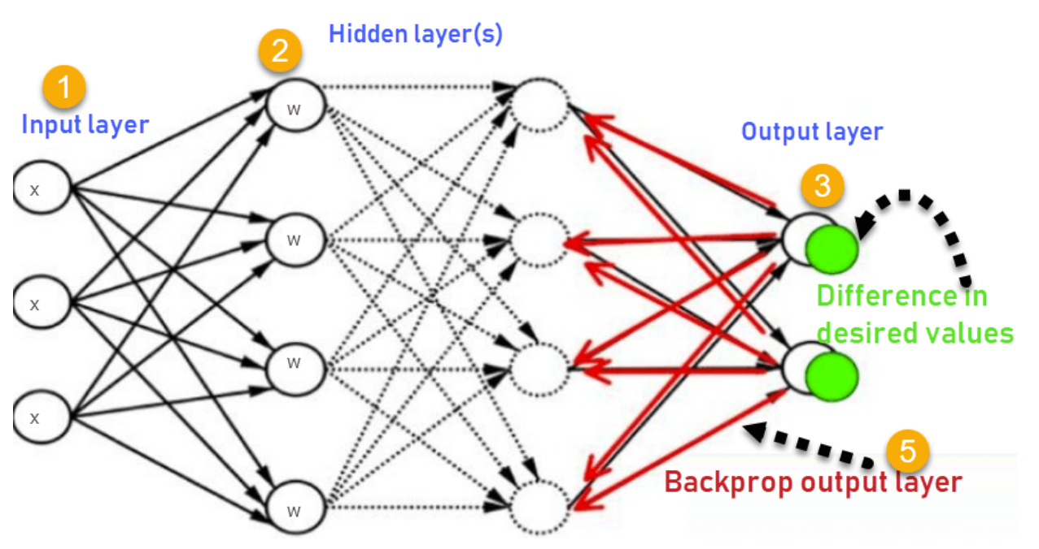

Hyperparameter Tuning Continued

This document discusses additional ways to improve your neural networks.

Adjusting the Decay Rate

Ideally, learning rates should be reduced as the training approaches the solutions. A decay rate can help to gradually reduce the learning rate. The SGD optimizer includes a *decay* attribute to set the decay rate directly:

opitimizer = tf.keras.optimizers.SGD(

learning_rate=0.0005, momentum=0.9, name="SGD", decay=decay_rate

)

SGD’s decay attribute makes the following calculation:

lrate = initial_lrate * (1 / (1 + decay * iteration))

*Example 1: Adjusting the Decay Rate*

The code in this example builds an MLP network to predict whether a person has diabetes. To establish a reliable conclusion, each decay rate is grid searched multiple times and the results are averaged. Table 1 Figure 1 and Table 1 show that some decay performs better than zero decay. A decay rate of **0.0010** wins with a 91.7% accuracy rate.

*Figure 1: Comparing Models with and without Decay*

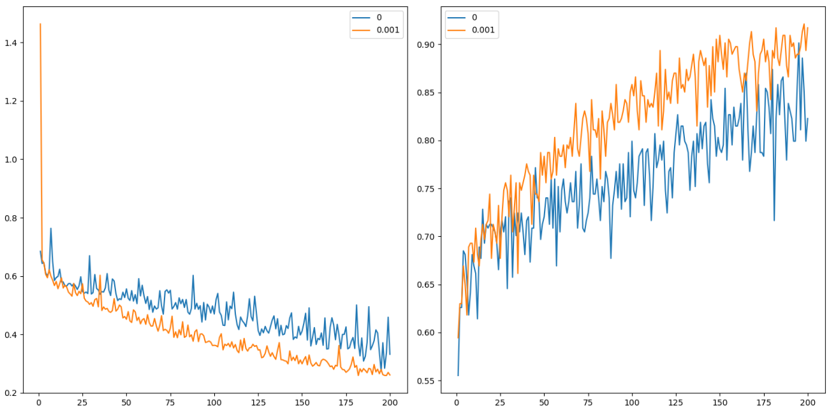

*Table 1: Averaged Decay Rates*

|  |
| --- |
| decay acc loss  0 0.000 0.822835 0.332191  1 0.001 0.917323 0.261379 |

Here is the code:

|  |
| --- |
| # first neural network with keras tutorial  from keras.models import Sequential  from keras.layers import Dense  import pandas as pd  from sklearn.model_selection import train_test_split  import matplotlib.pyplot as plt  PATH = "/Users/pm/Desktop/DayDocs/data/"  import tensorflow as tf  # load the dataset  df = pd.read_csv(PATH + 'diabetes.csv', sep=',')  # split into input (X) and output (y) variables  X = df[['Pregnancies','Glucose','BloodPressure','SkinThickness','Insulin','BMI',  'DiabetesPedigreeFunction', 'Age']]  y = df[['Outcome']]  # Split into train and test data sets.  X_train, X_test, y_train, y_test = train_test_split( X, y, test_size=0.33)  resultList = []  def buildModel(decayRate):  # define the keras model  model = Sequential()  model.add(Dense(230, input_dim=8, activation='relu',  kernel_initializer='he_normal'))  NUM_LAYERS = 7  for i in range(0, NUM_LAYERS-1):  model.add(Dense(230, activation='relu',  kernel_initializer='he_normal'))  model.add(Dense(1, activation='sigmoid'))  opitimizer = tf.keras.optimizers.SGD(  learning_rate=0.0005, momentum=0.9, name="SGD", decay=decayRate  )  # Compile the keras model.  model.compile(loss='binary_crossentropy', optimizer=opitimizer,  metrics=['accuracy'])  # Fit the keras model on the dataset.  history = model.fit(X, y, epochs=200, batch_size=10,  validation_data=(X_test, y_test))  # Evaluate the model.  loss, acc = model.evaluate(X_test, y_test, verbose=0)  resultList.append({'loss':loss, 'acc':acc, 'decay':decayRate})  print('Test Accuracy: %.3f' % acc)  return history  def showLoss(history, rates):  # Get training and test loss histories  training_loss = history.history['loss']  validation_loss = history.history['val_loss']  # Create count of the number of epochs  epoch_count = range(1, len(training_loss) + 1)  # Visualize loss history for training data.  actualLabel = str(rates)  plt.subplot(1, 2, 1)  # View loss on unseen data.  plt.plot(epoch_count, validation_loss, label=actualLabel)  plt.legend()  def showAccuracy(history, rates):  # Get training and test loss histories  training_loss = history.history['accuracy']  validation_loss = history.history['val_accuracy']  # Create count of the number of epochs  epoch_count = range(1, len(training_loss) + 1)  plt.subplot(1, 2, 2)  actualLabel = str(rates)  # View loss on unseen data.  plt.plot(epoch_count, validation_loss, label=actualLabel)  plt.legend()  decayRates = [0, 0.001]  plt.subplots(nrows=1, ncols=2, figsize=(14,7))  for i in range(0, len(decayRates)):  history = buildModel(decayRates[i])  showLoss(history, decayRates[i])  showAccuracy(history, decayRates[i])  plt.show()  import pandas as pd  df = pd.DataFrame(columns=['decay', 'acc', 'loss'])  for result in resultList:  df = df.append(result, ignore_index=True)  print(df) |

*Exercise 1 (2 marks)*

Change the decayRates grid search list to the following.

decayRates = [0, 0.001, 0.0005, 0.0001]

What are the accuracy and loss values for the different decay rates when running the code sample?

|  |
| --- |
| decay acc loss  0 0.0000 0.889764 0.271136  1 0.0010 0.897638 0.266808  2 0.0005 0.897638 0.210469  3 0.0001 0.940945 0.189229 |

Which decay rate appears to have the best accuracy and loss rating?

|  |
| --- |
| The decay rate of 0.0001 has the best accuracy of 94.09% and loss rating of 0.1892. |

Show the accuracy and loss plots that appear when grid searching the values in this exercise.

|  |
| --- |
|  |

What do the accuracy and loss plots tell us about the number of epochs?

|  |
| --- |
| Higher epochs tend to result in lower loss and higher accuracy. |

*Exercise 2 (3 marks)*

Can you find a decay rate that performs better with a different number of epochs?

Yes / No

What number of epochs did you use?

|  |
| --- |
| 300 |

What are the accuracy and loss values for the different decay rates when running the code sample with adjusted epochs?

|  |
| --- |
| decay acc loss  0 0.0000 0.846457 0.299924  1 0.0010 0.921260 0.233803  2 0.0005 0.972441 0.107956  3 0.0001 0.968504 0.106252 |

Show the accuracy and loss plots that appear when grid searching the values in this exercise with the new number of epochs.

|  |
| --- |
|  |

*Exercise 3 (2 marks0*

Show the accuracy and loss plots and statistics that are displayed when running your optimized solution for Exercise 2.

|  |
| --- |
| decay acc loss  0 0.0000 0.866142 0.239151  1 0.0010 0.854331 0.325965  2 0.0005 0.850394 0.317502  3 0.0001 0.944882 0.124999 |

**Note:** I will not get into the math but a nice explanation of vanishing gradients. However, this article offers a nice summary of how they work.

<https://medium.com/analytics-vidhya/how-batch-normalization-and-relu-solve-vanishing-gradients-3f1a8ace1c88>

ReLU – Vanishing Gradients

Deep networks were not possible until recently with the emergence of the ReLU activation function. Back propagation with activation functions like **sigmoid** and **tanh** led to vanishing gradients. The derivative of the tanh and sigmoid functions effectively solves to 0 for really large and really small values of X. As a result, sigmoid and tanh activation functions often cause failures to update weights during back propagation. When weights fail to update the neurons stopped learning.

The rectified linear unit (ReLU) helps to avoid the problem for vanishing gradients. The derivative of the activation function for positive values of X solves to 1 so gradients can back propagate (See Figure 2). Some neurons with negative values of X will still die but enough neurons will survive to keep learning most of the time.

*Figure 2: ReLU Function*

|  |  |
| --- | --- |
|  | # ReLu function  def relu(X):  return np.maximum(0,X)  # Example with matrix input of:  # [[1,2,3],[4,5,6]]  relu(mmatrix)  # Output:  array([[1, 2, 3], [4, 5, 6]]) |

Leaky ReLU – Avoiding Dying ReLU

Activation functions like the Leaky ReLU have been created to avoid the vanishing gradient altogether (see Figure 3). It turns out though that ReLU often performs just as well as the Leaky ReLU so a standard ReLU is more common.

*Figure 3: Leaky ReLU*

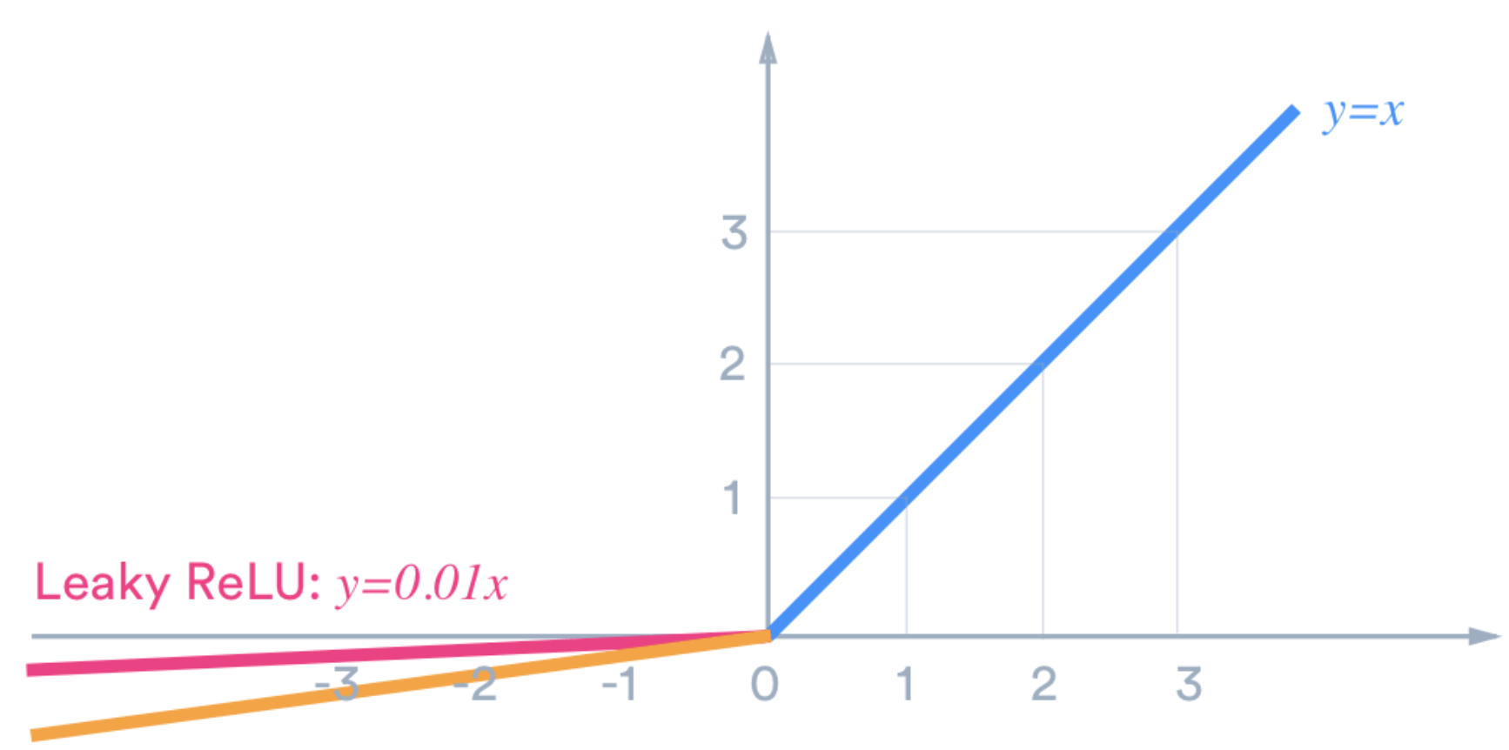

*Example 2: Under-performing deep network with Tanh function (See chapter 7 of Better Deep Learning)*

This example demonstrates a situation where vanishing gradients occurs. For this case, the loss and accuracy curves that are displayed in Figure 4 show that the network is unable to learn. To enable this failure a deep network has been built with the ‘tanh’ activation function.

*Figure 4: Loss and Accuracy Curves for Vanishing Gradients*

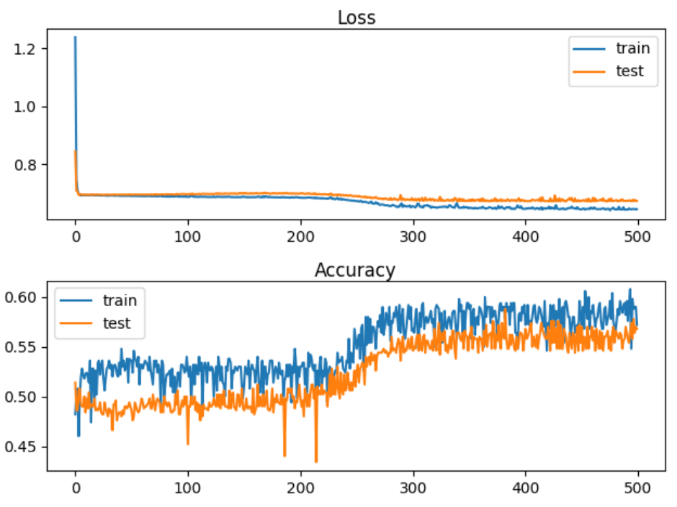

The quantitative output shows that the accuracy stagnates at around 57% for training and for testing.

Train Accuracy: 0.578, Test Accuracy: 0.568

Here is the code. Note that the ‘tanh’ activation function is used as the activation function with a random uniform kernel initializer.

|  |
| --- |
| # deeper mlp with tanh for the two circles classification problem  from sklearn.datasets import make_circles  from sklearn.preprocessing import MinMaxScaler  from keras.layers import Dense  from keras.models import Sequential  from keras.optimizers import SGD  from keras.initializers import RandomUniform  import matplotlib.pyplot as plt  # Generate 2d classification dataset.  X, y = make_circles(n_samples=1000, noise=0.1, random_state=1)  scaler = MinMaxScaler(feature_range=(-1, 1))  X = scaler.fit_transform(X)  # split into train and test  n_train = 500  trainX, testX = X[:n_train, :], X[n_train:, :]  trainy, testy = y[:n_train], y[n_train:]  # Define the model.  model = Sequential()  init = RandomUniform(minval=0, maxval=1)  model.add(Dense(5, input_dim=2, activation='tanh', kernel_initializer=init))  model.add(Dense(5, activation='tanh', kernel_initializer=init))  model.add(Dense(5, activation='tanh', kernel_initializer=init))  model.add(Dense(5, activation='tanh', kernel_initializer=init))  model.add(Dense(5, activation='tanh', kernel_initializer=init))  model.add(Dense(1, activation='sigmoid', kernel_initializer=init))  # Compile model.  opt = SGD(lr=0.01, momentum=0.9)  model.compile(loss='binary_crossentropy', optimizer=opt, metrics=['accuracy'])  # fit model  history = model.fit(trainX, trainy, validation_data=(testX, testy), epochs=500, verbose=1)  # evaluate the model  _, train_acc = model.evaluate(trainX, trainy, verbose=0)  _, test_acc = model.evaluate(testX, testy, verbose=0)  print('Train Accuracy: %.3f, Test Accuracy: %.3f' % (train_acc, test_acc))  # Plot loss learning curves.  plt.subplot(211)  plt.title('Loss', pad=-40)  plt.plot(history.history['loss'], label='train')  plt.plot(history.history['val_loss'], label='test')  plt.legend()  # Plot accuracy learning curves.  plt.subplot(212)  plt.title('Accuracy', pad=-40)  plt.plot(history.history['accuracy'], label='train')  plt.plot(history.history['val_accuracy'], label='test')  plt.legend()  plt.show() plt.show() |

*Example 3: Using RELU to Enable Deeper Networks (See Chapter 7 of Better Deep Learning)*

This example shows how to solve the vanishing gradient problem that occurs in Example 2. A ReLU activation function with an ‘he_uniform’ kernel_initializer performs much better. The train and test accuracy scores jump by approximately 25% after implementing the ReLU activation functions.

Train Accuracy: 0.832, Test Accuracy: 0.824

*Figure 5: Accuracy and Loss Curves when using the ReLU activation function with ‘he_normal’.*

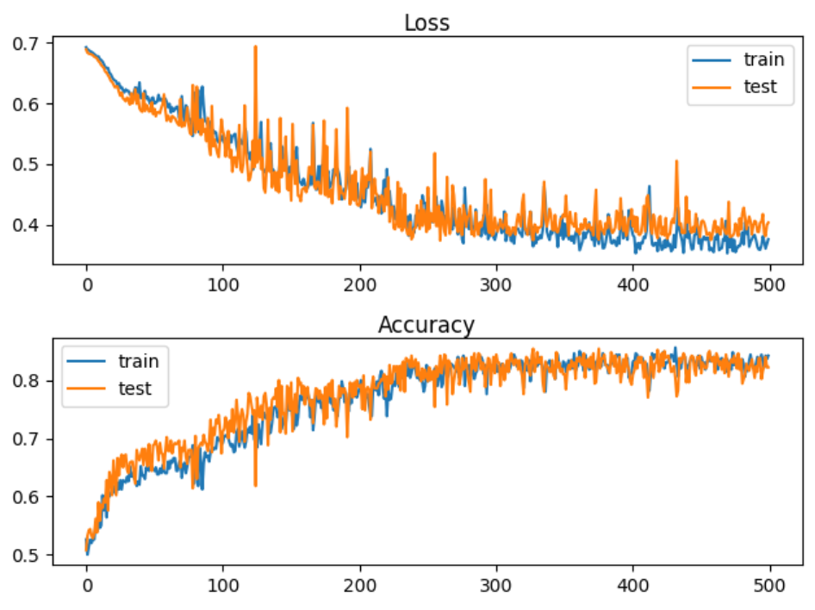

To build this model, replace the model definition code in Example 2 with this version. The difference with this new code is in activation and kernel_initializer function which enable the deep network:

|  |
| --- |
| # Define the model.  model = Sequential()  model.add(Dense(5, input_dim=2, activation='relu', kernel_initializer='he_uniform'))  model.add(Dense(5, activation='relu', kernel_initializer='he_uniform'))  model.add(Dense(5, activation='relu', kernel_initializer='he_uniform'))  model.add(Dense(5, activation='relu', kernel_initializer='he_uniform'))  model.add(Dense(5, activation='relu', kernel_initializer='he_uniform'))  model.add(Dense(1, activation='sigmoid')) |

*Exercise 4 (3 marks)*

The code that was presented in Example 1 is used to build a network for diagnosing heart disease. Starting with the code that is used in Exercise 1, replace the input and hidden layer definitions with the following definitions. These definitions use a tanh activation function with a RandomUniform kernel initializer.

|  |
| --- |
| init = RandomUniform(minval=0, maxval=1)  model.add(Dense(230, input_dim=8, activation='tanh',  kernel_initializer=init))  NUM_LAYERS = 7  for i in range(0, NUM_LAYERS-1):  model.add(Dense(230, activation='tanh', kernel_initializer=init)) |

Remember to include the RandomUniform import:

|  |
| --- |
| from keras.initializers import RandomUniform |

How do the accuracy and loss levels from the output in this exercise compare with the accuracy and loss levels that are generated in Example 1Exercise 1? Explain why this occurred.

|  |
| --- |
| decay acc loss  0 0.0000 0.665354 0.641172  1 0.0010 0.665354 0.637703  2 0.0005 0.665354 0.638860  3 0.0001 0.665354 0.638983  The use of tanh activation function for back propagation led to a vanishing gradient. The derivative of the tanh functions effectively solves to 0 for really large and really small values of X. As a result, the tanh activation function caused a failure to update weights during back propagation. When weights fail to update the neurons stopped learning. |

*Exercise 5 (3 marks)*

Show the loss and accuracy plots which are displayed when running the code in Exercise 4. Explain what happened.

|  |
| --- |
| The tanh activation function is failing to update the weights as you can see on the loss plot. The accuracy goes down then spikes back up after failing to update. The accuracy plot shows a flat line, also showing the failure of updating the weights. |

*Example 4: Leaky ReLU*

To implement a leaky ReLU replace the model definition code inside example 3 with the following:

|  |
| --- |
| import tensorflow as tf  leakyReLU = tf.keras.layers.LeakyReLU(alpha=0.3)  # Define the model.  model = Sequential()  model.add(Dense(5, input_dim=2, activation=leakyReLU, kernel_initializer='he_uniform'))  model.add(Dense(5, activation=leakyReLU, kernel_initializer='he_uniform'))  model.add(Dense(5, activation=leakyReLU, kernel_initializer='he_uniform'))  model.add(Dense(5, activation=leakyReLU, kernel_initializer='he_uniform'))  model.add(Dense(5, activation=leakyReLU, kernel_initializer='he_uniform'))  model.add(Dense(1, activation='sigmoid')) |

Overfitting-Early Stopping and Model Save

Early stopping is a technique to help prevent over-fitting. Early stopping exits training when either losses increase or accuracy begins to diminish. A patience property can be included to set an additional number of epochs that must occur before the routine ends training.

An additional helpful technique involves saving the very best model during training. EarlyStopping and ModelCheckpoint work together to save you time and to provide you with the best model. Both features are set up with a callback.

Two important parameters of the EarlyStopping() function are:

**min_delta**: Minimum change in the monitored quantity to qualify as an improvement.

An absolute change of less than min_delta, will count as no improvement.

**patience**: Number of epochs with no improvement after which training will be

stopped.

# Simple early stopping.

es = EarlyStopping(monitor='val_loss', mode='min', verbose=1, min_delta=0.1, patience=200)

mc = ModelCheckpoint('best_model.h5', monitor='val_accuracy', mode='max', verbose=1,

save_best_only=True)

# Fit model.

history = model.fit(trainX, trainy, validation_data=(testX, testy), epochs=4000, verbose=0,

callbacks=[es, mc])

The model can then be loaded later.

# Load the saved model.

saved_model = load_model('best_model.h5')

The following code snippet above allows you to save the model when the best validation accuracy. However, you can also trigger a model save based on minimum validation loss.

tf.keras.callbacks.ModelCheckpoint(

filepath, monitor='val_loss', verbose=0, save_best_only=False,

save_weights_only=False, mode='auto', save_freq='epoch', options=None, **kwargs

)

*Example 5: Preventing overfitting with early-stopping and model save.*

This example demonstrates a network that fails due to overfitting. Figure 6 shows a typical overfitting situation where a loss curve which starts out by gradually declining and then rising.

*Figure 6: Failed Network due to Overfitting*

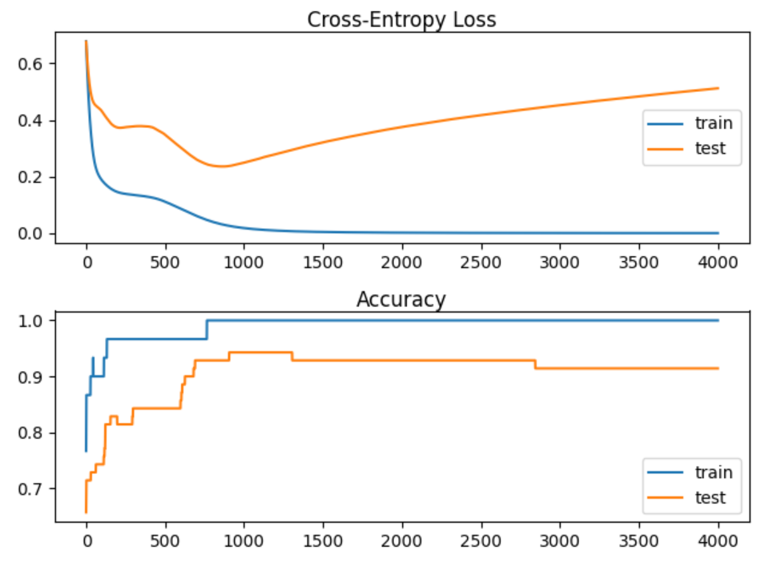

Here is the code to set up and evaluate the failed network:

|  |
| --- |
| # Creating an overfit situation with the moons data set.  from sklearn.datasets import make_moons  from keras.layers import Dense  from keras.models import Sequential  import matplotlib.pyplot as plt  # Generate 2d classification dataset.  X, y = make_moons(n_samples=100, noise=0.2, random_state=1)  # Split data into train and test.  n_train = 30  trainX, testX = X[:n_train, :], X[n_train:, :]  trainy, testy = y[:n_train], y[n_train:]  # Define the model.  model = Sequential()  model.add(Dense(500, input_dim=2, activation='relu'))  model.add(Dense(1, activation='sigmoid'))  model.compile(loss='binary_crossentropy', optimizer='adam', metrics=['accuracy'])  # Fit the model.  history = model.fit(trainX, trainy, validation_data=(testX, testy), epochs=4000, verbose=1)  # Evaluate the model.  train_loss, train_acc = model.evaluate(trainX, trainy, verbose=0)  test_loss, test_acc = model.evaluate(testX, testy, verbose=0)  print('Train accuracy: %.3f, Test accuracy: %.3f' % (train_acc, test_acc))  print('Train loss: %.3f, Test loss: %.3f' % (train_loss, test_loss))  # Plot loss learning curves.  plt.subplot(211)  plt.title('Cross-Entropy Loss', pad=-40)  plt.plot(history.history['loss'], label='train')  plt.plot(history.history['val_loss'], label='test')  plt.legend()  # Plot accuracy learning curves.  plt.subplot(212)  plt.title('Accuracy', pad=-40)  plt.plot(history.history['accuracy'], label='train')  plt.plot(history.history['val_accuracy'], label='test')  plt.legend()  plt.show() |

*Example 6: Early Stopping*

The code needed to save the best model and to implement early stopping w

To build this example, replace the green highlighted section in Example 5 with this version.

|  |
| --- |
| # Fit the model.  from keras.callbacks import EarlyStopping  from keras.callbacks import ModelCheckpoint  from keras.models import load_model  # simple early stopping  # Apparently we must set patience to at least 1 for it to work on certain machines.  es = EarlyStopping(monitor='val_loss', mode='min', verbose=1,  min_delta=0.1, patience=1)  mc = ModelCheckpoint('best_model.h5', monitor='val_loss', mode='min', verbose=1,  save_best_only=True)  # fit model  history = model.fit(trainX, trainy, validation_data=(testX, testy), epochs=4000, verbose=0,  callbacks=[es, mc])  # load the saved model  model = load_model('best_model.h5') |

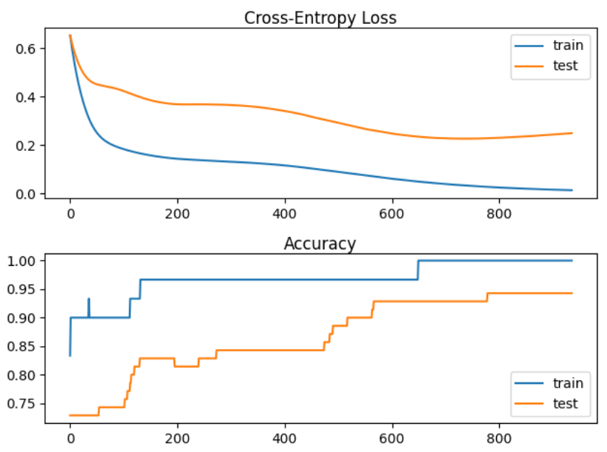

Train accuracy: 1.000, Test accuracy: 0.943

Train loss: 0.026, Test loss: 0.235

*Exercise 6 (3 marks)*

Study the output after running Example 6. How many epochs executed? How many epochs would have executed without the patience attribute? How many epochs would have executed without early stopping?

|  |
| --- |
| 2 epochs were executed, 4000 would have been executed without the early stopping. 0 epochs may have executed without patience=1 attribute. |

*Exercise 7 (2 marks)*

Show a screenshot of the model that is saved in your project folder.

|  |
| --- |
|  |

*Exercise 8 (3 marks)*

Replace the model checkpoint code in Example 6 with this version which saves the best model based on the lowest validation loss.

|  |
| --- |
| mc = ModelCheckpoint('best_model.h5', monitor='val_loss', mode='auto', verbose=1,  save_best_only=True) |

Run the code and show the output. Compare the output here with the output in Example 6. How is the output different?

|  |
| --- |
| Original:  Epoch 1: val_loss improved from inf to 0.67217, saving model to best_model.h5  Epoch 2: val_loss improved from 0.67217 to 0.66171, saving model to best_model.h5  Epoch 2: early stopping  Train accuracy: 0.833, Test accuracy: 0.671  Train loss: 0.635, Test loss: 0.662  Replaced:  Epoch 1: val_loss improved from inf to 0.67791, saving model to best_model.h5  Epoch 2: val_loss improved from 0.67791 to 0.66746, saving model to best_model.h5  Epoch 2: early stopping  Train accuracy: 0.833, Test accuracy: 0.614  Train loss: 0.660, Test loss: 0.667  The output is very similar. The replaced code uses mode=’auto’ instead of mode=’min’. This is the same because mode=’auto’ uses a value of ‘min’ for ‘val_loss’ to minimize loss. |

**Table of Contents**

**Exploding Gradients 1**

Norm Scaling 3

Gradient Clipping 5

**Importance of Scaling 5**

**Input and Output Scaling 7**

**Greedy Layer-wise Pretraining 7**

Exploding Gradients

Exploding gradients can occur when overflowing gradients are back propagated. This situation is more common with LSTM’s where the context from several past gradients are included with the back propagation.

Exploding gradients can occur due to:

* Improperly scaled inputs to the network.
* Poorly chosen learning rates that allow for large weight updates.
* Loss functions which allow the calculation of large error values.

Gradient clipping can be used to fix this error. There are two ways to clip gradients:

* Norm scaling
* Norm clipping

*Example 1: Bad Exploding Gradient (See Chapter 8 of Better Deep Learning)*

This example causes exploding gradients because the inputs are not scaled. The sample data has 20 unscaled features. The y-value is unscaled as well (see Figure 1).

*Figure 1: Unscaled y-values*

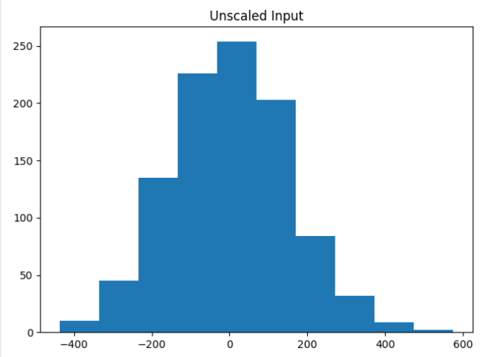

The unscaled data caused the model weights to explode during training. Very large errors were generated while the data was fed through the network. The network was unable to learn anything. As a result, the predictions are NaN values which leads to MSE values that are also not numbers.

Train MSE: nan, Test MSE: nan

Here is the code which sets up the data and network that causes the exploding gradients.

|  |
| --- |
| # mlp with unscaled data for the regression problem  from sklearn.datasets import make_regression  from keras.layers import Dense  from keras.models import Sequential  from keras.optimizers import SGD  import matplotlib.pyplot as plt  # Generate the regression dataset.  X, y = make_regression(n_samples=1000, n_features=20, noise=0.1, random_state=1)  plt.hist(y)  plt.title("Unscaled Input")  plt.show()  # Split into train and test.  n_train = 500  trainX, testX = X[:n_train, :], X[n_train:, :]  trainy, testy = y[:n_train], y[n_train:]  # Define the model.  model = Sequential()  model.add(Dense(25,input_dim=20, activation='relu',kernel_initializer='he_uniform'))  model.add(Dense(1, activation='linear'))  # Compile the model.  model.compile(loss='mean_squared_error', optimizer=SGD(lr=0.01, momentum=0.9))  # Fit the model.  history = model.fit(trainX, trainy, validation_data=(testX, testy), epochs=100, verbose=1)  # Evaluate the model.  train_mse = model.evaluate(trainX, trainy, verbose=0)  test_mse = model.evaluate(testX, testy, verbose=0)  print('Train MSE: %.3f, Test MSE: %.3f' % (train_mse, test_mse))  # Plot losses during training.  plt.title('Losses')  plt.plot(history.history['loss'], label='train')  plt.plot(history.history['val_loss'], label='test')  plt.legend()  plt.show() |

Norm Scaling

One way to clip the gradients involves norm scaling. When weights are greater than a specific value, they are rescaled to a chosen value. Norm scaling is implemented with the *clipnorm* attribute. In this case clipnorm is set to 1 but other values could have been used.

opt = SGD(lr=0.01, momentum=0.9, clipnorm=1.0)

*Example 2: Norm Scaling (See Chapter 8 Better Deep Learrning)*

A way to fix the exploding gradient issue presented in Example 2 is to replace the compilation statement with one that includes a *clipnorm* attribute in the optimizer.

|  |
| --- |
| opt = SGD(lr=0.01, momentum=0.9, clipnorm=1.0)  model.compile(loss='mean_squared_error', optimizer=opt) |

When running the example now, training is possible. An MSE value of 16.874 is generated.

Train MSE: 1.158, Test MSE: 16.874

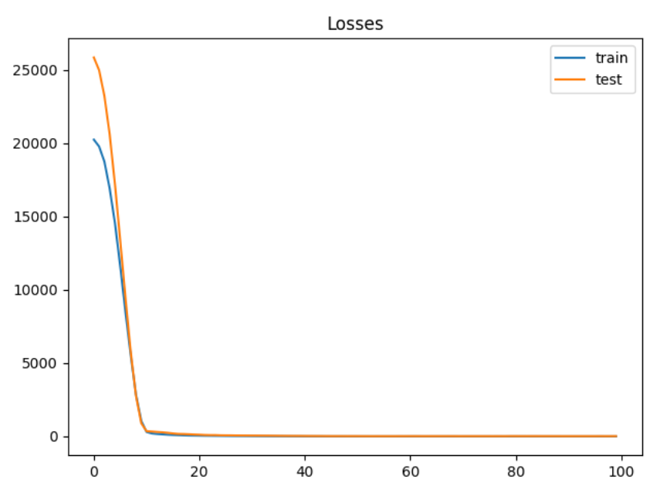

*Exercise 1 (2 marks)*

Starting with the following code, determine if you can find a better clip norm:

|  |
| --- |
| # mlp with unscaled data for the regression problem  from sklearn.datasets import make_regression  from keras.layers import Dense  from keras.models import Sequential  from keras.optimizers import SGD  import matplotlib.pyplot as plt  # Generate the regression dataset.  X, y = make_regression(n_samples=1000, n_features=20, noise=0.1, random_state=1)  plt.hist(y)  plt.title("Unscaled Input")  plt.show()  # Split into train and test.  n_train = 500  trainX, testX = X[:n_train, :], X[n_train:, :]  trainy, testy = y[:n_train], y[n_train:]  clipResults = []  def buildModel(clipSize):  # Define the model.  model = Sequential()  model.add(Dense(25,input_dim=20, activation='relu',kernel_initializer='he_uniform'))  model.add(Dense(1, activation='linear'))  # Compile the model.  opt = SGD(lr=0.01, momentum=0.9, clipnorm=1.0)  model.compile(loss='mean_squared_error', optimizer=opt)  # Fit the model.  history = model.fit(trainX, trainy, validation_data=(testX, testy), epochs=100, verbose=1)  # Evaluate the model.  train_mse = model.evaluate(trainX, trainy, verbose=0)  test_mse = model.evaluate(testX, testy, verbose=0)  print('Train MSE: %.3f, Test MSE: %.3f' % (train_mse, test_mse))  clipResults.append({'train mse': train_mse, 'test mse':test_mse,  'clip size':clipSize})  # Plot losses during training.  plt.title('Losses')  plt.plot(history.history['loss'], label='train')  plt.plot(history.history['val_loss'], label='test')  plt.legend()  plt.show()  clipSizes = [0.9, 1, 1.1, 2]  for i in range(0, len(clipSizes)):  buildModel(clipSizes[i])  for clipResult in clipResults:  print(clipResult) |

Try to improve the clips scale. Show your optimal clip norm scale here and explain why you chose it.

|  |
| --- |
| {'train mse': 0.7066060900688171, 'test mse': 14.414047241210938, 'clip size': 0.7}  {'train mse': 0.45103055238723755, 'test mse': 16.370412826538086, 'clip size': 0.8}  {'train mse': 0.40858176350593567, 'test mse': 15.985372543334961, 'clip size': 0.9}  **{'train mse': 0.4082964062690735, 'test mse': 14.278223037719727, 'clip size': 0.95}**  {'train mse': 1.2649400234222412, 'test mse': 14.364845275878906, 'clip size': 1}  {'train mse': 0.9165008664131165, 'test mse': 16.532474517822266, 'clip size': 1.05}  {'train mse': 1.1797434091567993, 'test mse': 15.216545104980469, 'clip size': 1.1}  {'train mse': 0.9404534697532654, 'test mse': 17.028005599975586, 'clip size': 1.3}  {'train mse': 1.9586129188537598, 'test mse': 21.995697021484375, 'clip size': 2}  Optimal clip norm scale is 0.95 because it has the lowest MSE out of the clip sizes tested. |

Gradient Clipping

Another solution involves clipping gradients if they become too large.

*Example 3: Norm Clipping (See Chapter 8 Better Deep Learning)*

To build this example, replace the compile statement in Example 1 with this code.

|  |
| --- |
| opt = SGD(lr=0.01, momentum=0.9, clipvalue=5.0)  model.compile(loss='mean_squared_error', optimizer=opt) |

Train MSE: 50.182, Test MSE: 71.380

*Figure 2: Loss Functions with Gradient Clipping*

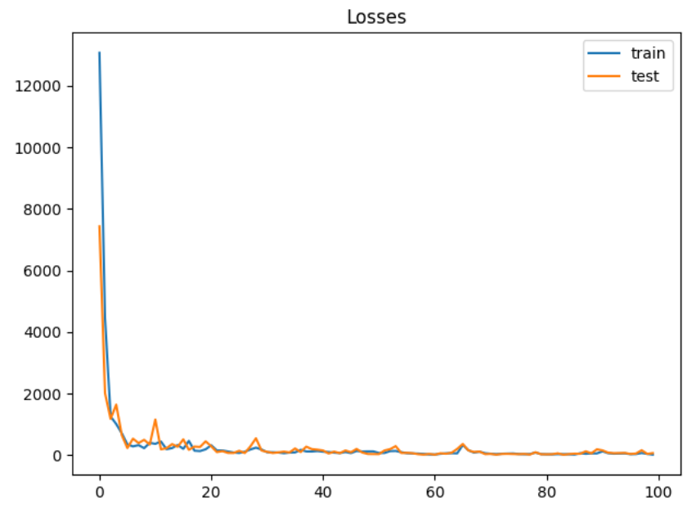

*Exercise 2 (2 marks)*

Modify the code in Exercise 1 to so it implements a grid search on clip value. Show your revised program here:

|  |
| --- |
| # mlp with unscaled data for the regression problem from sklearn.datasets import make_regression from keras.layers import Dense from keras.models import Sequential from keras.optimizers import SGD import matplotlib.pyplot as plt  # Generate the regression dataset. X, y = make_regression(n_samples=1000, n_features=20, noise=0.1, random_state=1)  plt.hist(y) plt.title("Unscaled Input") plt.show()  # Split into train and test. n_train = 500 trainX, testX = X[:n_train, :], X[n_train:, :] trainy, testy = y[:n_train], y[n_train:]  clipResults = [] def buildModel(clipValueSize):  # Define the model.  model = Sequential()  model.add(Dense(25,input_dim=20, activation='relu',kernel_initializer='he_uniform'))  model.add(Dense(1, activation='linear'))   # Compile the model.  opt = SGD(lr=0.01, momentum=0.9, clipvalue=clipValueSize)  model.compile(loss='mean_squared_error', optimizer=opt)   # Fit the model.  history = model.fit(trainX, trainy, validation_data=(testX, testy), epochs=100, verbose=1)   # Evaluate the model.  train_mse = model.evaluate(trainX, trainy, verbose=0)  test_mse = model.evaluate(testX, testy, verbose=0)  print('Train MSE: %.3f, Test MSE: %.3f' % (train_mse, test_mse))  clipResults.append({'train mse': train_mse, 'test mse':test_mse,  'clip value':clipValueSize})  # Plot losses during training.  plt.title('Losses')  plt.plot(history.history['loss'], label='train')  plt.plot(history.history['val_loss'], label='test')  plt.legend()  plt.show()  clipValueSizes = [2,3,4,5,6,7] for i in range(0, len(clipValueSizes)):  buildModel(clipValueSizes[i])  for clipResult in clipResults:  print(clipResult) |

Show an optimized value here and show the MSE.

|  |
| --- |
| {'train mse': 52.36796951293945, 'test mse': 89.49208068847656, 'clip value': 2}  {'train mse': 80.23286437988281, 'test mse': 101.4061279296875, 'clip value': 3}  {'train mse': 49.562679290771484, 'test mse': 61.44961929321289, 'clip value': 4}  {'train mse': 81.38309478759766, 'test mse': 100.7852554321289, 'clip value': 5}  **{'train mse': 36.556434631347656, 'test mse': 37.80767059326172, 'clip value': 6}**  {'train mse': 69.10971069335938, 'test mse': 71.18988800048828, 'clip value': 7}  Optimized at a clipvalue of 6. |

Importance of Scaling

Since neural networks rely heavily on properly sized weights for the model, scaling the data often matters.

*Example 4: Unscaled Data*

For comparison, this example generates mse values from regression without scaling.

|  |
| --- |
| Train loss: 10.055, Test loss: 13.413 |

Here is the code.

|  |
| --- |
| from sklearn.datasets import make_regression  from keras.layers import Dense  from keras.models import Sequential  from keras.optimizers import SGD  from matplotlib import pyplot  # Generate regression set.  X, y = make_regression(n_samples=1000, n_features=20,  noise=0.1, random_state=1)  # Split data into train and test.  n_train = 500  trainX, testX = X[:n_train, :], X[n_train:, :]  trainy, testy = y[:n_train], y[n_train:]  normSizeEvaluations = []  # Define the model.  model = Sequential()  model.add(Dense(25, input_dim=20, activation='relu',  kernel_initializer='he_uniform'))  model.add(Dense(1, activation='linear'))  # Compile the model.  model.compile(loss='mean_squared_error',  optimizer=SGD(lr=0.01, momentum=0.9, clipvalue=1.05))  # Fit the model.  history = model.fit(trainX, trainy,  validation_data=(testX, testy),  epochs=200, verbose=1)  # Evaluate the model.  train_mse = model.evaluate(trainX, trainy, verbose=0)  test_mse = model.evaluate(testX, testy, verbose=0)  print('Train loss: %.3f, Test loss: %.3f' % (train_mse, test_mse))  normSizeEvaluations.append({'train mse':train_mse,  'test mse':test_mse,  'size':1})  # Plot the loss during training.  pyplot.title('Mean Squared Error - norm size: ')  pyplot.plot(history.history['loss'], label='train')  pyplot.plot(history.history['val_loss'], label='test')  pyplot.legend()  pyplot.show() |

Input and Output Scaling

As you may have guessed, gains can be achieved by scaling the X and Y values.

*Example 5: Input and Output Scaling*

For this case we can achieve better gains by scaling the y-value. The output is:

|  |
| --- |
| Train loss: 0.002, Test loss: 0.004 |

To implement this solution, replace the compile instruction in Example 4 with this version.

|  |
| --- |
| # Compile the model.  model.compile(loss='mean_squared_error',  optimizer=SGD(lr=0.01, momentum=0.9))  from sklearn.preprocessing import StandardScaler  # reshape 1d arrays to 2d arrays  trainy = trainy.reshape(len(trainy), 1)  testy = testy.reshape(len(trainy), 1)  # Scale y  scaler = StandardScaler()  scaler.fit(trainy)  trainy = scaler.transform(trainy)  testy = scaler.transform(testy)  # Scale x  xscaler = StandardScaler()  xscaler.fit(trainX)  trainX = xscaler.transform(trainX)  testX = xscaler.transform(testX) |

Greedy Layer-wise Pretraining

Greedy layer-wise pretraining involves successively adding a new hidden layer to a model and refitting, allowing the newly added model to learn the inputs from the existing hidden layer, often while keeping the weights for the existing hidden layers. Sometimes, but not always, being able to build layers in isolation can lead to a better model.

The algorithm begins with a base model just like we have created before. However, when adding new layers, the output layer is stored and removed, existing layers are set so they cannot be modified, a new layer is added and then the output layer is added back.

|  |
| --- |
| # Add one new layer and re-train only the new layer.  def add_layer(model, trainX, trainy):  # Store the output layer.  output_layer = model.layers[-1]  # Remove the output layer.  model.pop()  # Mark all remaining layers as non-trainable.  for layer in model.layers:  layer.trainable = False  # Add a new hidden layer.  model.add(Dense(10, activation='relu', kernel_initializer='he_uniform'))  # Add the output layer back.  model.add(output_layer)  # fit model  model.fit(trainX, trainy, epochs=100, verbose=1)  return model |

*Example 6: Data Setup (See Chapter 20 of Better Deep Learning)*

This example sets up the data for greedy layer-wise pretraining classification problem by generating three separate clusters.

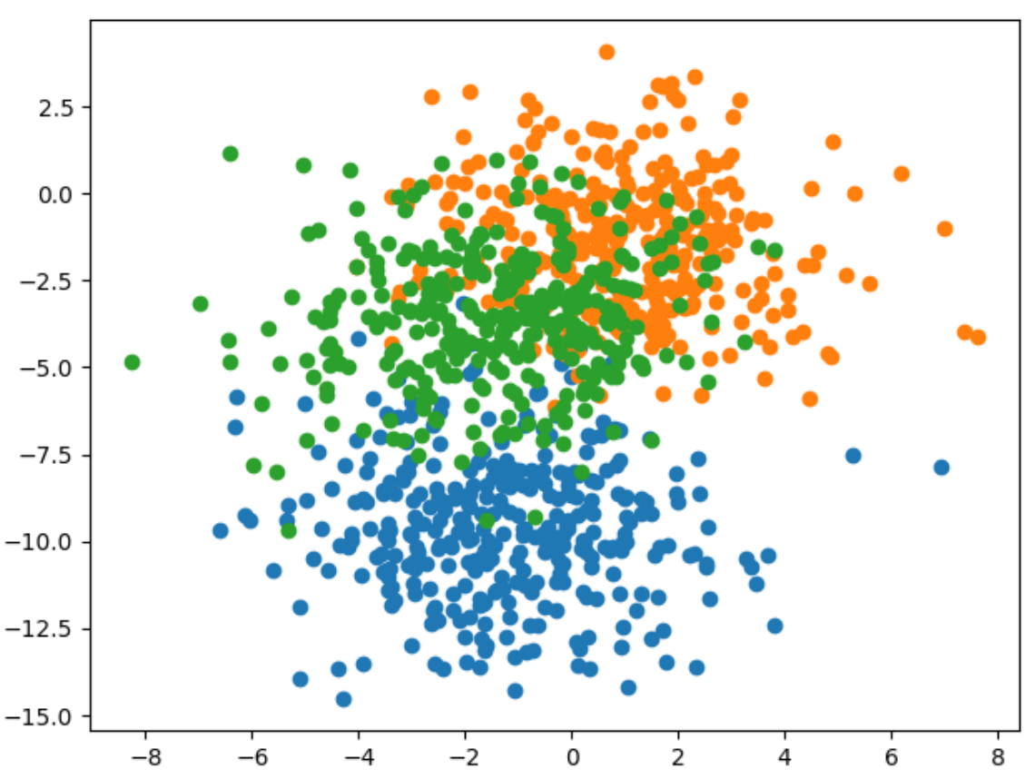

Here is the code that generates and displays the data for the example

|  |
| --- |
| # scatter plot of blobs dataset  from sklearn.datasets import make_blobs  from matplotlib import pyplot  from numpy import where  # generate 2d classification dataset  X, y = make_blobs(n_samples=1000, centers=3, n_features=2, cluster_std=2, random_state=2)  # scatter plot for each class value  for class_value in range(3):  # select indices of points with the class label  row_ix = where(y == class_value)  # scatter plot for points with a different color  pyplot.scatter(X[row_ix, 0], X[row_ix, 1])  # show plot  pyplot.show() |

*Example 7: Greedy Layer-wise Pretraining (See Chapter 20 of Better Deep Learning)*

Here is the entire code needed to implement greedy layer-wise pretraining.

|  |
| --- |
| from sklearn.datasets import make_blobs  from keras.layers import Dense  from keras.models import Sequential  from keras.optimizers import SGD  from keras.utils import to_categorical  import matplotlib.pyplot as plt  # Generate the data.  def prepare_data():  X, y = make_blobs(n_samples=1000, centers=3,  n_features=2, cluster_std=2, random_state=2)  y = to_categorical(y)  n_train = 500  trainX, testX = X[:n_train, :], X[n_train:, :]  trainy, testy = y[:n_train], y[n_train:]  return trainX, testX, trainy, testy  # Build the base model.  def get_base_model(trainX, trainy):  # Define the model.  model = Sequential()  model.add(Dense(10, input_dim=2, activation='relu',  kernel_initializer='he_uniform'))  model.add(Dense(3, activation='softmax'))  # Compile the model.  opt = SGD(lr=0.01, momentum=0.9)  model.compile(loss='categorical_crossentropy', optimizer=opt,  metrics=['accuracy'])  # Fit the model.  model.fit(trainX, trainy, epochs=100, verbose=0)  return model  stats = []  # Evaluate the model.  def evaluate_model(numLayers, model, trainX, testX, trainy, testy):  train_loss, train_acc = model.evaluate(trainX, trainy, verbose=1)  test_loss, test_acc = model.evaluate(testX, testy, verbose=1)  stats.append({ '# layers':numLayers, 'train_acc':train_acc, 'test_acc':test_acc,  'train_loss':train_loss, 'test_loss':test_loss })  # Add one new layer and re-train only the new layer.  def add_layer(model, trainX, trainy):  # Store the output layer.  output_layer = model.layers[-1]  # Remove the output layer.  model.pop()  # Mark all remaining layers as non-trainable.  for layer in model.layers:  layer.trainable = False  # Add a new hidden layer.  model.add(Dense(10, activation='relu', kernel_initializer='he_uniform'))  # Add the output layer back.  model.add(output_layer)  # fit model  model.fit(trainX, trainy, epochs=100, verbose=1)  return model  # Get the data and build the base model.  trainX, testX, trainy, testy = prepare_data()  model = get_base_model(trainX, trainy)  # Evaluate the base model  scores = dict()  evaluate_model(-1, model, trainX, testX, trainy, testy)  # add layers and evaluate the updated model  n_layers = 10  for i in range(n_layers):  model = add_layer(model, trainX, trainy)  evaluate_model(i, model, trainX, testX, trainy, testy)  import pandas as pd  columns = ['# layers', 'train_acc', 'test_acc', 'train_loss', 'test_loss']  df = pd.DataFrame(columns=columns)  for i in range(0, len(stats)):  df = df.append(stats[i], ignore_index=True)  print(df) |

The test accuracy appears to improve. The first row shows the full model with all layers when no greedy layer-wise pretraining is used. However, three rows with greedy layer-wise pretraining shows some slight improvement in accuracy.

|  |
| --- |
| # layers train_acc test_acc train_loss test_loss  0 -1.0 0.836 0.818 0.398433 0.413762  1 0.0 0.836 0.824 0.388216 0.407569  2 1.0 0.838 0.822 0.385031 0.411448  3 2.0 0.828 0.830 0.396971 0.411076  4 3.0 0.822 0.820 0.390866 0.409562  5 4.0 0.844 0.822 0.383811 0.418827  6 5.0 0.828 0.802 0.396735 0.437487  7 6.0 0.840 0.824 0.392394 0.433040  8 7.0 0.840 0.816 0.380537 0.412962  9 8.0 0.838 0.826 0.384223 0.426899  10 9.0 0.818 0.836 0.405867 0.413323 |

*Exercise 3 (4 marks)*

This code uses greedy layer-wise pretraining to add layers to a model which performs diabetes diagnosis classification.

|  |
| --- |
| from sklearn.datasets import make_blobs  from keras.layers import Dense  from keras.models import Sequential  from keras.optimizers import SGD  from keras.utils import to_categorical  import matplotlib.pyplot as plt  # Generate the data.  import tensorflow as tf  from sklearn.model_selection import train_test_split  import pandas as pd  def prepare_data():  PATH = "/Users/pm/Desktop/DayDocs/data/"  # load the dataset  df = pd.read_csv(PATH + 'diabetes.csv', sep=',')  # split into input (X) and output (y) variables  X = df[['Pregnancies', 'Glucose', 'BloodPressure', 'SkinThickness', 'Insulin', 'BMI',  'DiabetesPedigreeFunction', 'Age']]  y = df[['Outcome']]  # Split into train and test data sets.  X_train, X_test, y_train, y_test = train_test_split(X, y, test_size=0.33)  return X_train, X_test, y_train, y_test  # Build the base model.  def get_base_model(trainX, trainy):  # define the keras model  model = Sequential()  model.add(Dense(230, input_dim=8, activation='relu',  kernel_initializer='he_normal'))  model.add(Dense(1, activation='sigmoid'))  opitimizer = tf.keras.optimizers.SGD(  learning_rate=0.0005, momentum=0.9, name="SGD",  )  # Compile the keras model.  model.compile(loss='binary_crossentropy', optimizer=opitimizer,  metrics=['accuracy'])  # Fit the keras model on the dataset.  model.fit(trainX, trainy, epochs=200, batch_size=10)  return model  stats = []  # Evaluate the model.  def evaluate_model(numLayers, model, trainX, testX, trainy, testy):  train_loss, train_acc = model.evaluate(trainX, trainy, verbose=1)  test_loss, test_acc = model.evaluate(testX, testy, verbose=1)  stats.append({ '# layers':numLayers, 'train_acc':train_acc, 'test_acc':test_acc,  'train_loss':train_loss, 'test_loss':test_loss })  # Add one new layer and re-train only the new layer.  def add_layer(model, trainX, trainy):  # Store the output layer.  output_layer = model.layers[-1]  # Remove the output layer.  model.pop()  # Mark all remaining layers as non-trainable.  for layer in model.layers:  layer.trainable = False  # Add a new hidden layer.  model.add(Dense(230, activation='relu', kernel_initializer='he_uniform'))  # Add the output layer back.  model.add(output_layer)  # fit model  model.fit(trainX, trainy, epochs=300, verbose=1)  return model  # Get the data and build the base model.  trainX, testX, trainy, testy = prepare_data()  model = get_base_model(trainX, trainy)  # Evaluate the base model  scores = dict()  evaluate_model(-1, model, trainX, testX, trainy, testy)  # add layers and evaluate the updated model  n_layers = 14  for i in range(n_layers):  model = add_layer(model, trainX, trainy)  evaluate_model(i, model, trainX, testX, trainy, testy)  columns = ['# layers', 'train_acc', 'test_acc', 'train_loss', 'test_loss']  df = pd.DataFrame(columns=columns)  for i in range(0, len(stats)):  df = df.append(stats[i], ignore_index=True)  print(df) |

Run the code and find the optimal number of layers. Show the output here and highlight the optimal number of layers based on test accuracy:

|  |
| --- |
| # layers train_acc test_acc train_loss test_loss  0 -1.0 0.813230 0.673228 0.460823 1.275653  1 0.0 0.838521 0.712598 0.334927 1.142595  2 1.0 0.852140 0.728346 0.349439 1.315949  3 2.0 0.867704 0.720472 0.307426 1.065675  4 3.0 0.865759 0.736220 0.321653 0.940315  5 4.0 0.863813 0.688976 0.321372 1.031350  6 5.0 0.846304 0.716535 0.326061 0.956837  **7 6.0 0.852140 0.751969 0.321356 0.738948**  8 7.0 0.793774 0.665354 0.490491 0.861082  9 8.0 0.867704 0.732283 0.303628 0.773556  10 9.0 0.844358 0.688976 0.354361 0.779690  11 10.0 0.852140 0.720472 0.346199 0.749457  12 11.0 0.852140 0.708661 0.325519 0.793386  13 12.0 0.822957 0.700787 0.376356 0.871078  14 13.0 0.799611 0.669291 0.369450 0.908168  6 layers yields the highest test accuracy. |

*Exercise 4 (1 mark)*

Which line of code in Exercise 3 saves the output layer for use later?

|  |
| --- |
| Line 58:  output_layer = model.layers[-1] |

*Exercise 5 (1 mark)*

Which line of code in Exercise 3 adds the output layer that is stored in memory back onto the network.

|  |
| --- |
| Line 71:  model.add(output_layer) |

*Exercise 6 (1 mark)*

Which line of code in Exercise 3 removes the output layer so a new layer can be added?

|  |
| --- |
| Line 61:  model.pop() |

*Exercise 7 (1 mark)*

Which lines of code in Exercise 3 ensures that the previously added hidden layers cannot be adjusted?

|  |
| --- |
| Line 64/65:  for layer in model.layers:  layer.trainable = False |

*Exercise 8 (1 mark)*

Explain in your own words how greedy layer-wise pretraining works.

|  |
| --- |
| Greedy layer-wise pretraining lets individual layers build/fit without the previous layers affecting it by storing previous output layers then adding it to the list of output layers. |

**Table of Contents**

**Decision Trees 1**

Advantages 1

Disadvantages 1

**Decision Trees for Classification 1**

Calculating Gini Impurity 3

Determining the Property for the Left Branch 4

Calculating the Gini Impurity before the Node is Separated 6

Calculating the Gini Impurity Index for Chest Pain 6

Visualizing the Decision Tree 9

About the Gini Index / Gini Split 10

**Performing Linear Regression with a DecisionTreeRegressor 12**

Decision Trees

A decision tree is a supervised training algorithm for performing regression and classification.

The decision tree algorithm follows a decision path of an upside-down tree from the root to a leaf node.

Advantages

Decision trees can be used to classify non-linearly separable data. They are very fast and easy to understand compared to KNN and other classification algorithms. They can also be useful for imputing data.

Disadvantages

Decision trees can lead to over fitting. Decision trees also lose information when working with continuous variables.

Decision Trees for Classification

This initial discussion covers how to manually create a decision tree with the guidance of the Gini impurity index. The discussion is based heavily on Josh Stormer’s video at:

<https://www.youtube.com/watch?v=7VeUPuFGJHk>

*Example 1: Manually Building a Decision Tree*

In this example we are building a best classifier to determine if a person has heart disease. We will not actually use a data set but we have a high-level look at how to build the tree. Figure 1 shows a snapshot of the data set.

*Figure 1: Snapshot of the Heart Disease Dataset*

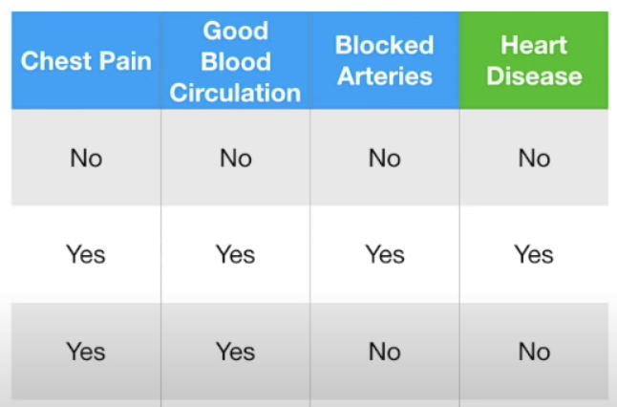

First, we will examine how to build a leaf node to classify heart disease with the ‘Chest Pain’ attribute (see Figure 2).

*Figure 2: Calculating Heart Disease Classification with Chest Pain*

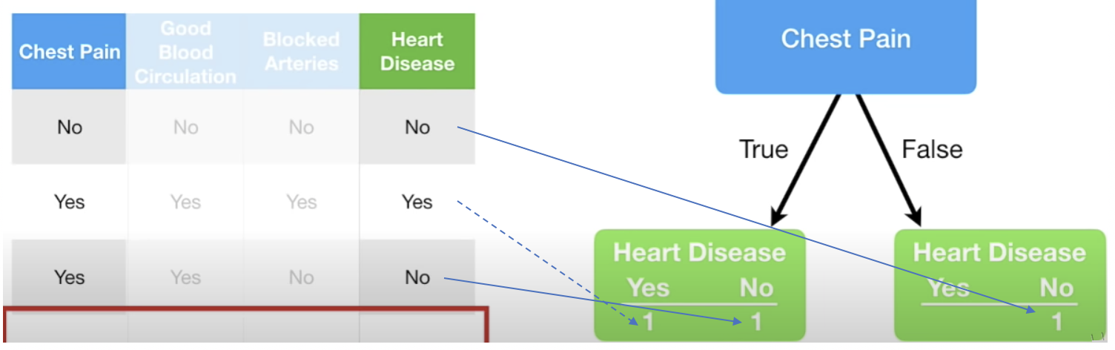

*Exercise 1 (3 marks)*

Given the data provided in Figure 2, add in the counts for categorizing heart disease based on Good Blood circulation. The numbers in the bottom row should add up to 3 if done correctly.

|  |  |  |  |
| --- | --- | --- | --- |
| Good Blood Circulation | | | |
| True | | False | |
| 1 | 1 | 1 |  |

While we do not have all of the data in the data set, if we did, the total sums of positive and negative heart disease diagnosis would appear in the leaves under the chest pain node in Figure 3.

*Figure 3: Heart Disease Classifications with Chest Pain*

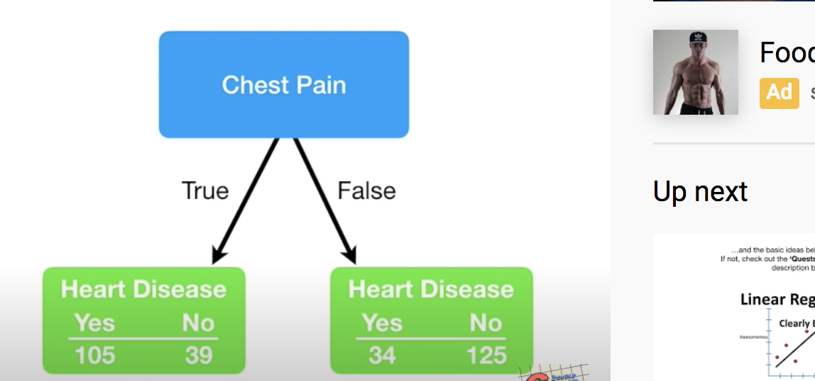

Similarly, we can calculate the heart disease classifications for blood circulation and blocked artery nodes like in Figure 4.

*Figure 4: Heart Disease totals with Blood Circulation and Blocked Arteries*

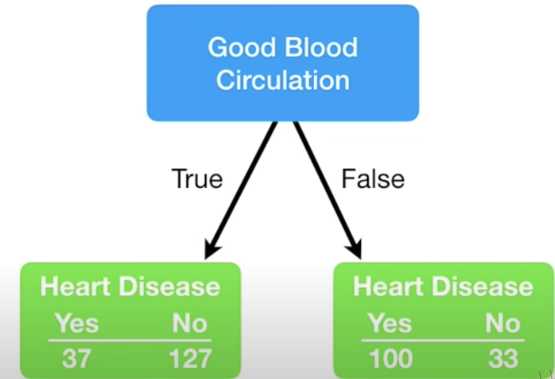 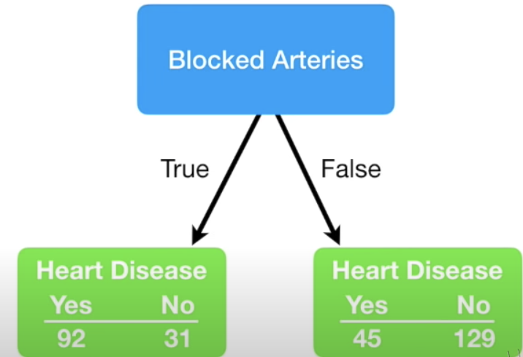

Based on the data provided for this problem, we can use chest pain, blood circulation and blocked arteries as classifying properties for heart disease. We now need to determine which property should be placed at the top of our tree. There are lots of ways to determine which property to select. We will use Gini impurity index to make this decision.

Calculating Gini Impurity

The lowest Gini impurity index helps to locate the best attribute to place at the top node. The Gini index is calculated as 1 – (P ${(Class1)}^{2}$ + P ${(Class2)}^{2}$ + … + P ${(ClassN)}^{2}$). The data in Figure 5 sets up the calculation for the Chest Pain node.

*Figure 5: Calculating Gini Impurity for Chest Pain*

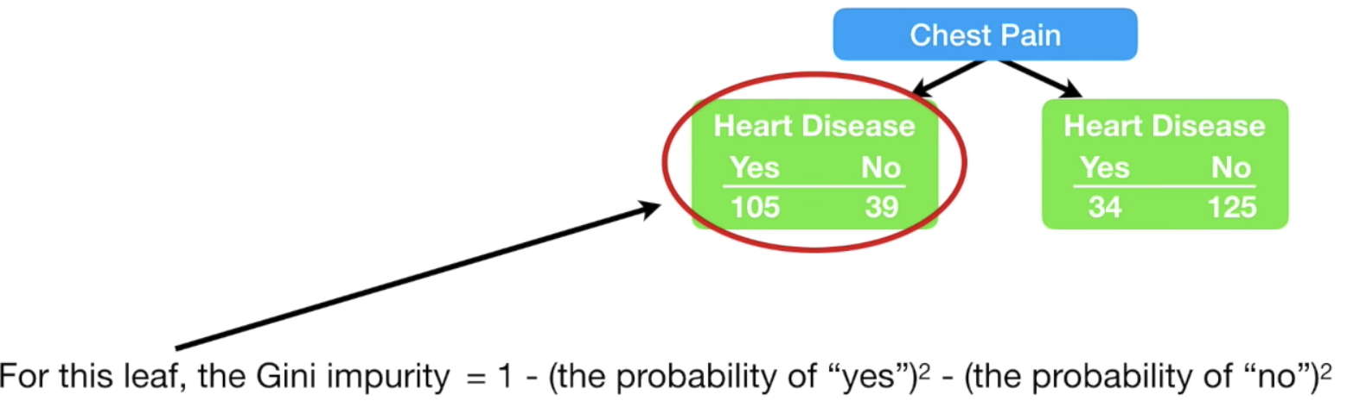

The Gini impurity for the leaf node on the left of Figure 5 is:

= 1 - ${(\frac{105}{105+39})}^{2}$- ${(\frac{39}{105+39})}^{2}$ = 0.395

The Gini impurity for the leaf node on the right branch of Figure 5 is:

= 1 - ${(\frac{34}{34+125})}^{2}$- ${(\frac{125}{34+125})}^{2}$ = 0.336

Next, we must add the weighted Gini impurity indexes for each branch. This calculation becomes:

Gini Impurity Index Chest Pain

= 0.395 $∙\frac{105+39}{105+39+34+125}$ + 0.336 $∙\frac{34+125}{105+39+34+125}$ = 0.395 $∙\frac{144}{303}$ + 0.336 $∙\frac{159}{303}$ = 0.36404

*Figure 6: Gini Impurity Indexes for Chest Pain, Good Blood Circulation, Blocked Arteries*

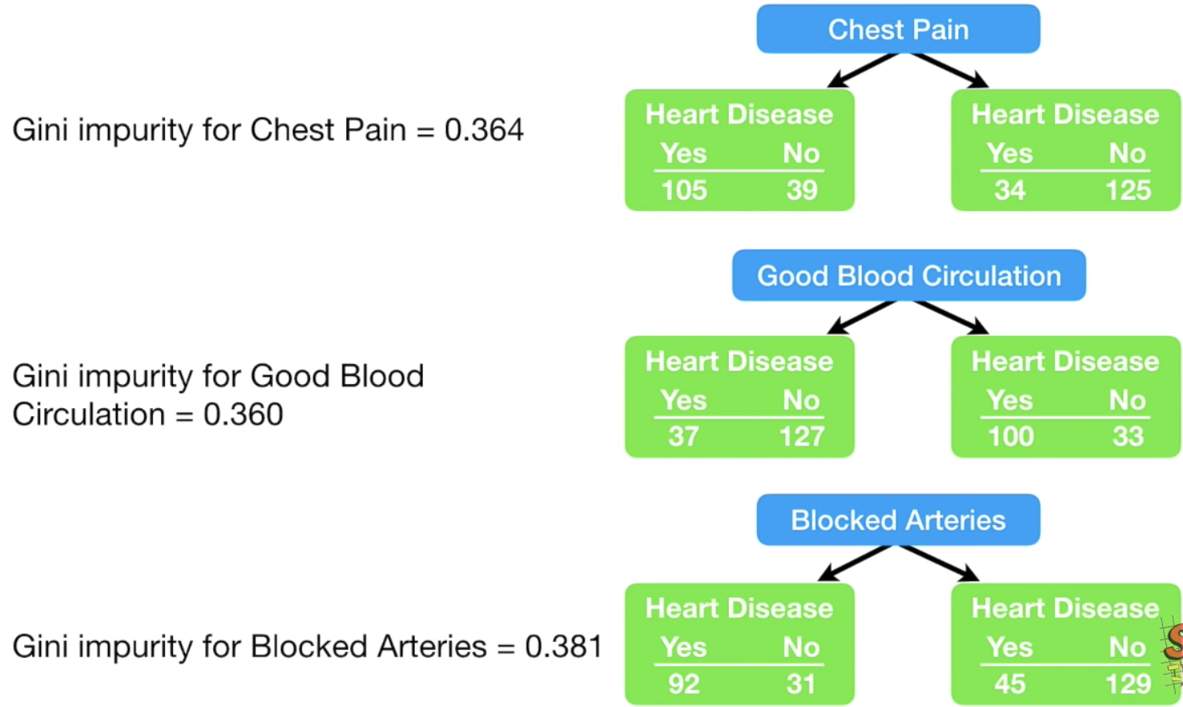

**Good Blood Circulation has the lowest Gini impurity**. It does the best job of separating candidates with or without heart disease. So, for this reason we will include good blood circulation at the top (root) of the decision tree.

*Exercise 2 (8 marks)*

Calculate the Gini impurity for good blood circulation. If done correctly the answer should be 0.360. Show your calculations here (you can take a screenshot if you prefer):

|  |
| --- |
| = 1 - ${(\frac{37}{37+127})}^{2}$- ${(\frac{127}{37+127})}^{2}$ = 0.349  =1 - ${(\frac{100}{100+33})}^{2}$- ${(\frac{33}{100+33})}^{2}$ = 0.373  == 0.349 $∙\frac{37+127}{37+127+100+33}$ + 0.373 $∙\frac{100+33}{37+127+100+33}$ = 0.360 |

Determining the Property for the Left Branch

Since Good Blood Circulation has the lowest Gini Impurity index, it is placed at the root of the tree in Figure 7.

*Figure 7: Viewing the Root and Two Branches*

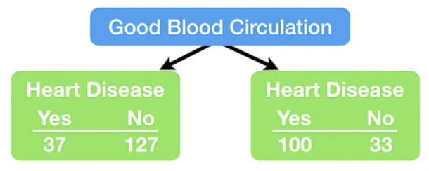

Since circulation is at the top of the tree, we need to figure out whether to use chest pain or blocked arteries to separate the leaf nodes in Figure 7. We will focus first on the left leaf node in Figure 7 to examine how to split it further. There are 164 rows of data to consider in the left branch. Figure 8 shows the Gini Impurity scores that would exist if we split the left node of Figure 7 either using chest pain or blocked arteries.

For the chest pain in Figure 8, the Gini impurity of the left node is calculated as

= 1 - ${(\frac{13}{13+98})}^{2}$- ${(\frac{98}{13+98})}^{2}$ = 0.2068

For the chest pain in Figure 8, the Gini impurity of the right node is calculated as

= 1 - ${(\frac{24}{24+29})}^{2}$- ${(\frac{29}{24+29})}^{2}$ = 0.49555

The weighted Gini impurity for chest pain in Figure 8 is:

0.2068 $∙\frac{13+98}{13+98+24+29}$ + 0.49555 $∙\frac{24+29}{13+98+24+29}$ = 0.2068 $∙\frac{111}{164}$ + 0.49555 $∙\frac{53}{164}$

= 0.1399683 + 0.1601473 = 0.30012

*Figure 8: Examining the Gini Impurity Indexes for the left node of Figure 7.*

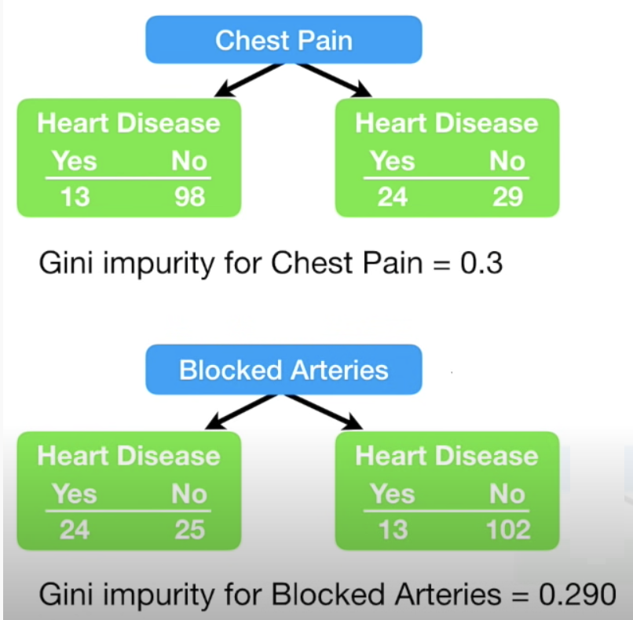

Since blocked arteries has the lowest Gini impurity index we will place it at the first left branch of the tree to separate patients (see Figure 9).

*Figure 9: Good Blood Circulation as Root and Blocked Arteries in the Left Branch*

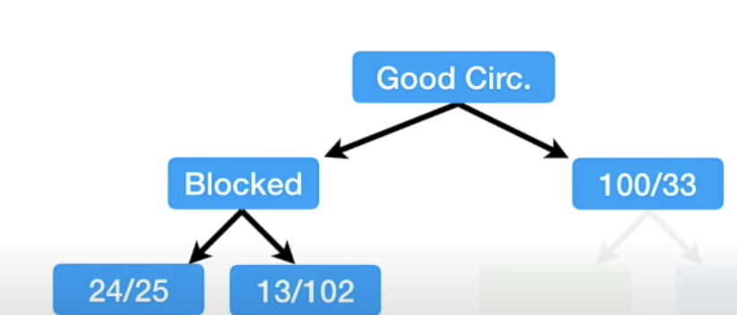

If we were to continue building the tree on the left we would only be able to consider if Chest Pain should be added as a branch under Blocked Artery to perform further classification of Heart Disease. See Figure 10.

*Figure 10: Adding Chest Pain to the bottom left node of the tree*

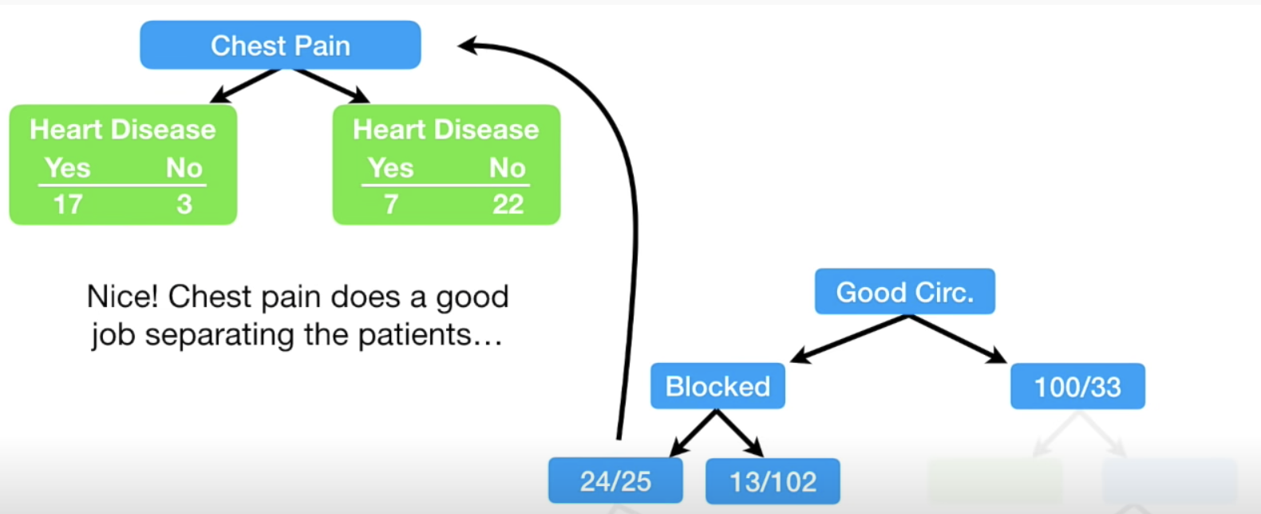

Calculating the Gini Impurity before the Node is Separated

$1- {(\frac{24}{24+25})}^{2}$ $-$ ${(\frac{25}{24+25})}^{2}$ = 0.4998

Calculating the Gini Impurity Index for Chest Pain

The Gini Impurity index for the left branch of Chest Pain in Figure 10 is:

$1- {(\frac{17}{17+3})}^{2}$ $-$ ${(\frac{3}{17+3})}^{2}$ = 0.255

The Gini Impurity index for the right branch of Chest Pain in Figure 10 is:

$1- {(\frac{7}{29})}^{2}$ $-$ ${(\frac{22}{29})}^{2}$ = 0.3662

The Gini Impurity index for Chest Pain is:

0.255 $∙\frac{17+3}{17+3+7+22}$ + 0.3662 $∙\frac{7+22}{17+3+7+22}$ = 0.3208

Since Chest Pain offers a lower Gini Impurity index we will add it to the left leaf of the tree as shown in Figure 11.

*Figure 11: Building Out Nodes of the Tree*

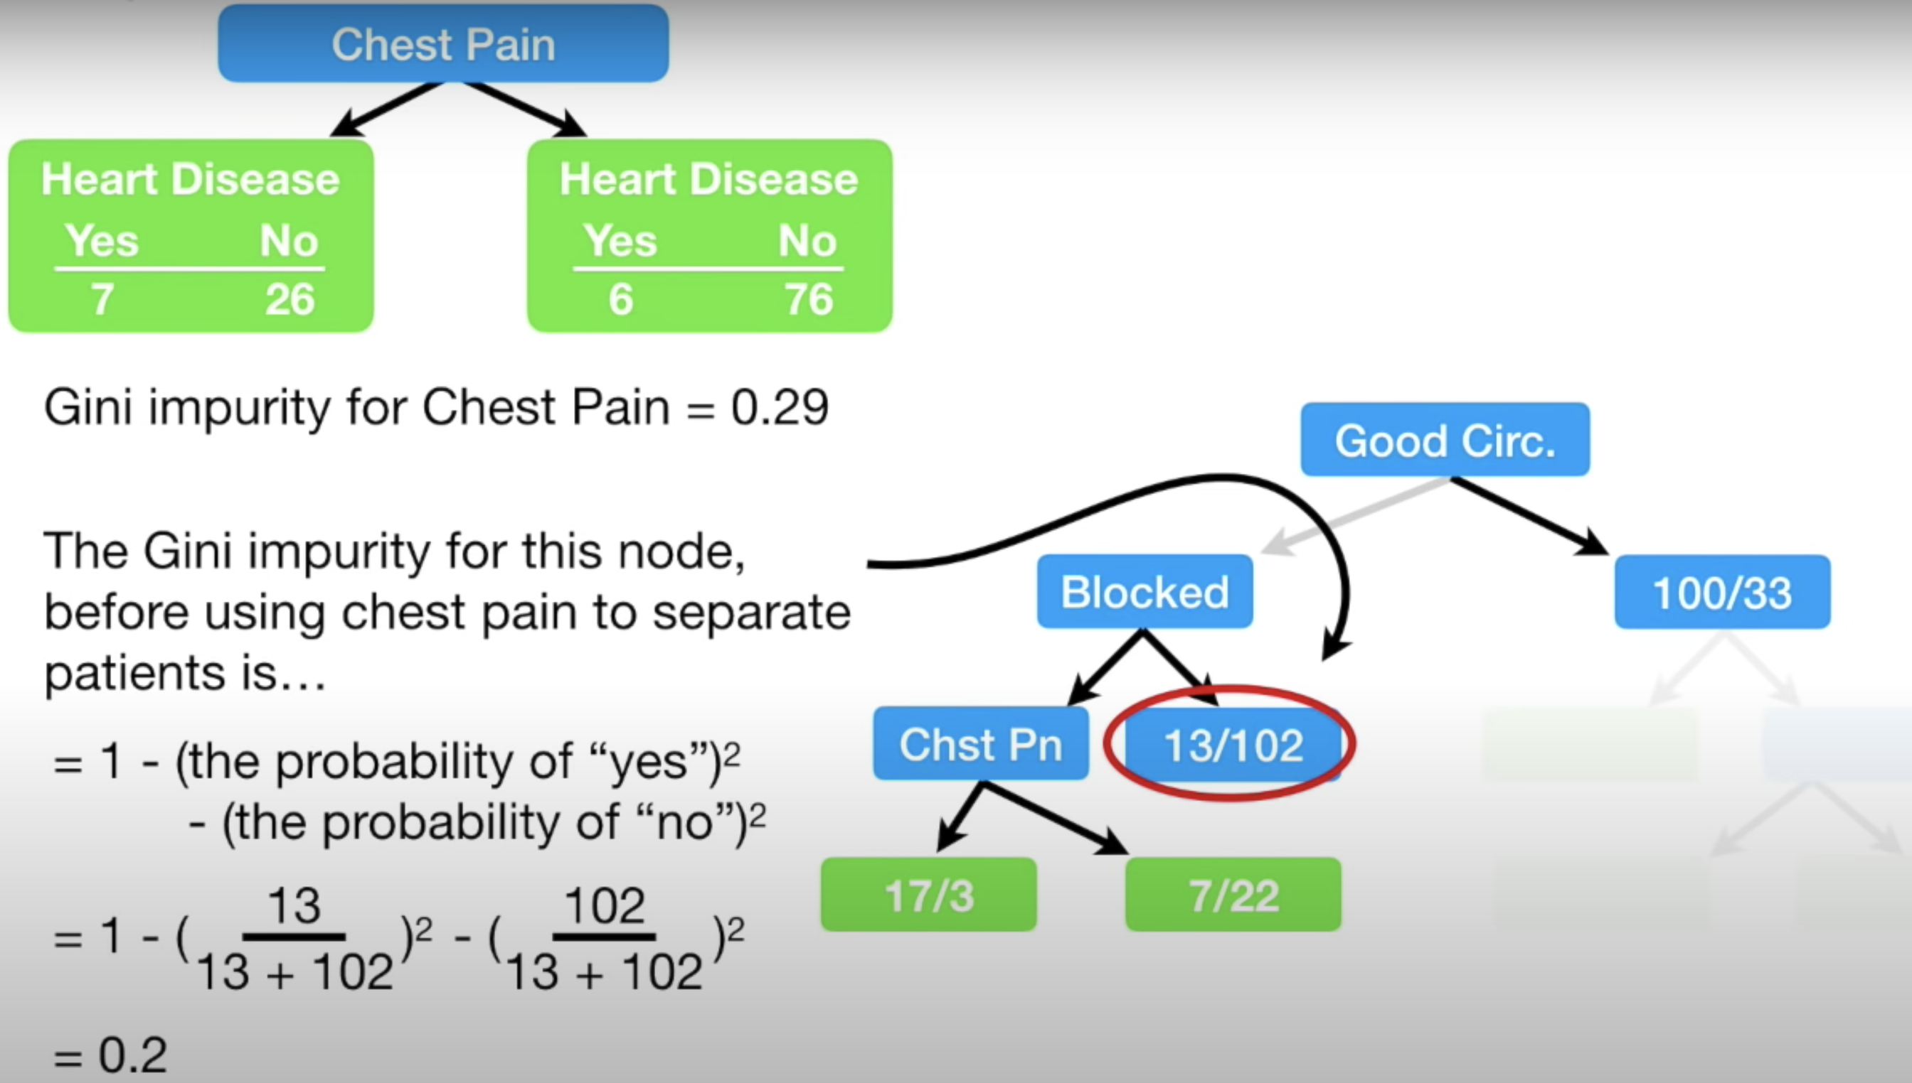

When calculating the Gini impurity index for the right side of the Blocked Artery node in Figure 11 we get 0.2. If we were to split on Chest Pain the Gini Impurity index would be 0.29 as shown in Figure 12. Since not splitting on Chest Pain offers a lower Gini Impurity index we will make the circled classification of heart disease in Figure 11 a leaf node.

*Figure 12: Calculating the Gini Impurity index at the bottom right of Blocked Arteries*

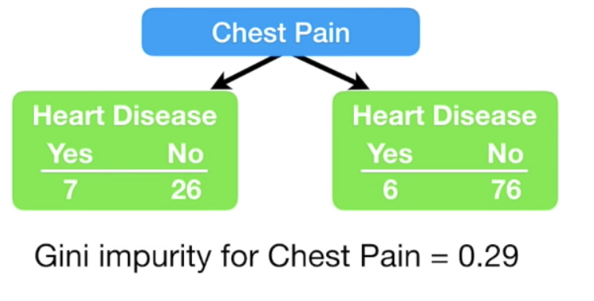

Figure 13 shows the completed tree.

*Figure 13: Completed Tree*

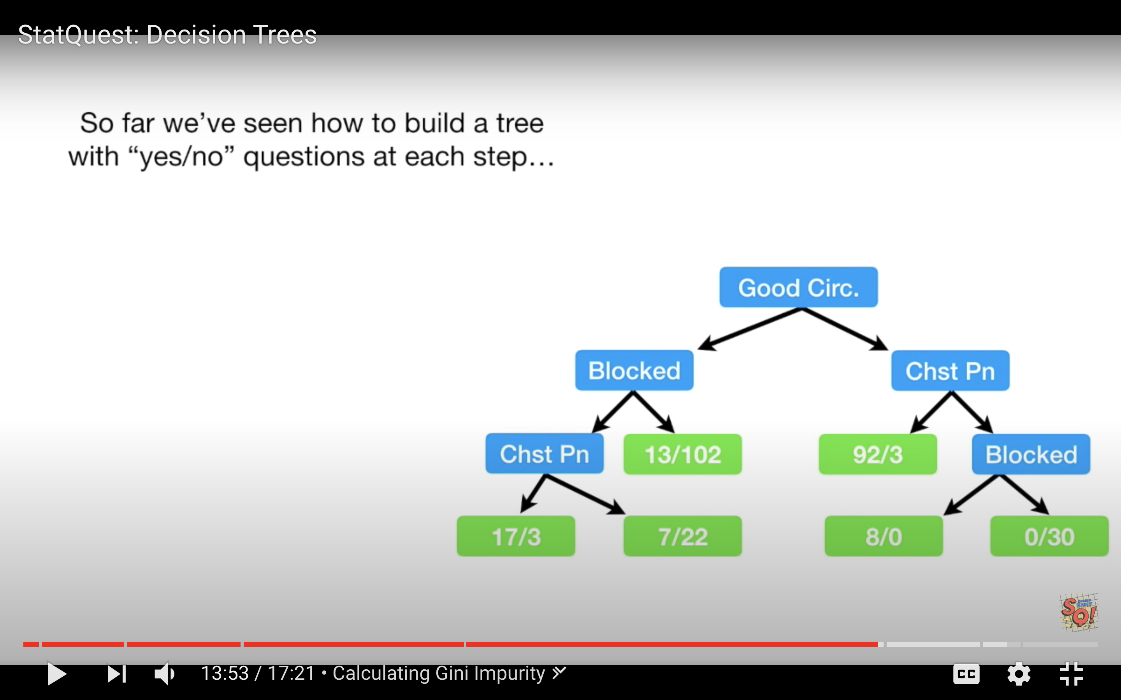

*Example 2: Decision Tree for Classification*

This example shows how to use decision trees to validate the authenticity of bank notes based on skewness of the wavelet transformed image, variance of the image, entropy of the image, and kurtosis of the image. Here is a sample of the data set:

|  |
| --- |
| Variance Skewness Kurtosis Entropy Class  0 3.62160 8.66610 -2.8073 -0.44699 0  1 4.54590 8.16740 -2.4586 -1.46210 0  ... ... ... ... ...  1367 0.40614 1.34920 -1.4501 -0.55949 1 |

By observing the scores in this case we can see the decision tree makes relatively accurate predictions.

|  |
| --- |
| Model Evaluation  [[146 11]  [ 14 104]]  Accuracy: 0.9090909090909091  Precision: 0.9043478260869565  Recall: 0.8813559322033898 |

Here is the code used the build **DecisionTreeClassifier** model to predict whether the bill is fraudulent or not. For this case we are setting the **max_depth** property to 2 so we can limit the depth of the tree.

|  |
| --- |
| import pandas as pd  import numpy as np  import matplotlib.pyplot as plt  PATH = "/Users/pm/Desktop/DayDocs/PythonForDataAnalytics/workingData/"  CSV = "bill_authentication.csv"  dataset = pd.read_csv(PATH + CSV)  X = dataset.drop('Class', axis=1)  y = dataset['Class']  print(dataset)  from sklearn.model_selection import train_test_split  X_train, X_test, y_train, y_test = train_test_split(X, y, test_size=0.20,  random_state=0)  from sklearn.tree import DecisionTreeClassifier  classifier = DecisionTreeClassifier(max_depth=2)  classifier.fit(X_train, y_train)  y_pred = classifier.predict(X_test)  from sklearn.metrics import classification_report, confusion_matrix  def showAccuracyScores(y_test, y_pred):  print("\nModel Evaluation")  cm = confusion_matrix(y_test, y_pred)  print(cm)  print("")  tn = cm[0][0]  fp = cm[0][1]  tp = cm[1][1]  fn = cm[1][0]  accuracy = (tp + tn)/(tn + fp + tp + fn)  precision = tp/(tp + fp)  recall = tp/(tp + fn)  print("Accuracy: " + str(accuracy))  print("Precision: " + str(precision))  print("Recall: " + str(recall))  showAccuracyScores(y_test, y_pred) |

Visualizing the Decision Tree

*Example 3: Visualizing the Decision Tree Model*

This example adds a visualization to observe the tree that is generated by the code in Example 2. Figure 14 shows the tree model. The nodes at the bottom are the leaves. The blue leaves represent cases where fraud occurred.

When a sample is perfectly classified the Gini index is 0. When looking at the tree you will notice the Gini index is higher at the root node and it is lower at the leaf nodes.

*Figure 14: Decision Tree for Predicting Fraud*

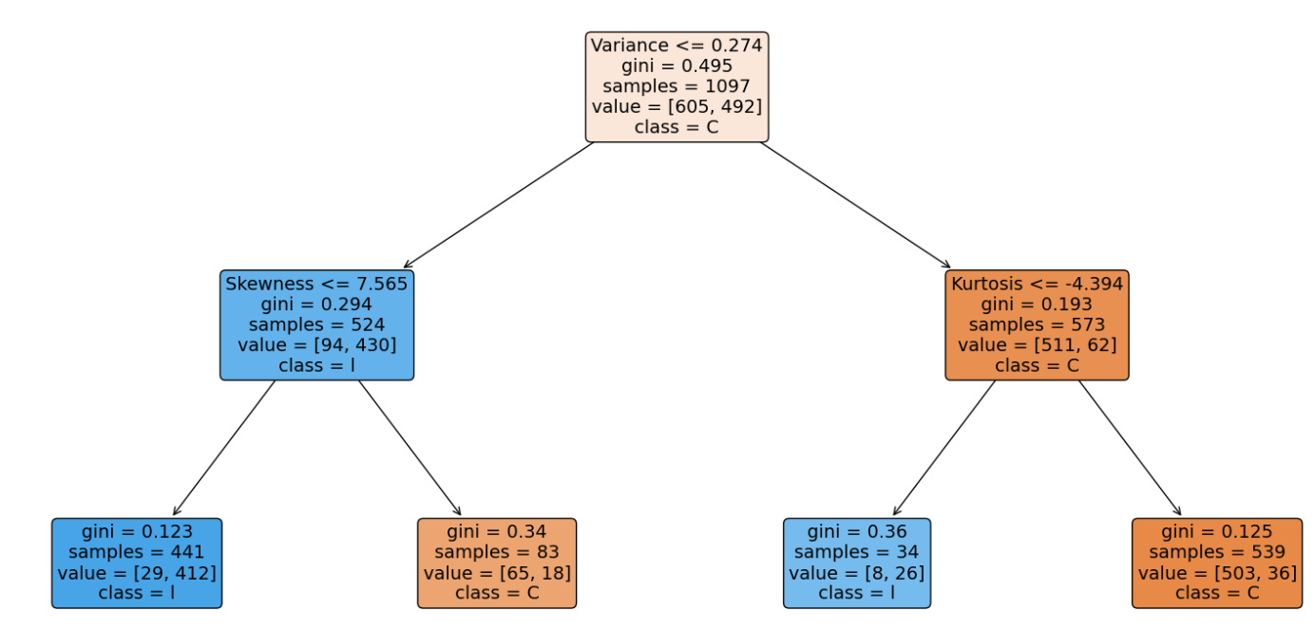

To build this example, add this code to the code in Example 2.

|  |
| --- |
| from sklearn.tree import plot_tree  fig, ax = plt.subplots(figsize=(20, 10))  plot_tree(classifier.fit(X_train, y_train), max_depth=4, fontsize=4)  a = plot_tree(classifier,  feature_names=['Variance', 'Skewness', 'Kurtosis', 'Entropy'],  class_names='Class',  filled=True,  rounded=True,  fontsize=14)  plt.show() |

*Example 4: Manually Implementing the Model*

When you examine the leaf nodes in Figure 14, keep in mind the blue nodes represent fraud and the orange nodes indicate that the bank note is valid.

*Figure 15: Leaf Nodes for Counterfeit Bank Note Classification*

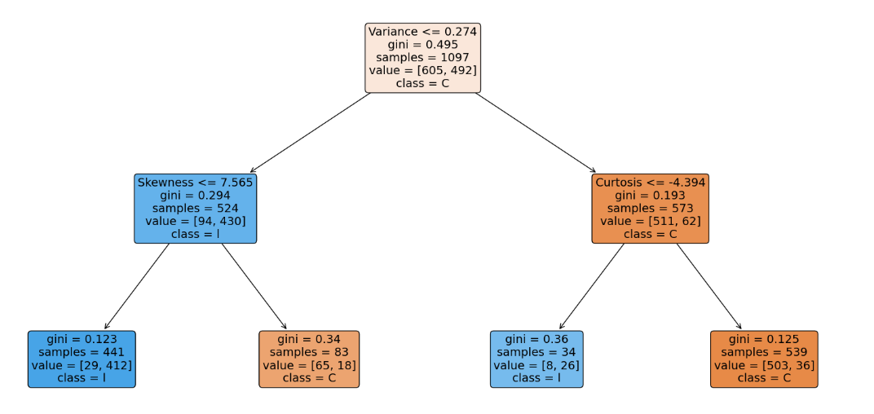

* The total number of fraudulent notes are 441 + 34 = 475.
* The total number of valid notes are 83 + 539 = 622

The information from the decision tree can be used to build the model. One way to verify the model is built correctly is to ensure the prediction counts from the training data match the summed prediction counts in the leaf nodes.

The following code reconstructs the tree manually and calculates the fraudulent and non-fraudulent counts with the training data. The output verifies the original predictions that are indicated in the decision tree output:

Zeros: 622

Ones: 475

|  |
| --- |
| import pandas as pd  PATH = "/Users/pm/Desktop/DayDocs/PythonForDataAnalytics/workingData/"  CSV = "bill_authentication.csv"  dataset = pd.read_csv(PATH + CSV)  X = dataset.drop('Class', axis=1)  y = dataset['Class']  from sklearn.model_selection import train_test_split  X_train, X_test, y_train, y_test = train_test_split(X, y,  test_size=0.20, random_state=0)  def manuallyClassify(X,y):  predictions=[]  ones = 0  zeros = 0  for i in range(0,len(X)):  if(X.iloc[i]['Variance'] <= 0.274): # Blue  if(X.iloc[i]['Skewness'] <= 7.565):  ones +=1 #Blue  else:  zeros +=1  else:  if(X.iloc[i]['Kurtosis'] <= -4.394):  ones += 1 # Blue  else:  zeros += 1  print("Zeros: " + str(zeros))  print("Ones: " + str(ones))  manuallyClassify(X_train,y_train)  print(len(X_train)) |

*Exercise 3 (1 mark)*

Is the Gini index in the leaf nodes higher or lower than the gini index in the nodes that are closer to the root?

1. Higher b) Lower

*Exercise 4 (10 marks)*

Starting with the following code, build a decision tree to predict if breast cancer is malignant with a depth of 2. Output the decision tree plot and show the accuracy, precision and recall scores.

|  |
| --- |
| import sklearn.datasets as datasets  from sklearn.tree import DecisionTreeClassifier  from sklearn.tree import plot_tree  import matplotlib.pyplot as plt  # check for the sklearn version, it has to be 0.21  import sklearn  print(sklearn.__version__)  breast_cancer = datasets.load_breast_cancer()  from sklearn.model_selection import train_test_split  X_train, X_test, y_train, y_test = train_test_split(  breast_cancer.data, breast_cancer.target, test_size=0.20,  random_state=0) |

Show your code here:

|  |
| --- |
| import sklearn.datasets as datasets from sklearn.tree import DecisionTreeClassifier from sklearn.tree import plot_tree import matplotlib.pyplot as plt import matplotlib matplotlib.use('TkAgg')  # check for the sklearn version, it has to be 0.21 import sklearn print(sklearn.__version__) breast_cancer = datasets.load_breast_cancer()  from sklearn.model_selection import train_test_split X_train, X_test, y_train, y_test = train_test_split(  breast_cancer.data, breast_cancer.target, test_size=0.20,  random_state=0)  from sklearn.tree import DecisionTreeClassifier classifier = DecisionTreeClassifier(max_depth=2) classifier.fit(X_train, y_train)  y_pred = classifier.predict(X_test)  from sklearn.metrics import classification_report, confusion_matrix  def showAccuracyScores(y_test, y_pred):  print("\nModel Evaluation")  cm = confusion_matrix(y_test, y_pred)  print(cm)  print("")  tn = cm[0][0]  fp = cm[0][1]  tp = cm[1][1]  fn = cm[1][0]  accuracy = (tp + tn)/(tn + fp + tp + fn)  precision = tp/(tp + fp)  recall = tp/(tp + fn)  print("Accuracy: " + str(accuracy))  print("Precision: " + str(precision))  print("Recall: " + str(recall))  showAccuracyScores(y_test, y_pred)  from sklearn.tree import plot_tree fig, ax = plt.subplots(figsize=(20, 10))  plot_tree(classifier.fit(X_train, y_train), max_depth=4, fontsize=4) a = plot_tree(classifier,  # feature_names=['Variance', 'Skewness', 'Kurtosis', 'Entropy'],  class_names='Breast Cancer',  filled=True,  rounded=True,  fontsize=14) plt.show() |

Show the accuracy, decision and recall scores here:

|  |
| --- |
|  |

Show the decision tree plot here:

|  |
| --- |
|  |

Performing Linear Regression with a DecisionTreeRegressor

It is possible to perform regression with a DecisionTreeRegressor. This may not seem so interesting now but it will offer a useful approach that can compete with other algorithms. Next week we will examine how to implement decision trees in random forests.

*Example 6: Decision Tree for Regression (Predicting Gas Consumption)*

This example demonstrates how to use decision trees to predict gasoline consumption. This is a sample of the data set:

|  |
| --- |
| Petrol_tax Average_income Paved_Highways Population_Driver_licence(%) Petrol_Consumption  0 9.00 3571 1976 0.525 541  1 9.00 4092 1250 0.572 524 |

The output shows that the predictions have a relatively decent accuracy.

|  |
| --- |
| Actual versus predicted values  Actual Predicted  29 534 541.0  4 410 414.0  26 577 574.0  …  Mean Absolute Error: 50.8  Mean Squared Error: 5065.0  Root Mean Squared Error: 71.16881339463234 |

Here is the code:

|  |
| --- |
| import pandas as pd  import numpy as np  import matplotlib.pyplot as plt  PATH = "/Users/pm/Desktop/DayDocs/PythonForDataAnalytics/workingData/"  CSV = "petrol_consumption.csv"  df = pd.read_csv(PATH + CSV)  # Show all columns.  pd.set_option('display.max_columns', None)  # Increase number of columns that display on one line.  pd.set_option('display.width', 1000)  X = df.drop('Petrol_Consumption', axis=1)  y = df['Petrol_Consumption']  print(df)  from sklearn.model_selection import train_test_split  X_train, X_test, y_train, y_test = train_test_split(X, y, test_size=0.2, random_state=0)  from sklearn.tree import DecisionTreeRegressor  regressor = DecisionTreeRegressor()  regressor.fit(X_train, y_train)  y_pred = regressor.predict(X_test)  df=pd.DataFrame({'Actual':y_test, 'Predicted':y_pred})  print("\nActual versus predicted values")  print(df)  from sklearn import metrics  print('Mean Absolute Error:', metrics.mean_absolute_error(y_test, y_pred))  print('Mean Squared Error:', metrics.mean_squared_error(y_test, y_pred))  print('Root Mean Squared Error:',  np.sqrt(metrics.mean_squared_error(y_test, y_pred))) |

**Table of Contents**

**Recurrent Neural Networks (RNNs) 1**

Sequential Data 1

Learning Sequences 2

Hidden State 2

**Long Short-Term Memory Networks 2**

**Multilayer LSTM’s 5**

Long Short-Term Memory 7

**Tokenizing and Sequencing Sentences 8**

**Long Short-Term Memory Terminology 9**

Embedding Layer 9

LSTM Layers 10

**Further Improvements 13**

Recurrent Neural Networks (RNNs)

This initial discussion about RNNs is based on the video at <https://www.youtube.com/watch?v=LHXXI4-IEns>

Sequential Data

Recurrent neural networks help to explain sequential data. For example, when trying to predict the direction of a moving ball, it is difficult to know with only the current position. Figure 1 shows a snapshot of the ball at its current position.

*Figure 1: Current Snapshot of a Ball*



To improve your accuracy, you need where the ball has been. Figure 2 shows several snapshots of the ball’s historical positions in succession.

*Figure 2: Sequence of Ball Positions*



Sequence data can be obtained and stored in many different ways. For example, audio files contain wave data which is sequential.

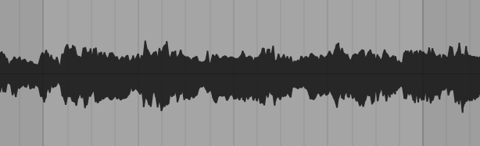

Words also follow a sequence. If you only read the words “the beach” you have no context about why “the beach” is mentioned. A more complete sentence with leading words provides more detail.

Mocha and Cocoa went to the beach.

In all sequential cases if we understand what occurred earlier we can better understand the current context.

Learning Sequences

Learning sequences can help with understanding. For example, if you were asked to list the letters of the alphabet you could very quickly recall the letters in a typical order. If you were asked to list the letters of the alphabet in reverse order you would probably pause and walk through those steps more slowly. However, an alternate sequence can be learned to make the task easier.

Hidden State

RNN’s include a hidden state to reference previous inputs. Figure 3 shows 5 steps to understand the meaning behind “What time is it?”. At the first step, the word “what” is read. At the second step, the word “time” is read and “what” is contained in a hidden state. In the third step, “is” is read and the previous two words are stored in the hidden state. By step 5, the representation of the initial states is significantly weighted less. As the RNN processes more steps it has difficulty retaining information from previous steps. Short term memory and vanishing gradients can often make it challenging for RNN’s to model with sequential data.

*Figure 3: Tracking Hidden States with RNN’s*

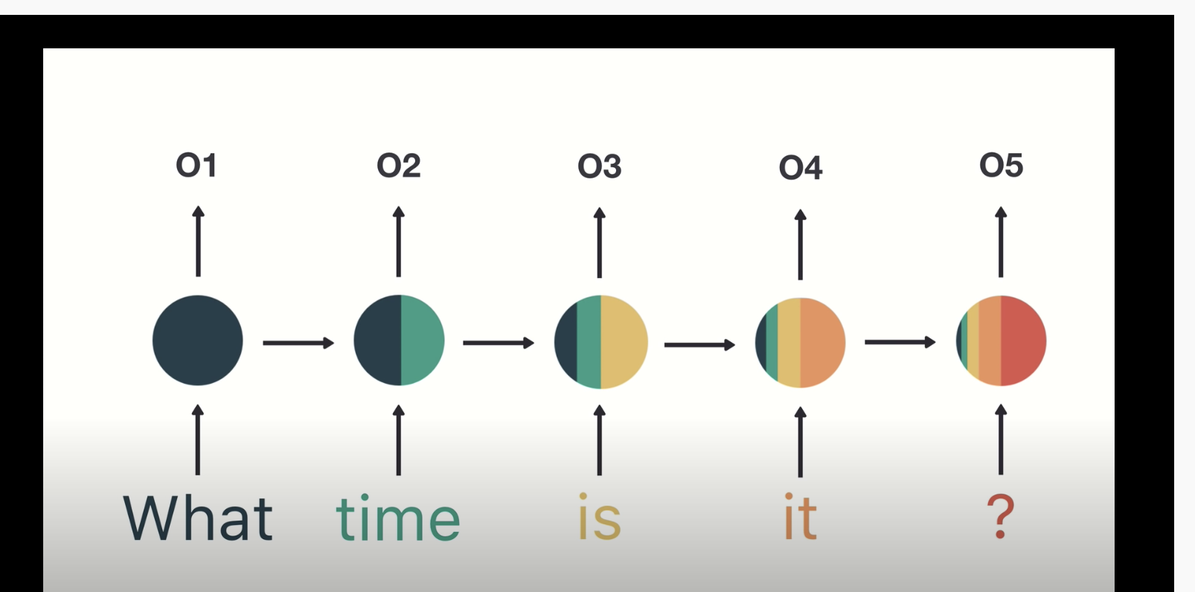

Long Short-Term Memory Networks

LSTM’s were developed to overcome problems with RNN’s. LSTM’s use gates which perform operations to learn what to store in memory.

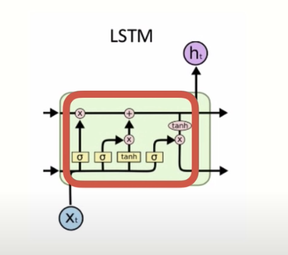

LSTM’s are computationally more expensive than RNN’s but LSTM’s can offer significant improvement to manage context about sequences. The result though is LSTM’s can be very slow to train.

*Example 1: Single Layer LSTM*

(This example is based on chapter 6 from Long Short Term Memory Networks by Dr. Jason Brownlee)

As mentioned earlier, LSTM’s use gates to determine what to store in memory. This example trains on samples of five numbers that range between 0 and 9. The numbers are one-hot-encoded so:

[5, 8, 3, 0, 9]

Becomes

# [[0, 0, 0, 0, 0, 1, 0, 0, 0, 0]

# [0, 0, 0, 0, 0, 0, 0, 0, 1, 0]

# [0, 0, 0, 1, 0, 0, 0, 0, 0, 0] # Third element where index = 2

# [1, 0, 0, 0, 0, 0, 0, 0, 0, 0]

# [0, 0, 0, 0, 0, 0, 0, 0, 0, 1]]

The target variable during training is always represented by the third element. In other words, y = 3 for this case. When the model is trained it will almost always pick the second element:

The code that creates the model and updates the weights is highlighted in green.

Here is the full program:

|  |
| --- |
| from random import randint  from numpy import array  from numpy import argmax  from keras.models import Sequential  from keras.layers import LSTM  from keras.layers import Dense  NUM_FEATURES = 10  NUM_SAMPLES = 5  TARGET_INDEX = 2  NUM_WEIGHT_UPDATES = 100  # generate array of 5 numbers like [5, 8, 3, 0, 9].  # each number is >=0 and <10  def generate_sequence():  return [randint(0, NUM_FEATURES-1) for _ in range(NUM_SAMPLES)]  # one hot encode sequence  def oneHotEncode(sequence):  encoding = list()  # Convert [5, 8, 3, 0, 9]  # to  # [[0, 0, 0, 0, 0, 1, 0, 0, 0, 0]  # [0, 0, 0, 0, 0, 0, 0, 0, 1, 0]  # [0, 0, 0, 1, 0, 0, 0, 0, 0, 0]  # [1, 0, 0, 0, 0, 0, 0, 0, 0, 0]  # [0, 0, 0, 0, 0, 0, 0, 0, 0, 1]]  for value in sequence:  # Create vector of zeros.  vector = [0 for _ in range(NUM_FEATURES)]  vector[value] = 1 # Add 1 to vector.  encoding.append(vector)  return array(encoding)  # decode a one hot encoded string  def oneHotDecode(encoded_seq):  # gets index of element with the maximum value.  return [argmax(vector) for vector in encoded_seq]  # generate one example for an lstm  def generateSample(targetIndex):  # generate sequence such as [5, 8, 3, 0, 9]  sequence = generate_sequence()  # one hot encode sequence so [5, 8, 3, 0, 9] becomes  # [[0, 0, 0, 0, 0, 1, 0, 0, 0, 0]  # [0, 0, 0, 0, 0, 0, 0, 0, 1, 0]  # [0, 0, 0, 1, 0, 0, 0, 0, 0, 0]  # [1, 0, 0, 0, 0, 0, 0, 0, 0, 0]  # [0, 0, 0, 0, 0, 0, 0, 0, 0, 1]]  encoded = oneHotEncode(sequence)  # reshape sequence to be 3D  X = encoded.reshape((1, NUM_SAMPLES, NUM_FEATURES))  # y becomes second element.  # [0, 0, 0, 1, 0, 0, 0, 0, 0, 0]  y = encoded[targetIndex].reshape(1, NUM_FEATURES)  return X, y  # define model  model = Sequential()  model.add(LSTM(25, input_shape=(NUM_SAMPLES, NUM_FEATURES)))  model.add(Dense(NUM_FEATURES, activation='softmax'))  # Our output is a one-hot encoded vector so use categorical  # crossentropy.  model.compile(loss='categorical_crossentropy',  optimizer='adam', metrics=['accuracy'])  model.summary()  for i in range(10000):  trainX, trainy = generateSample(TARGET_INDEX)  # Update model - weights are updated and are not reset.  model.fit(trainX, trainy, epochs=1, verbose=2)  # evaluate model  correct = 0  NUM_EVALUATIONS = 100  for i in range(NUM_EVALUATIONS):  X, y = generateSample(TARGET_INDEX)  yhat = model.predict(X)  if oneHotDecode(yhat) == oneHotDecode(y):  correct += 1  print('Accuracy: %f' % ((correct / NUM_EVALUATIONS))) |

*Exercise 1 (1 mark)*

When model.fit() is called, indicate if the weights are updated or reset.

1. Updated b) Reset

Multilayer LSTM’s

Multilayer LSTM’s have additional memory cells and each layer helps to boost performance by solving different parts of the problem.

*Example 2: Multilayer LSTM*

(This example is based on chapter 7 from Long Short Term Memory Networks by Dr. Jason Brownlee)

This example shows how a multi-layer LSTM can help to predict the next step in a sine wave sequence.

Samples used for this example include sets of sine waves that are defined by 55 points each. The first 50 points in the sequence define X. The last five points in the sequence are held back for y.

*Figure 4: Three sequential sine wave samples. The first 50 points are X. The last 5 points are y.*

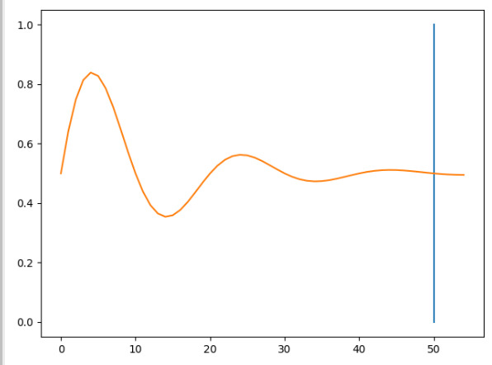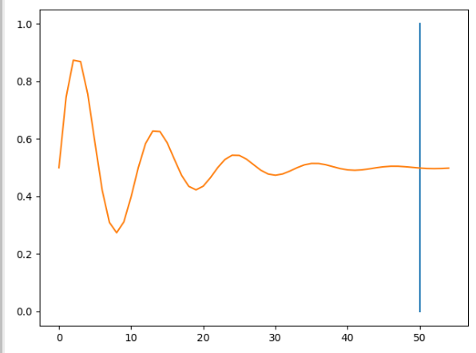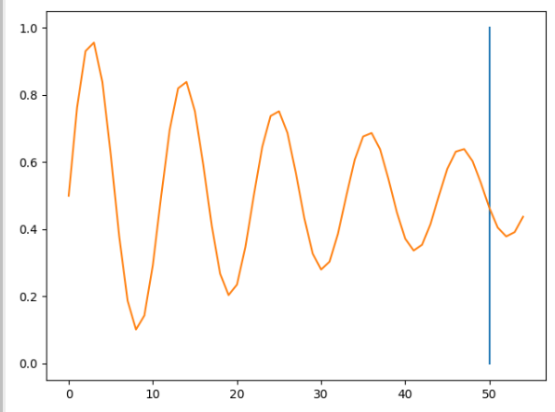

The fitted model tries to predict the next five steps in the sequence.

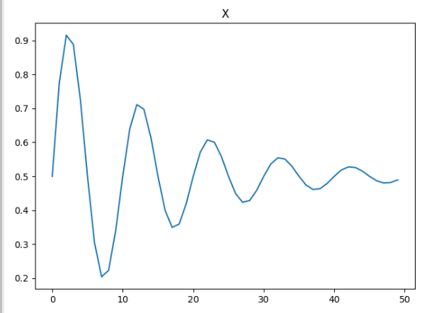 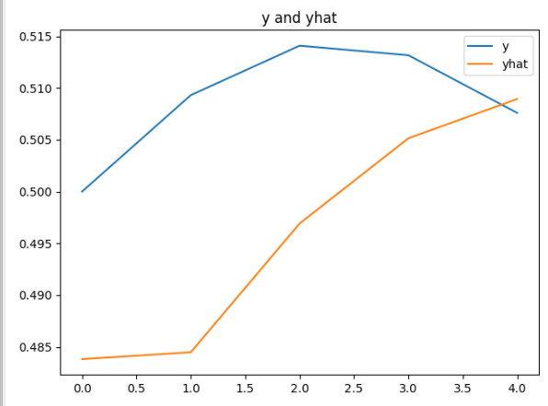

Here is the code:

|  |
| --- |
| from math import sin  from math import pi  from math import exp  from random import randint  from random import uniform  from numpy import array  from matplotlib import pyplot  from keras.models import Sequential  from keras.layers import LSTM  from keras.layers import Dense  # generate damped sine wave in [0,1]  def generate_sequence(length, period, decay):  return [0.5 + 0.5 * sin(2 * pi * i / period) * exp(-decay * i) \  for i in range(length)]  # generate input and output pairs of damped sine waves  def generate_examples(input_len, n_patterns, output_len):  X, y = list(), list()  for _ in range(n_patterns):  p = randint(10, 20)  d = uniform(0.01, 0.1)  sequence = generate_sequence(input_len + output_len, p, d)  X.append(sequence[:-output_len])  y.append(sequence[-output_len:]) # Assigns next 5 values in sequence.  X = array(X).reshape(n_patterns, input_len, 1)  y = array(y).reshape(n_patterns, output_len)  return X, y  # configure problem  INPUT_LEN = 50  OUTPUT_LEN = 5  # define model  model = Sequential()  model.add(LSTM(20, input_shape=(INPUT_LEN, 1)))  model.add(Dense(OUTPUT_LEN))  model.compile(loss='mae', optimizer='adam')  model.summary()  # fit model  X, y = generate_examples(INPUT_LEN, 10000, OUTPUT_LEN)  history = model.fit(X, y, batch_size=10, epochs=1)  # evaluate model  X, y = generate_examples(INPUT_LEN, 1000, OUTPUT_LEN)  loss = model.evaluate(X, y, verbose=0)  print('Mean squared error: %f' % loss)  print("\n*** Make predictions")  for i in range(0, 5):  # prediction on new data  X, y = generate_examples(INPUT_LEN, 1, OUTPUT_LEN)  yhat = model.predict(X, verbose=0)  pyplot.title("Y and Yhat")  pyplot.plot(y[0], label='y')  pyplot.plot(yhat[0], label='yhat')  pyplot.legend()  pyplot.show() |

Long Short-Term Memory

LSTM’s were developed to overcome problems with RNN’s. LSTM’s use gates which perform operations to learn what to store in memory.



LSTM’s are computationally more expensive than RNN’s but LSTM’s can offer significant improvement to manage context about sequences. The result though is LSTM’s can be very slow to train.

Tokenizing and Sequencing Sentences

We are going to look at LSTM’s to predict sentiment so we will take a moment first to discuss tokenization.

*Example 3: Tokenizing and Sequencing Sentences*

We are going to use LSTM’s to predict sentiment. Before we do though we are going to take a moment to understand how the words are converted to numeric vectors for modelling.

Starting with the following sentences:

"This is not yellow."

"This is a blue moon."

"Hello all."

texts_to_sequences()converts the sentences sets of integers:

[[1, 2, 3, 4],

[1, 2, 5, 6, 7],

[8, 9]]

The vectors are then padded with zeros so all sentence vectors are the same size. The first sentence vector represents four words. The second sentence vector represents five words. The third sentence vector represents two words.

|  |
| --- |
| array([[0, 1, 2, 3, 4],  [1, 2, 5, 6, 7],  [0, 0, 0, 8, 9]], dtype=int32) |

Here is all of the code which performs the transformation for the sentences. This code converts the code into a vertical array of features. We end up with is a vertical array of numerical features which is ideal input for a neural network.

|  |
| --- |
| from keras.preprocessing.text import Tokenizer  from keras_preprocessing.sequence import pad_sequences  sentence1 = "This is not yellow."  sentence2 = "This is a blue moon."  sentence3 = "Hello all."  sentences = [sentence1, sentence2, sentence3]  # Restrict tokenizer to use top 2500 words.  tokenizer = Tokenizer(num_words=2500, lower=True,split=' ')  tokenizer.fit_on_texts(sentences)  # Convert to sequence of integers.  X = tokenizer.texts_to_sequences(sentences)  print(X)  # Showing padded sentences:  paddedX = pad_sequences(X)  print(paddedX) |

*Exercise 2 (2 marks)*

Just for fun, tokenize and pad the following sentences with your first and last name in it. Use three or more sentences such as:

YourFirstName Yourlastname is prepared to succeed.

YourFirstName Yourlastname sees opportunity in every challenge.

To get the mark, you must use your first and last name but if you want you can change the sentences. Show your code here:

|  |
| --- |
| from keras.preprocessing.text import Tokenizer from keras_preprocessing.sequence import pad_sequences  sentence1 = "Hyerim Shin is prepared to succeed." sentence2 = "Hyerim Shin sees opportunity in every challenge." sentence3 = "Hyerim Shin says Hello all." sentences = [sentence1, sentence2, sentence3]  # Restrict tokenizer to use top 2500 words. tokenizer = Tokenizer(num_words=2500, lower=True,split=' ') tokenizer.fit_on_texts(sentences)  # Convert to sequence of integers. X = tokenizer.texts_to_sequences(sentences) print(X)  # Showing padded sentences: paddedX = pad_sequences(X) print(paddedX) |

Show your final output after tokenizing and padding here. Highlight the numbers which represent your first and last name.

|  |
| --- |
|  |

Long Short-Term Memory Terminology

We are not going to dive into the math or logic that enables an LSTM network but I will discuss some high-level definitions here before we build an LSTM model in code.

Embedding Layer

Embedding layers are used in sentiment problems to store weights for words. Related words are geometrically closer such as dinner and kitchen. Words such as glacier and coconut are likely geometrically far apart. During a forward pass words are referenced in this layer to get a particular embedding. During a backward pass gradients are included in this layer.

LSTM Layers

LSTM layers define cells for managing hidden states while iterating through different time steps. You have flexibility to adjust these values. Usually LSTM layers are accompanied with drop out layers.

*Example 4: LSTM for Sentiment Analysis*

This example predicts sentiment for yelp reviews. It predicts based on this example.

<https://towardsdatascience.com/understanding-lstm-and-its-quick-implementation-in-keras-for-sentiment-analysis-af410fd85b47>

I used a smaller file called yelp_mini.csv to save time while tuning the hyperparameters. A larger yelp_review.csv file is in the data sets folder for more rigorous training.

The loss and accuracy functions indicate a favourable situation where training and validation estimates coincide. Based on the graphs though, it may be possible that the model is underfit and that more epochs could improve results.

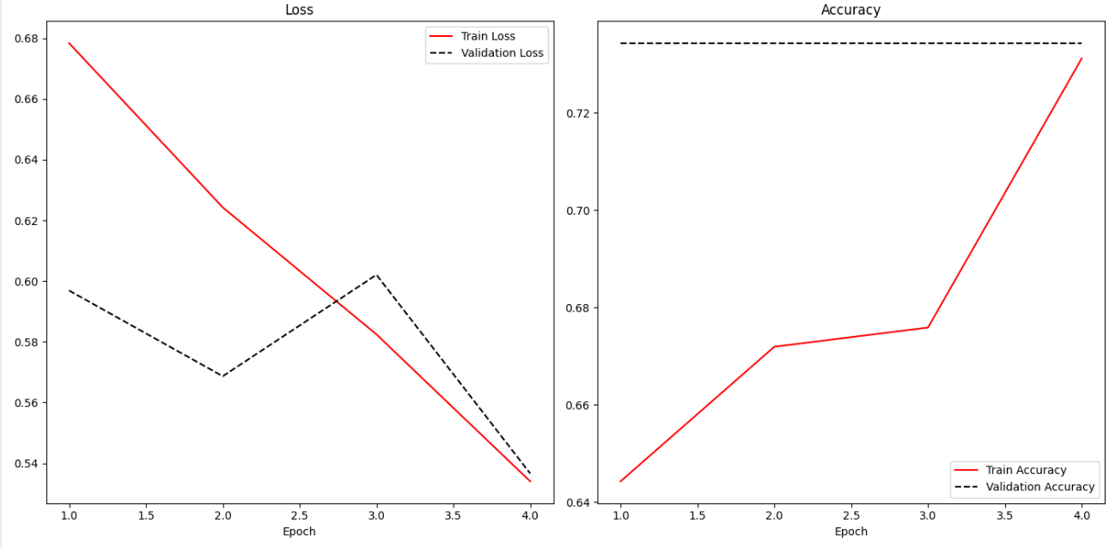

Here is the code:

|  |
| --- |
| import pandas as pd  import re  from keras_preprocessing.sequence import pad_sequences  from sklearn.model_selection import train_test_split  from tensorflow.python.keras import Sequential  from tensorflow.python.keras.layers import Embedding, LSTM, Dense  PATH = "/Users/pm/Desktop/DayDocs/data/"  FILE = "yelp_mini.csv"  data = pd.read_csv(PATH + FILE)  # Show all columns.  pd.set_option('display.max_columns', None)  pd.set_option('display.width', 1000)  # Create a sentiment column.  # Ratings above 3 are positive, otherwise they are negative.  data['sentiment'] = ['pos' if (x>3) else 'neg' for x in data['stars']]  data['text'] = data['text'].apply((lambda x: re.sub('[^a-zA-z0-9\s]','',x)))  from keras.preprocessing.text import Tokenizer  VOCABULARY_SIZE = 2500  tokenizer = Tokenizer(num_words=VOCABULARY_SIZE, lower=True,split=' ')  tokenizer.fit_on_texts(data['text'].values)  X = tokenizer.texts_to_sequences(data['text'].values)  X = pad_sequences(X)  WORDS_PER_SENTENCE = X.shape[0]  NUM_REVIEWS = X.shape[1]  import numpy as np  VOCABULARY_SIZE = np.amax(X) + 1  word_info_sz = 128 # Size of output vector for each word.  # This can be changed.    # Stores info about word sequence -  # "Eat to live" vs. "Live to eat" are very different.  sentence_info_sz = 200 # Vector size for storing info about  # entire sequence.  # This can be changed.  batch_size = 32  model = Sequential()  model.add(Embedding(VOCABULARY_SIZE, word_info_sz))  model.add(LSTM(sentence_info_sz, dropout=0.2))  model.add(Dense(2, activation='softmax')) # Two column one-hot encoded output.  # Target data is one-hot encoded so we must use ‘categorical_crossentropy’ for loss.  # Here we are using one-hot encoding so we must use categorical_crossentropy.  # One-hot encoding is a fancy way to say multi-column binary encoding.  # Y_train  # [[0 1]  # [1 0]  # [0 1]  model.compile(loss = 'categorical_crossentropy',  optimizer='adam',metrics = ['accuracy'])  print(model.summary())  Y = pd.get_dummies(data['sentiment']).values  X_train, X_test, Y_train, y_test = train_test_split(X,Y, test_size = 0.20)  history = model.fit(X_train, Y_train, batch_size =batch_size, epochs =4,  verbose = 1, validation_data=(X_test, y_test))  score, acc = model.evaluate(X_test, y_test, verbose=2, batch_size=batch_size)  print("Score: %.2f" % (score))  print("Validation Accuracy: %.2f" % (acc))  import matplotlib.pyplot as plt  def showLoss(history):  # Get training and test loss histories  training_loss = history.history['loss']  validation_loss = history.history['val_loss']  # Create count of the number of epochs  epoch_count = range(1, len(training_loss) + 1)  plt.subplot(1, 2, 1)  # Visualize loss history for training data.  plt.plot(epoch_count, training_loss, label='Train Loss', color='red')  # View loss on unseen data.  plt.plot(epoch_count, validation_loss, 'r--', label='Validation Loss',  color='black')  plt.xlabel('Epoch')  plt.legend(loc="best")  plt.title("Loss")  def showAccuracy(history):  # Get training and test loss histories  training_loss = history.history['accuracy']  validation_loss = history.history['val_accuracy']  # Create count of the number of epochs  epoch_count = range(1, len(training_loss) + 1)  plt.subplot(1, 2, 2)  # Visualize loss history for training data.  plt.plot(epoch_count, training_loss, label='Train Accuracy', color='red')  # View loss on unseen data.  plt.plot(epoch_count, validation_loss, 'r--',  label='Validation Accuracy', color='black')  plt.xlabel('Epoch')  plt.legend(loc="best")  plt.title('Accuracy')  plt.subplots(nrows=1, ncols=2, figsize=(14,7))  showLoss(history)  showAccuracy(history)  plt.show() |

Further Improvements

* We can use much larger dataset with more epochs to increase the accuracy. See yelp_review.csv.
* We might use more hidden dense layers can be used to improve the accuracy (or not). We can tune other hyper parameters as well.

*Exercise 3 (1 mark)*

What kind of loss function option is suitable when the target variable values are stored in a single column and values range between 0 and 1. You may have to refer to notes from earlier in the course to confirm.

|  |
| --- |
| binary_crossentropy |

*Exercise 4 (1 mark)*

What kind of loss function option is appropriate when the target variable values are stored in multiple columns and values for each column range between 0 and 1.

|  |
| --- |
| binary_crossentropy |

*Exercise 5 (1 mark)*

What kind of loss function option is appropriate when the target variable values are stored in a single column and the possible values range between 0 and 5?

|  |
| --- |
| categorical_crossentropy |

*Exercise 6 (1 mark)*

What kind of loss function option is appropriate when the target variable is one hot encoded?

|  |
| --- |
| categorical_crossentropy |

*Exercise 7 (5 marks)*

Grid search the word vector and sequence vector sizes ideally to improve accuracy. Or, if accuracy cannot be improved, then determine if the word vector and sequence vector sizes be reduced without deteriorating the accuracy.

NOTE: LSTM’s take a notoriously long amount of time to run. Please keep your grid search reasonable.

Show your accuracy score, word vector and sequence vector sizes here:

|  |
| --- |
|  |

Show the code used to perform the grid search here:

|  |
| --- |
| import pandas as pd import re  from keras_preprocessing.sequence import pad_sequences from sklearn.model_selection import train_test_split from tensorflow.python.keras import Sequential from tensorflow.python.keras.layers import Embedding, LSTM, Dense  PATH = "/Users/hyerimshin/PycharmProjects/MachineLearning/datasets/" FILE = "yelp_mini.csv" data = pd.read_csv(PATH + FILE)  # Show all columns. pd.set_option('display.max_columns', None) pd.set_option('display.width', 1000)  # Create a sentiment column. # Ratings above 3 are positive, otherwise they are negative. data['sentiment'] = ['pos' if (x > 3) else 'neg' for x in data['stars']] data['text'] = data['text'].apply((lambda x: re.sub('[^a-zA-z0-9\s]', '', x)))  from keras.preprocessing.text import Tokenizer  VOCABULARY_SIZE = 2500 tokenizer = Tokenizer(num_words=VOCABULARY_SIZE, lower=True, split=' ') tokenizer.fit_on_texts(data['text'].values)  X = tokenizer.texts_to_sequences(data['text'].values) X = pad_sequences(X) WORDS_PER_SENTENCE = X.shape[0] NUM_REVIEWS = X.shape[1]  import numpy as np  VOCABULARY_SIZE = np.amax(X) + 1  word_info_sz = 128 # Size of output vector for each word. # This can be changed.  # Stores info about word sequence - # "Eat to live" vs. "Live to eat" are very different. sentence_info_sz = 200 # Vector size for storing info about # entire sequence. # This can be changed. batch_size = 32  model = Sequential() model.add(Embedding(VOCABULARY_SIZE, word_info_sz)) model.add(LSTM(sentence_info_sz, dropout=0.2)) model.add(Dense(2, activation='softmax')) # Two column one-hot encoded output.  # Target data is one-hot encoded so we must use ‘categorical_crossentropy’ for loss. # Here we are using one-hot encoding so we must use categorical_crossentropy. # One-hot encoding is a fancy way to say multi-column binary encoding. # Y_train # [[0 1] # [1 0] # [0 1] model.compile(loss='categorical_crossentropy',  optimizer='adam', metrics=['accuracy']) print(model.summary())  Y = pd.get_dummies(data['sentiment']).values X_train, X_test, Y_train, y_test = train_test_split(X, Y, test_size=0.20)  history = model.fit(X_train, Y_train, batch_size=batch_size, epochs=4,  verbose=1, validation_data=(X_test, y_test))  score, acc = model.evaluate(X_test, y_test, verbose=2, batch_size=batch_size) print("Score: %.2f" % (score)) print("Validation Accuracy: %.2f" % (acc))  import matplotlib.pyplot as plt   def showLoss(history):  # Get training and test loss histories  training_loss = history.history['loss']  validation_loss = history.history['val_loss']   # Create count of the number of epochs  epoch_count = range(1, len(training_loss) + 1)  plt.subplot(1, 2, 1)  # Visualize loss history for training data.  plt.plot(epoch_count, training_loss, label='Train Loss', color='red')   # View loss on unseen data.  plt.plot(epoch_count, validation_loss, 'r--', label='Validation Loss',  color='black')   plt.xlabel('Epoch')  plt.legend(loc="best")  plt.title("Loss")   def showAccuracy(history):  # Get training and test loss histories  training_loss = history.history['accuracy']  validation_loss = history.history['val_accuracy']   # Create count of the number of epochs  epoch_count = range(1, len(training_loss) + 1)  plt.subplot(1, 2, 2)  # Visualize loss history for training data.  plt.plot(epoch_count, training_loss, label='Train Accuracy', color='red')   # View loss on unseen data.  plt.plot(epoch_count, validation_loss, 'r--',  label='Validation Accuracy', color='black')  plt.xlabel('Epoch')  plt.legend(loc="best")  plt.title('Accuracy')   plt.subplots(nrows=1, ncols=2, figsize=(14, 7)) showLoss(history) showAccuracy(history) plt.show() |

*Exercise 8 (5 marks)*

Starting with the solution from Exercise 7, increase the number of epochs. Add a callback to save the best model with early stopping. (Please refer to the week 4 lesson for notes on how to do this). Then load the binary model and use it to make a prediction with the test set. Show the accuracy score that is achieved with the binary model.

Show your accuracy score here:

|  |
| --- |
|  |

Show your code here:

|  |
| --- |
| import pandas as pd import re  from keras_preprocessing.sequence import pad_sequences from sklearn.model_selection import train_test_split from tensorflow.python.keras import Sequential from tensorflow.python.keras.layers import Embedding, LSTM, Dense from keras.callbacks import EarlyStopping from keras.callbacks import ModelCheckpoint  PATH = "/Users/hyerimshin/PycharmProjects/MachineLearning/datasets/" FILE = "yelp_mini.csv" data = pd.read_csv(PATH + FILE)  # Show all columns. pd.set_option('display.max_columns', None) pd.set_option('display.width', 1000)  # Create a sentiment column. # Ratings above 3 are positive, otherwise they are negative. data['sentiment'] = ['pos' if (x > 3) else 'neg' for x in data['stars']] data['text'] = data['text'].apply((lambda x: re.sub('[^a-zA-z0-9\s]', '', x)))  from keras.preprocessing.text import Tokenizer  VOCABULARY_SIZE = 2500 tokenizer = Tokenizer(num_words=VOCABULARY_SIZE, lower=True, split=' ') tokenizer.fit_on_texts(data['text'].values)  X = tokenizer.texts_to_sequences(data['text'].values) X = pad_sequences(X) WORDS_PER_SENTENCE = X.shape[0] NUM_REVIEWS = X.shape[1]  import numpy as np  VOCABULARY_SIZE = np.amax(X) + 1  word_info_sz = 128 # Size of output vector for each word. # This can be changed.  # Stores info about word sequence - # "Eat to live" vs. "Live to eat" are very different. sentence_info_sz = 200 # Vector size for storing info about # entire sequence. # This can be changed. batch_size = 32   # simple early stopping # Apparently we must set patience to at least 1 for it to work on certain machines. es = EarlyStopping(monitor='val_loss', mode='min', verbose=1,  min_delta=0.1, patience=1) mc = ModelCheckpoint('best_model.h5', monitor='val_loss', mode='min', verbose=1, save_best_only=True)  model = Sequential() model.add(Embedding(VOCABULARY_SIZE, word_info_sz)) model.add(LSTM(sentence_info_sz, dropout=0.2)) model.add(Dense(2, activation='softmax')) # Two column one-hot encoded output.  # Target data is one-hot encoded so we must use ‘categorical_crossentropy’ for loss. # Here we are using one-hot encoding so we must use categorical_crossentropy. # One-hot encoding is a fancy way to say multi-column binary encoding. # Y_train # [[0 1] # [1 0] # [0 1] model.compile(loss='categorical_crossentropy',  optimizer='adam', metrics=['accuracy']) print(model.summary())  Y = pd.get_dummies(data['sentiment']).values X_train, X_test, Y_train, y_test = train_test_split(X, Y, test_size=0.20)  history = model.fit(X_train, Y_train, batch_size=batch_size, epochs=6,  verbose=1, validation_data=(X_test, y_test))  score, acc = model.evaluate(X_test, y_test, verbose=2, batch_size=batch_size) print("Score: %.2f" % (score)) print("Validation Accuracy: %.2f" % (acc))  import matplotlib.pyplot as plt   def showLoss(history):  # Get training and test loss histories  training_loss = history.history['loss']  validation_loss = history.history['val_loss']   # Create count of the number of epochs  epoch_count = range(1, len(training_loss) + 1)  plt.subplot(1, 2, 1)  # Visualize loss history for training data.  plt.plot(epoch_count, training_loss, label='Train Loss', color='red')   # View loss on unseen data.  plt.plot(epoch_count, validation_loss, 'r--', label='Validation Loss',  color='black')   plt.xlabel('Epoch')  plt.legend(loc="best")  plt.title("Loss")   def showAccuracy(history):  # Get training and test loss histories  training_loss = history.history['accuracy']  validation_loss = history.history['val_accuracy']   # Create count of the number of epochs  epoch_count = range(1, len(training_loss) + 1)  plt.subplot(1, 2, 2)  # Visualize loss history for training data.  plt.plot(epoch_count, training_loss, label='Train Accuracy', color='red')   # View loss on unseen data.  plt.plot(epoch_count, validation_loss, 'r--',  label='Validation Accuracy', color='black')  plt.xlabel('Epoch')  plt.legend(loc="best")  plt.title('Accuracy')   plt.subplots(nrows=1, ncols=2, figsize=(14, 7)) showLoss(history) showAccuracy(history) plt.show() |

**Table of Contents**

**References 1**

**Conjoint Analysis 1**

Fractional Factorial Designs 1

Level 1

Part Worth 1

Relative Importance 1

Utility 2

**Survey Design 2**

Level Part Worth Utility 3

Attribute Importance 3

**Predicting User Preferences 3**

References

<https://www.informit.com/articles/article.aspx?p=2350028> (Dr. Tom Miller)

<https://www.linkedin.com/pulse/conjoint-analysis-simple-python-implementation-prajwal-sreenivas>

Conjoint Analysis

Conjoint analysis is a marketing technique for discovering consumer preferences. Conjoint analysis can help to predict consumer behaviour and it can help with product positioning. The product is described by a number of attributes and each **attribute** has several **levels**.

Fractional Factorial Designs

Product designs can be created using an even matching of each attribute with all others to understand preferences (utility). In this manner, it is not necessary to study an exhaustive set of combinations.

Level

Products or services have different attributes. Attributes may have more than one option and these options are called levels. For example, when developing a new car, an important consideration is the fuel economy attribute. **Levels** for this attributemight include **18KM/L*,* 15KM/L,** or **13KM/L**.

Part Worth

Part worth is the consumer preference at each level for every attribute of the product.

Relative Importance

Relative importance is how much difference an attribute can add to the utility of a product.

Utility

Utility is the level of individual consumer preference.

Survey Design

Figure 1 identifies 9 mutually exclusive attribute combinations for a car. There are actually 3x3x3=27 potential choices. However, we can design a simple survey with 9 combinations where each attribute level is represented with the same amount. In other words, each attribute appears in two of the nine survey choices. In this case, each respondent’s ranking of these 9 combinations can reveal their preferences for all 27 combinations.

*Figure 1: Fractional Factorial Survey Design*

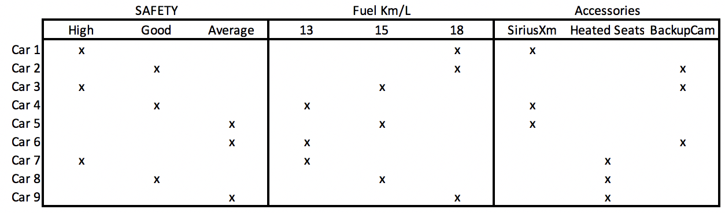

Based on the combinations identified, a survey can be created. The survey in Figure 2 asks respondents to rank their preferred car options between 1 and 9 where 9 is the best.

*Figure 2: Car Survey*

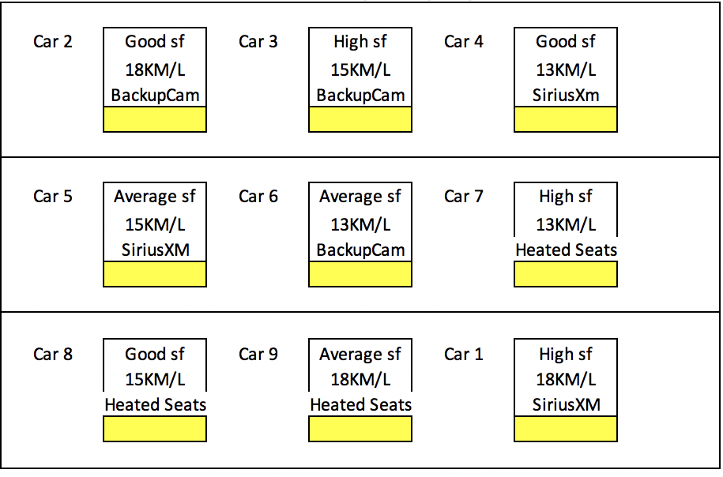

Level Part Worth Utility

Level part worth is a utility value that quantifies a user’s preference. For our use case, most survey respondents likely prefer higher fuel economy.

The part worth score for each level = Average of the sum of all rankings which contain the level.

(See Figure 3)

Attribute Importance

The importance score rates an attribute relative to others. In our case, it is possible that many drivers would may rate vehicle safety as a more important attribute than any car accessories.

The importance score for an attribute

= (Max(level) – Min(level))/(Sum of level ranges for each attribute)

Figure 3 shows a spreadsheet which enables the calculation of the part worth utilities and attribute importance scores.

*Figure 3: Calculating part worth utilities and Attribute Importance*

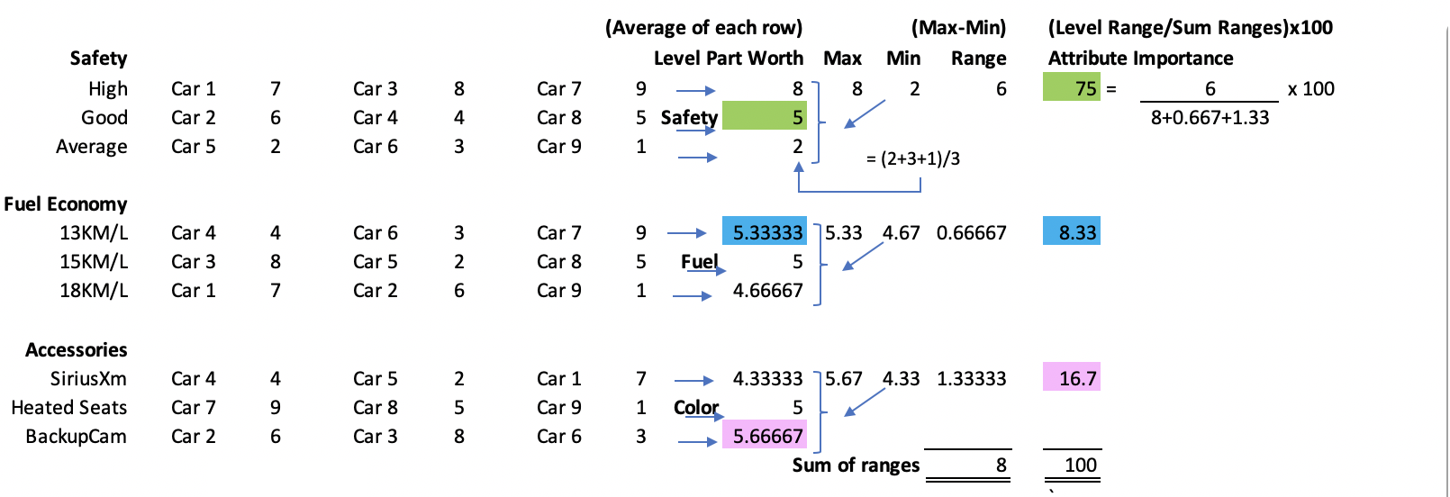

Predicting User Preferences

The level part worth and attribute importance scores can now be used to make predictions about a user’s preferences (see Figure 4).

*Figure 4: Comparing Actual Preferences with Predicted Utility*

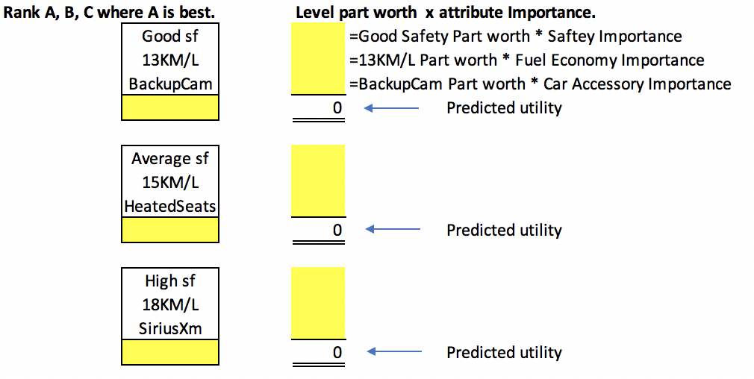

For this next set of exercises, follow the steps in the CarUtiliityPrediction.xls file.

*Exercise 1 (3 marks)*

Take the survey and rank your car preferences between 1 and 9 where 9 is the best. Show a screenshot of your completed survey here.

|  |
| --- |
|  |

*Exercise 2 (3 marks)*

After completing the survey, show a screenshot of your level part worth and attribute importance values in your spreadsheet here:

|  |
| --- |
|  |

*Exercise 3 (6 marks)*

Next, rate the three car options presented in step 3. Then use the level part worth and attribute importance scores to calculate the predicted responses. Show a screenshot of the spreadsheet results here for your actual and predicted values.

|  |
| --- |
|  |

*Exercise 4 (4 marks)*

Starting with the code below, replace the part-worth values with the values that you calculated for your preferences.

|  |
| --- |
| from matplotlib import pyplot as plt  import pylab as plb  plb.rcParams['font.size'] = 16  def mk_groups(data):  try:  newdata = data.items()  except:  return  thisgroup = []  groups = []  for key, value in newdata:  newgroups = mk_groups(value)  if newgroups is None:  thisgroup.append((key, value))  else:  thisgroup.append((key, len(newgroups[-1])))  if groups:  groups = [g + n for n, g in zip(newgroups, groups)]  else:  groups = newgroups  return [thisgroup] + groups  def add_line(ax, xpos, ypos):  line = plt.Line2D([xpos, xpos], [ypos + .1, ypos],  transform=ax.transAxes, color='black')  line.set_clip_on(False)  ax.add_line(line)  def label_group_bar(ax, data):  groups = mk_groups(data)  xy = groups.pop()  x, y = zip(*xy)  ly = len(y)  xticks = range(1, ly + 1)  ax.bar(xticks, y, align='center')  ax.set_xticks(xticks)  ax.set_xticklabels(x, Rotation=0, )  ax.set_xlim(.5, ly + .5)  ax.yaxis.grid(True)  scale = 1. / ly  for pos in range(ly + 1):  add_line(ax, pos * scale, -.1)  ypos = -.2 # Adjust this to shift the bottom labels  while groups:  group = groups.pop()  pos = 0  for label, rpos in group:  lxpos = (pos + .5 * rpos) * scale  ax.text(lxpos, ypos, label, ha='center', transform=ax.transAxes, rotation=70,  color='red')  add_line(ax, pos * scale, ypos)  pos += rpos  add_line(ax, pos * scale, ypos)  ypos -= .1  dataDict = {  # Set attributes and level part worths for the attribute.  "Car Safety": { "High":1, "Good":1, "Average":-1},  "Fuel": { "18km/l":1, "15km/l":1, "13km/l":-1},  "Accessories": { "Roadside Assist":1, "BackupCam":1, "Heated Seats":-1},  }  fig = plt.figure(figsize=(13,10))  ax = fig.add_subplot(1, 1, 1)  label_group_bar(ax, dataDict)  plt.title("Part Worths")  plt.show() |

Show the resulting plot here:

|  |
| --- |
|  |

*Exercise 5 (4 marks)*

Start with the following code, replace the importance values for the attributes with your importance values that were calculated in the spreadsheet.

|  |
| --- |
| import matplotlib.pyplot as plt  carAttributes = ['Saftey', 'Fuel Economy', 'Accessories']  importanceLevels = [2,1,0]  plt.bar(carAttributes, importanceLevels)  plt.xticks(rotation=75)  plt.title("Car Attribute Importance")  plt.show() |

Show your bar plot here:

|  |
| --- |
|  |